**Legend**

# Walton OSSR sites, LGS sites and Wildlife Sites Note the LGS sites are proposals only at Sept 2015

## Not recommended for LGS Designation

l Farm Fish

Mil ery - Gilmorton

## Recommended for LGS designation Wildlife Sites

Open Space, Sport and Recreation Sites

**OS MM Boundary**

**DESCTERM**

!!!!!!!!!!!!!!!!!!!! County

## District Electoral Parish

Bike Track in BruntingthorpeLGS/BRU/2 - Bike Track Bruntingthorpe

LGS/BRUN/1 - Amenity Land Upper Bruntingthorpe Upper Bruntingthorpe - Amenity Land

Gravel Hole at Walton

All Saints Church - Kimcote and Walton

Walton Village Hall Playground Playing Fields at Walton Village Hall

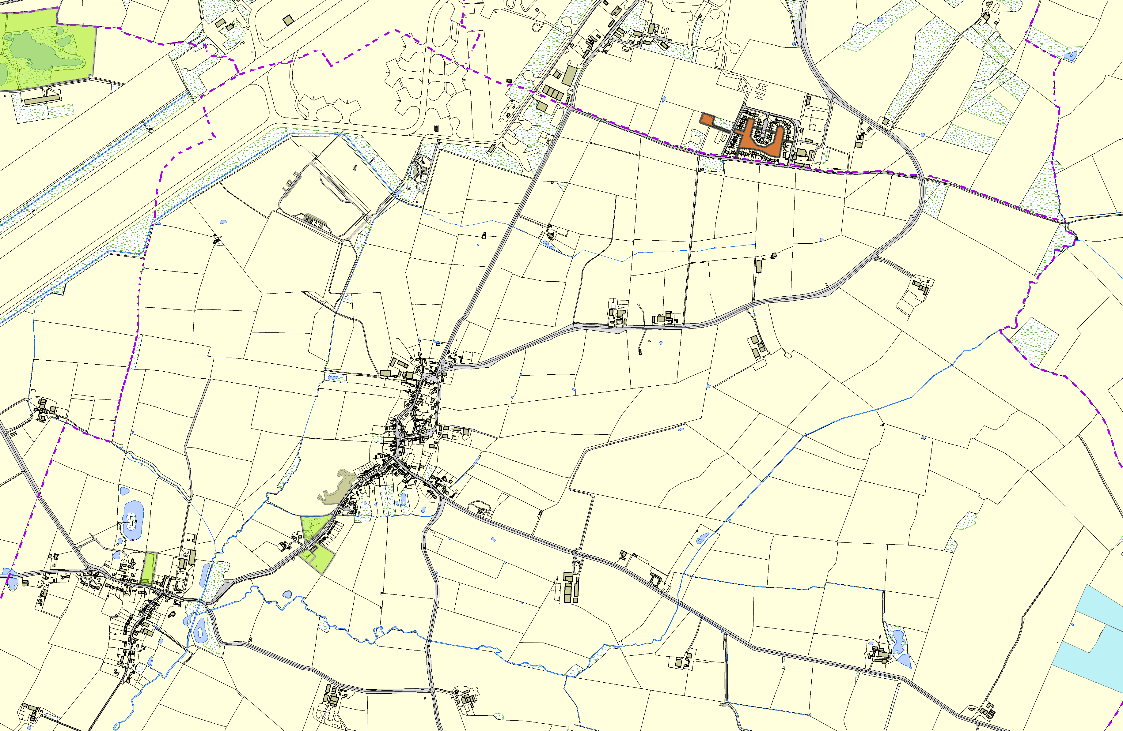

Walton Gorse Meadow

Walton Holt Gorse

**©Crown Copyright. All rights reserved. Harborough District Council 100023843 2014**