# KImcote and Walton OSSR sites, LGS sites and Wildlife Sites Note the LGS sites are proposals only at Sept 2015

Gravel Hole at Walton

Walton Village Hall Playground Playing Fields at Walton Village Hall

All Saints Church - Kimcote and Walton

Walton Gorse Meadow

Walton Holt Gorse

**Legend**

## Not recommended for LGS Designation Recommended for LGS designation Wildlife Sites

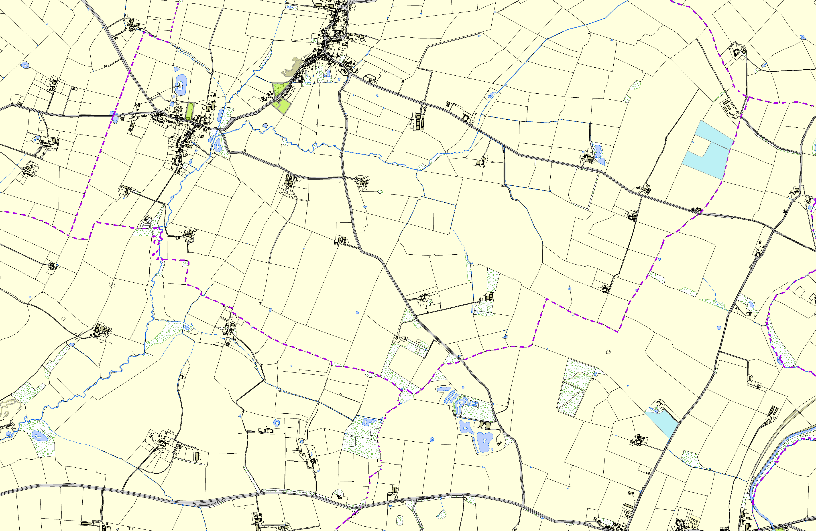

Open Space, Sport and Recreation Sites

**OS MM Boundary**

**DESCTERM**

!!!!!!!!!!!!!!!!!!!! County

## District Electoral Parish

**©Crown Copyright. All rights reserved. Harborough District Council 100023843 2014**

Grassland, North Kilworth

North Kilworth Grand Union Canal