Kings Norton OSSR sites, LGS sites and Wildlife Sites Note the LGS sites are proposals only at Sept 2015

Legend

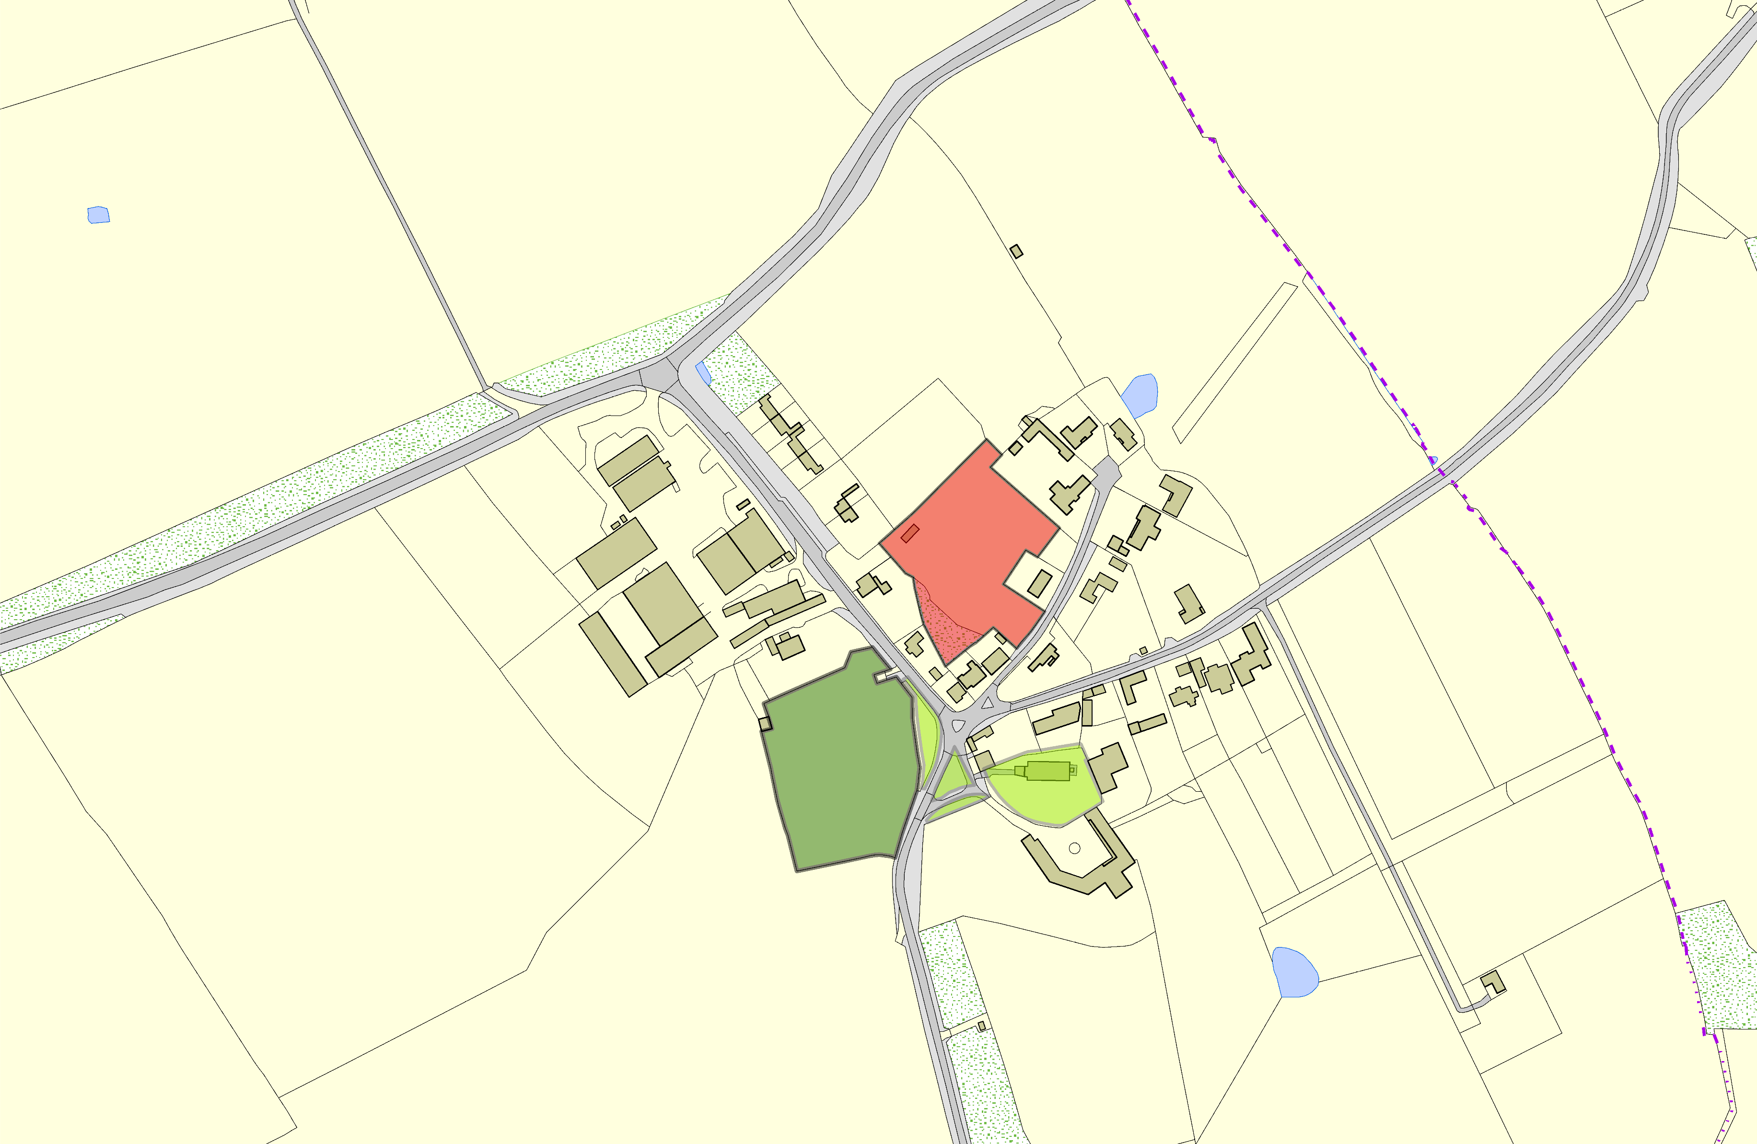

Not recommended for LGS Designation Recommended for LGS designation Wildlife Sites
Open Space, Sport and Recreation Sites
OS MM Boundary
DESCTERM
!!!!!!!!!!!!!!!!!!!! County

District Electoral Parish

LGS/KIN/1- Land adjacent to Home Farm Kings Norton

Kings Norton Village Green 1

LGS/KIN/2 - Land Adjacent to Grange Farm Kings Norton
Kings Norton Village Green 2Kings Norton Churchyard Kings Norton Village Green 3

©Crown Copyright. All rights reserved. Harborough District Council 100023843 2014

