Launde OSSR sites, LGS sites and Wildlife Sites Note the LGS sites are proposals only at Sept 2015

Withcote Chapel
Legend

Sauvey Woodlands area 8
Sauvey Woodlands area 7

Sauvey Woodlands area 1

Not recommended for LGS Designation Recommended for LGS designation Wild ife Sites

Open Space, Sport and Recreation Sites
Mature Ash Tree 1, Withcote Lodge

Brook Farm Meadow

Sauvey Woodlands area 4
Sauvey Woodlands area 5

OS MM Boundary
DESCTERM

Sauvey Woodlands area 3

Sauvey Woodlands area 6

Launde Ash, Launde Launde grassland, Launde

!!!!!!!!!!!!!!!!!!!!! County

District Electoral

Mature Ash Tree 2, Withcote Lodge Mature Oak Tree 1, Withcote Lodge

Fish Pond 1 - Launde
PaMraitusrehOak Tree 2, Withcote Lodge
Mature Oak Tree 4, Withcote Lodge
Mature Oak Tree 3, Withcote Lodge
Mature Ash Tree 7, Withco e Lodge Mature Ash Tree 6, Withcote Lodge

Fish Pond 2, LaundeMature Oak Tree 5, Withcote Lodge
Chater Valley

Mature Ash Tree 5, Withcote odge

Marshy grassland, Launde Marshy grassland, Launde
Mature Ash Tree 4, Withcote Lodge Mature Ash Tree 8, Withcote Lodge

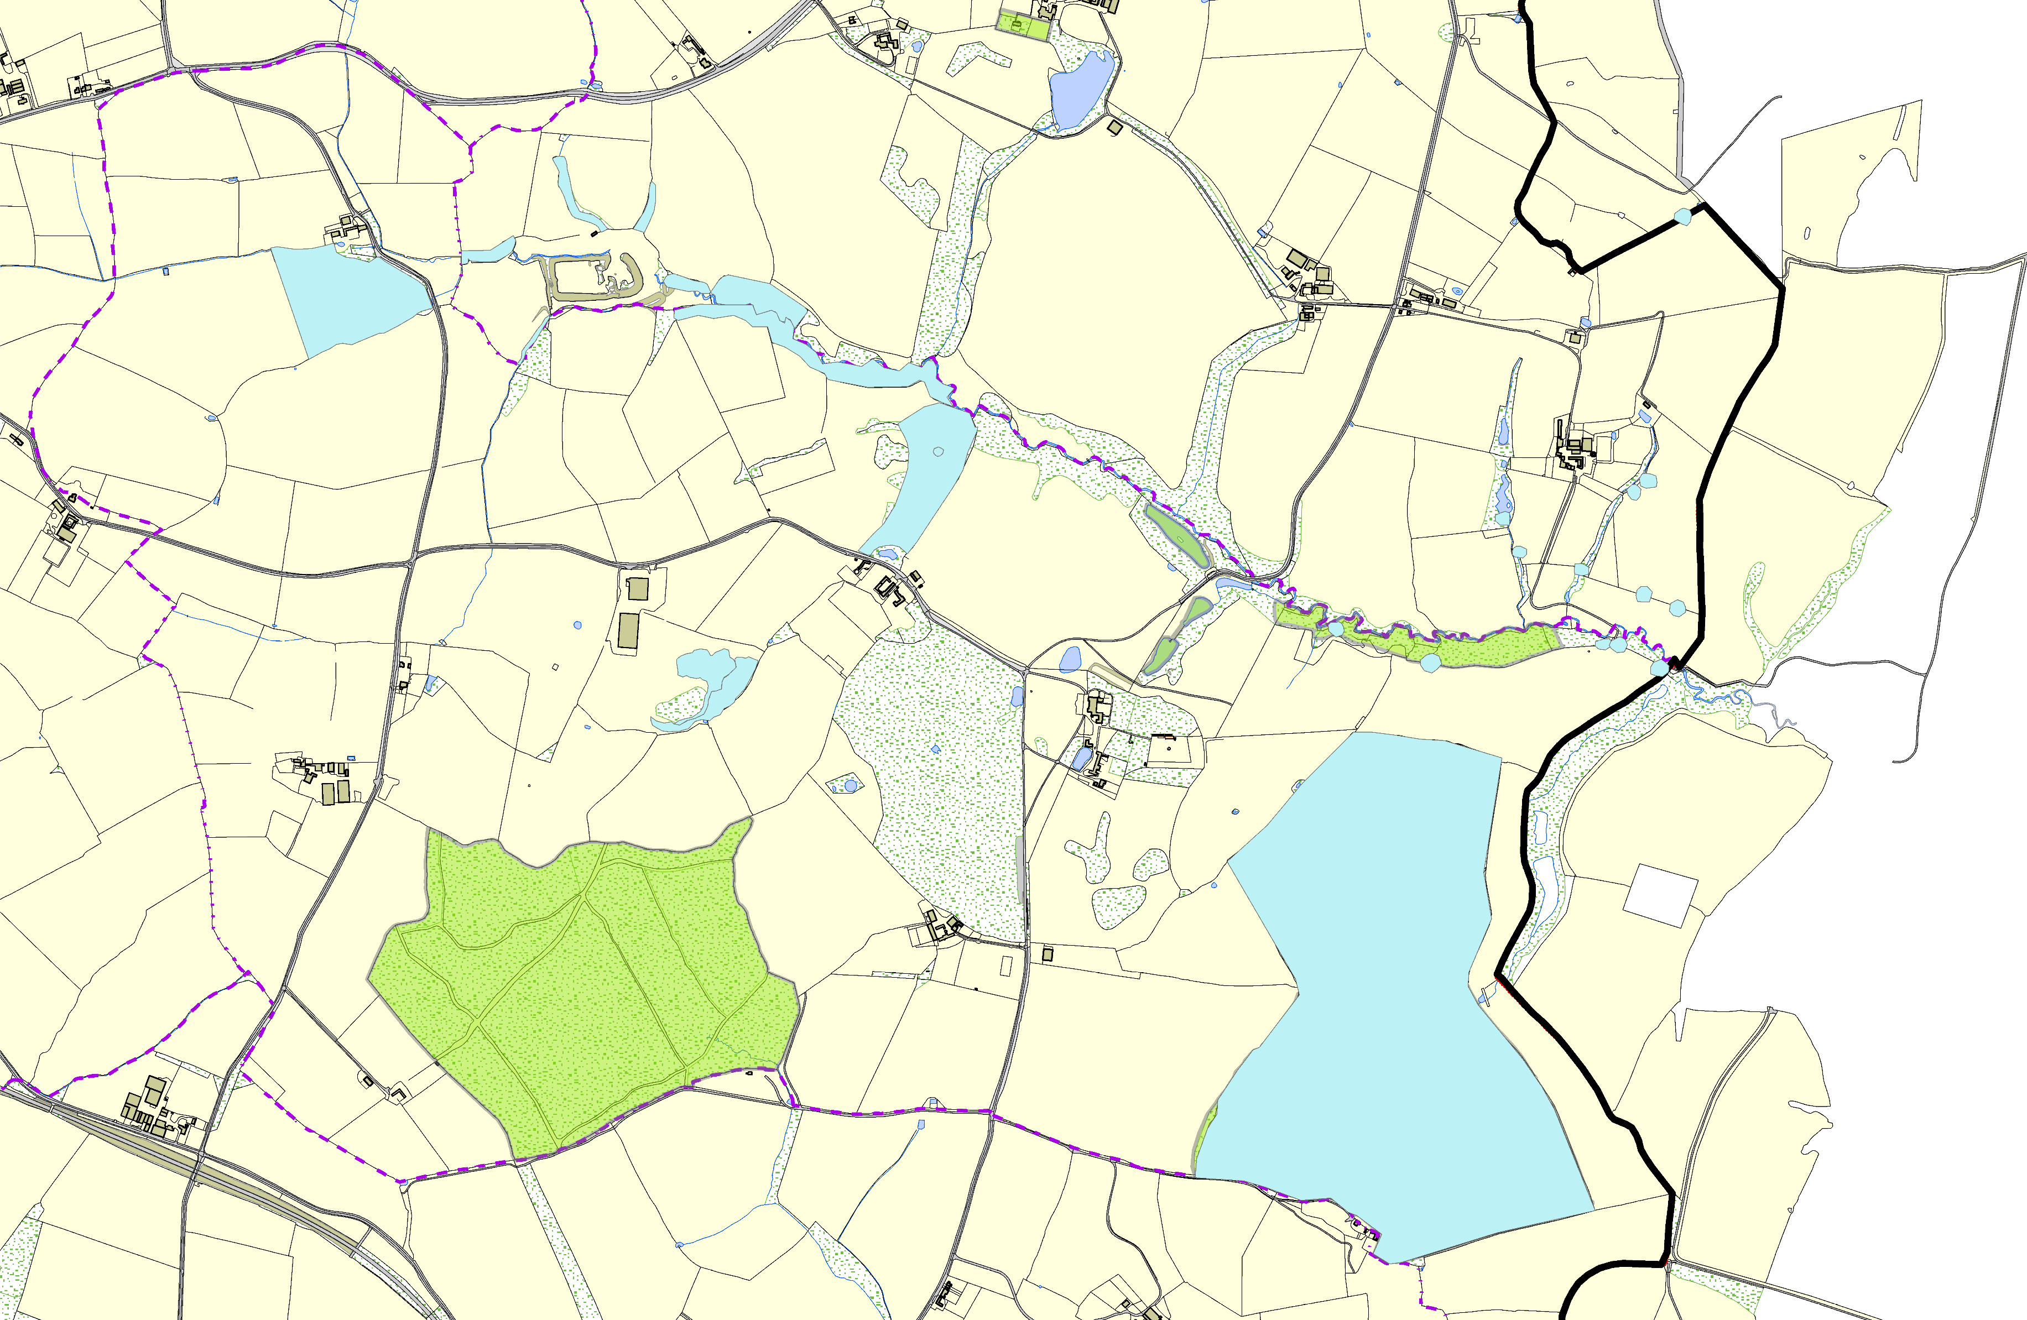

Launde Big Wood
Launde Park Wood

Park Wood - Launde

©Crown Copyright. All rights reserved. Harborough District Council 100023843 2014

