Legend

Leire OSSR sites, LGS sites and Wildlife Sites Note the LGS sites are proposals only at Sept 2015

Not recommended for LGS Designation Recommended for LGS designation Wildlife Sites
Open Space, Sport and Recreation Sites
OS MM Boundary
DESCTERM
!!!!!!!!!!!!!!!!!!!!! County

District Electoral Parish

St Peters Close Amenity Green Space - Leire

Childrens Play Area - Leire

Playing Fields - Leire

Frolesworth Road Allotments, Leire

St Peters Churchyard - Leire

Cemetery at Leire

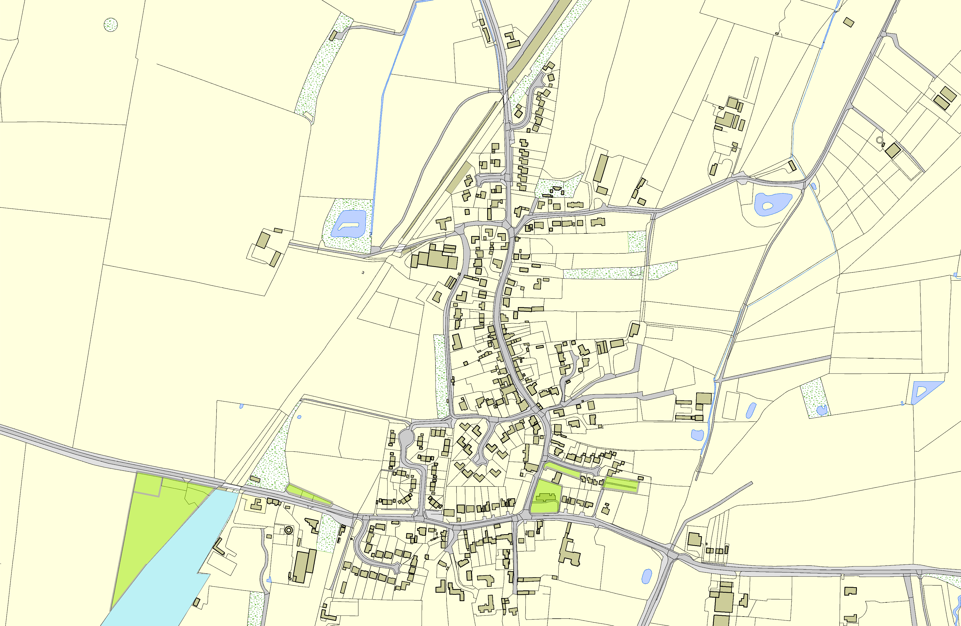

Jubilee Walk

©Crown Copyright. All rights reserved. Harborough District Council 100023843 2014

