Leire OSSR sites, LGS sites and Wildlife Sites Note the LGS sites are proposals only at Sept 2015

Legend

Not recommended for LGS Designation

Hallbrook School - Broughton Astley
Coltsfoot Way / Clump Hill - Broughton AstleyOrchid Place, Broughton Astley
Broughton Lake Near Green space Coltsfoot Way / Clump Hill - Broughton Astley
Foxglove Close, Broughton Astley

Recommended for LGS designation Wildlife Sites
Open Space, Sport and Recreation Sites
OS MM Boundary
DESCTERM
!!!!!!!!!!!!!!!!!!!! County

District Elector l Parish
Dunton Road Natural Green Space - Broughton Astley

Allotments at Dunton Bassett

LGS/

Frolesworth Irrigation Lake 2
Spring-fed marshy grassland Dunton Bassett

LGS/D

Land at Leire Lane - Dunton Bassett

Childrens Play Area - Leire

St Peters Close Amenity Green Space - Leire
Cemetery at Leire

Frolesworth Road Allotments, LeireSt Peters Churchyard - Leire Playing Fields - Leire
Leire Marsh - Carex
Stemborough Brook, Leire Leire Marsh (Dunton Road), Leire

Dunton Bassett Quarry; Site A Dunton Bassett Quarry; Site B
Dunton Bassett Quarry; Site A

Jubilee Walk

Dunton Bassett Grassland

Wet Woodland, Dunton Bassett - Woodland

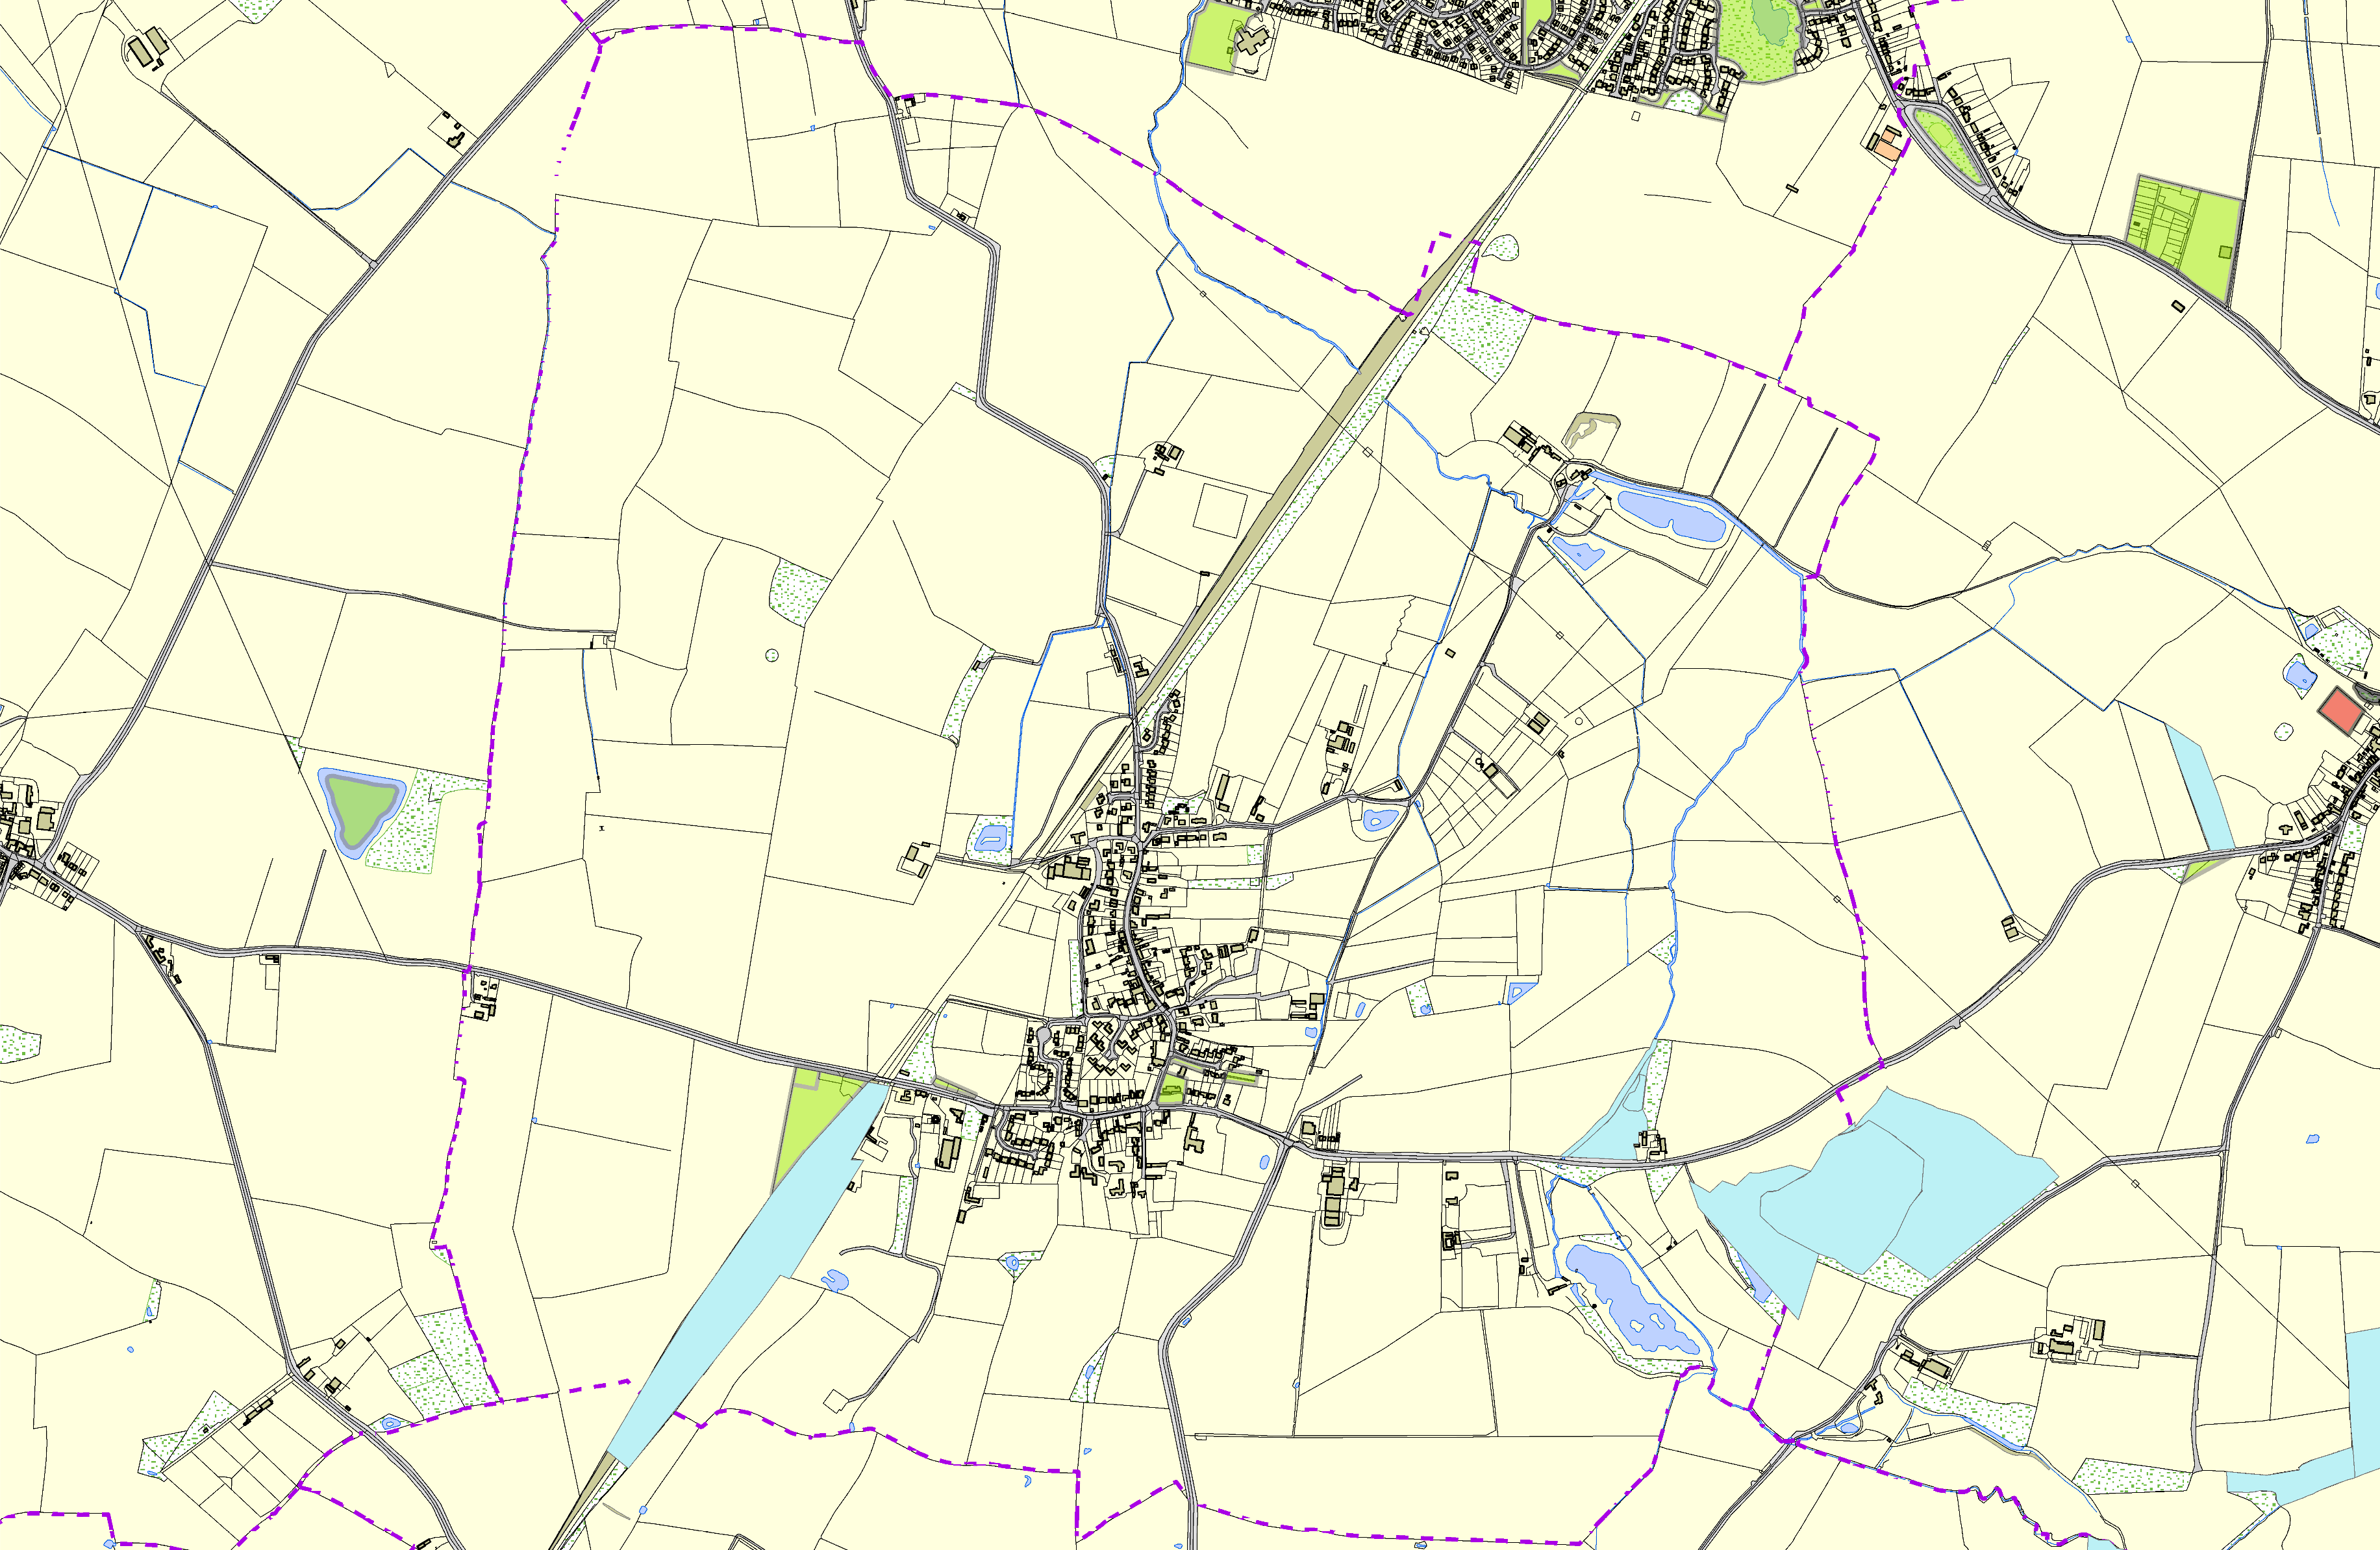
©Crown Copyright. All rights reserved. Harborough District Council 100023843 2014
Buttercup Slope

