Little Stretton OSSR sites, LGS sites and Wildlife Sites Note the LGS sites are proposals only at Sept 2015

Village Play Area, Gaulby Way - Stoughton

LGS/STO/1 - Paddock opp Church Land Stoughton
Legend

Not recommended for LGS Designation Recommended for LGS designation Wildlife Sites
Open Space, Sport and Recreation Sites
OS MM Boundary

DESCTERM
!!!!!!!!!!!!!!!!!!!!! County

District Electoral Parish
Stretton Circuit - Stoughton

L

Kings Norton Village Green 1 LGS/KIN/2 - Land Adjacent to Grange Farm Kings Norton

Little Stretton Church/Cemetery Village Hall and Small Play Area - Little Stretton

Chestnut Drive, Stretton Hall, Great Glen
Pheasant Woodland

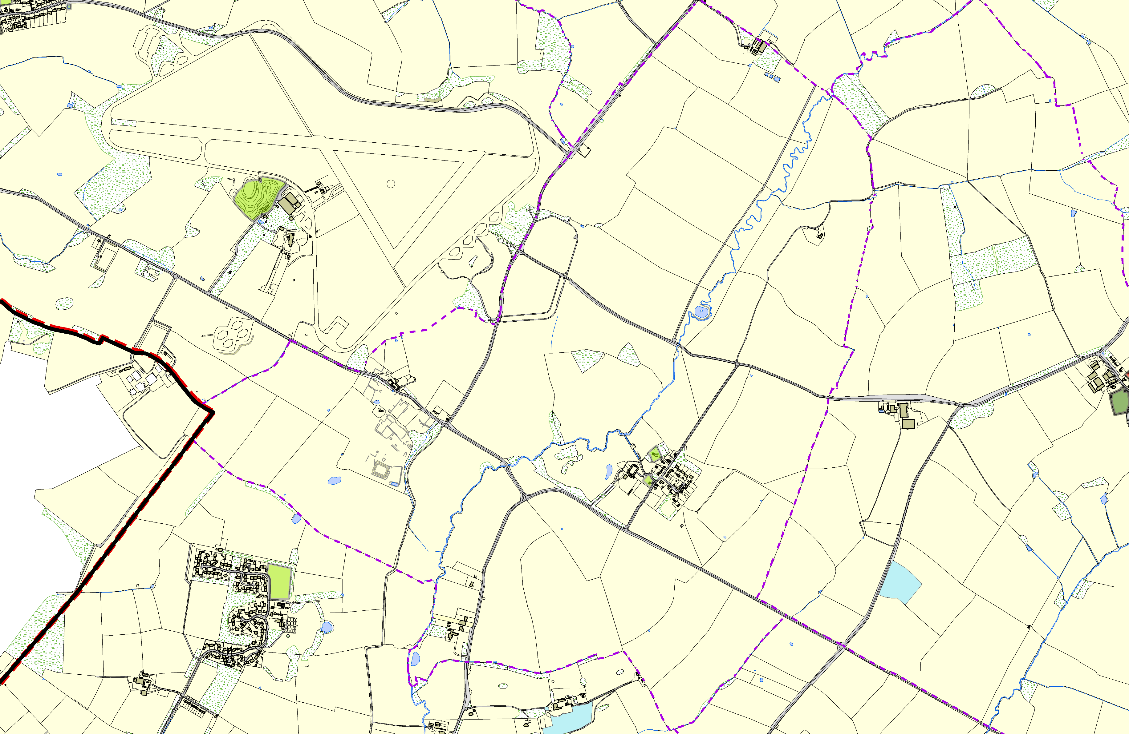

©Crown Copyright. All rights reserved. Harborough District Council 100023843 2014
Old Oak
Stackley House Grassland

