Legend

Not recommended for LGS Designation Recommended for LGS designation Wildlife Sites
Open Space, Sport and Recreation Sites
Loddington OSSR sites, LGS sites and Wildlife Sites Note the LGS sites are proposals only at Sept 2015

Launde Big Wood

Launde Park Wood Park Wood - Launde

OS MM Boundary
DESCTERM
!!!!!!!!!!!!!!!!!!!!! County

District Electoral Parish

Leighfield Forest

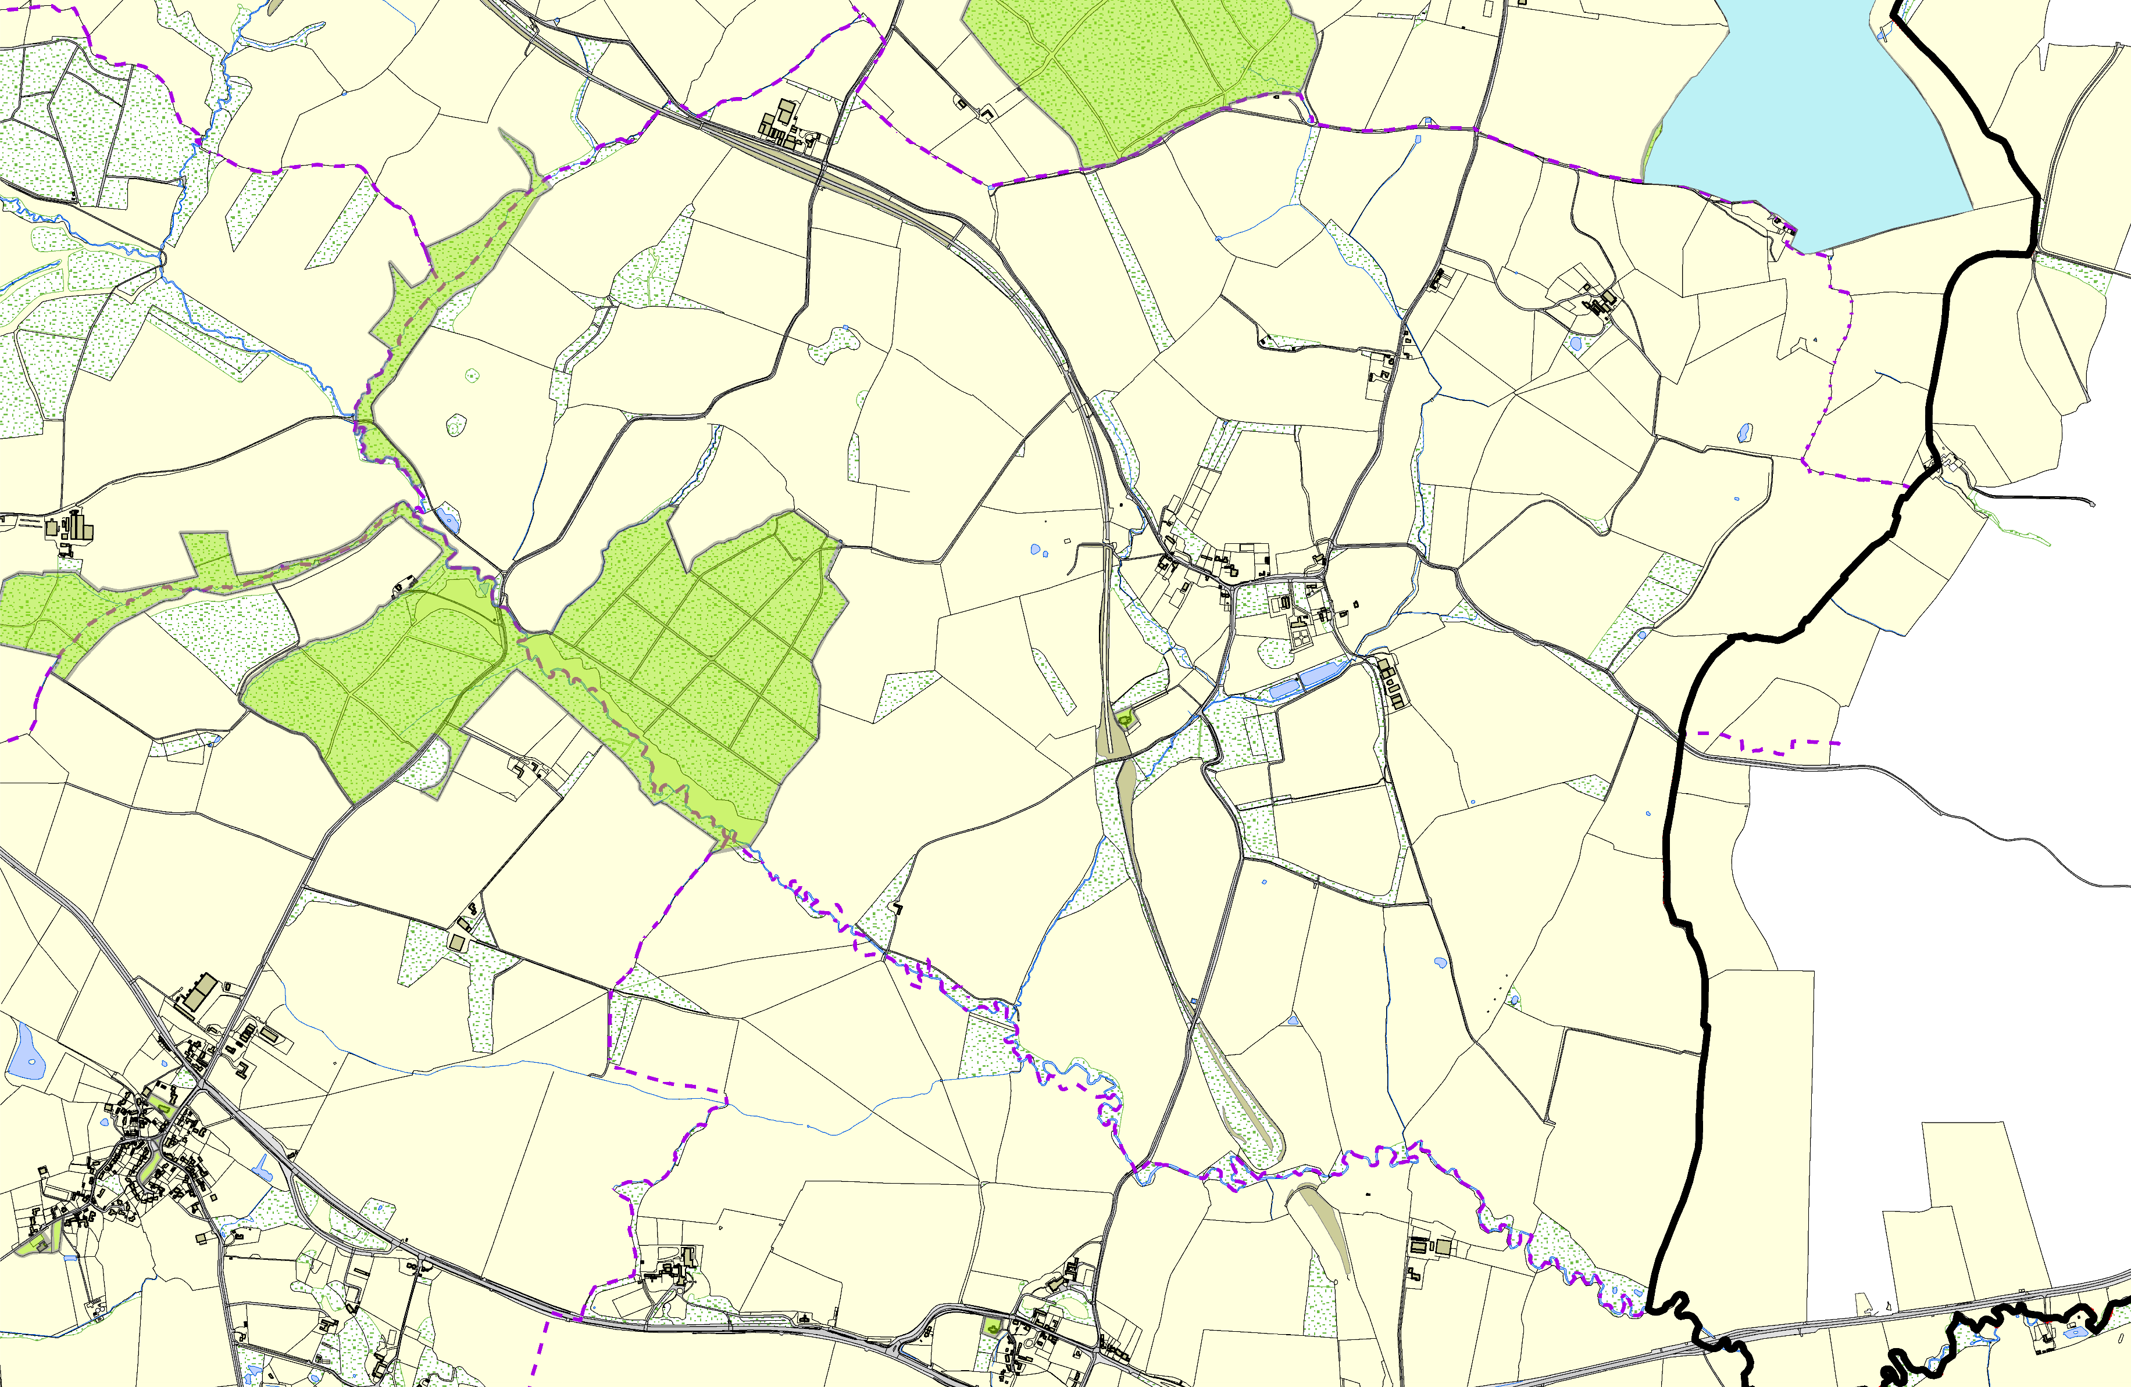

Leighfield Forest

St Michaels and All Angels Church C of E - Lodding

Thomas Beckett Church - Tugby & Keythorpe

Tugby & Keythorpe Village Green Wellfield Green - Tugby & Keythorpe

The Tugby Centre - Main Street

Churchyard - East Norton

©Crown Copyright. All rights reserved. Harborough District Council 100023843 2014

