Lowesby OSSR sites, LGS sites and Wildlife Sites Note the LGS sites are proposals only at Sept 2015

Lake 3 - Hungarton

Carr Bridge Grassland & Marsh (Grassland) Carr Bridge Grassland & Marsh (Marsh)

Legend

Not recommended for LGS Designation Recommended for LGS designation
Wildlife Sites

Lowesby Cricket Pitch

Village Green - Lowesby

Open Space, Sport and Recreation Sites
OS MM Boundary
DESCTERM
All Saints Lowesby Church

!!!!!!!!!!!!!!!!!!!!! County

District
Quenby Fishing LakEe lectoral
Lake 2 - Hungarton

Parish
Valley Grassland, Cold Newton

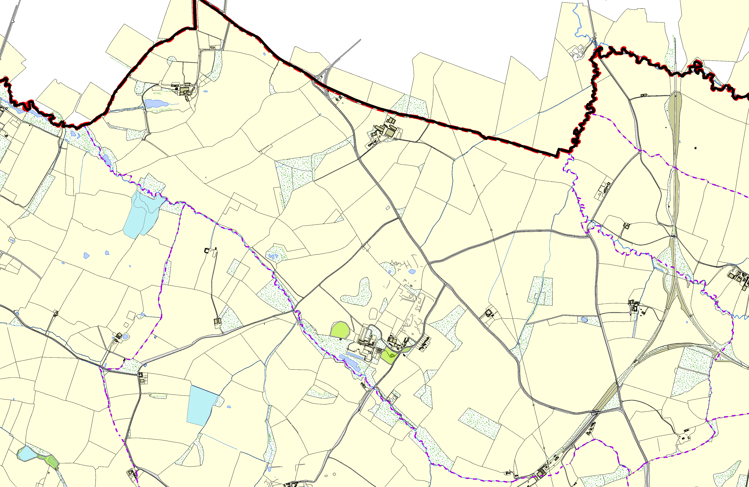
©Crown Copyright. All rights reserved. Harborough District Council 100023843 2014

