Foxton Locks

Lubenham OSSR sites, LGS sites and Wildlife Sites Note the LGS sites are proposals only at Sept 2015
LGS/FOX/3 - Black Horse garden LGS/FOX/5 - Foxton Lodge Garden LGS/FOX/2 - Manor House Gardens Foxton
Church Cemetery - Foxton
LGSL/GFOS/XF/O4 X- /L8a-nMd itlol HfroounsteofGSaurdmemnserFHooxtuosne Foxton Cemetery
School in Foxton

Legend

Not recommended for LGS Designation Recommended for LGS designation Wildlife Sites

Gartree Green Spaces - Lubenham Gartree Green Spaces - Lubenham
Gartree Green Spaces - Lubenham

Open Space, Sport and Recreation Sites
OS MM Boundary
DESCTERM

Gartree Green Spaces - Lubenham
Gartree Green Spaces - Lubenham
!!!!!!!!!!!!!!!!!!!! County

District Electoral
Kingston Way, Market Harborough
Upper Green

Davies Close, Market Harborough

arish

Bates Close, MH
Monroe Close, MH
Coales Gardens, MHMonroe Close, Market Harborough Leicester Road Scrubland, MH

Leicester Road, Market Harborough
Ridgeway Primary, The Ridgeway, MH The Robert Smythe School, Burnmill Road, MHScott Close, Market Harborough

Woodlands Open Space, MH
Leicester Road 'The Woodland', MHVictoria Avenue, Market Harborough

Sherrard Road Play Area

Ridgeway, MH

Sherrard Road Recreation Ground, MH
Arboretum

Arden Way, MH

Park Drive Open Space, MH Park Drive, Market Harborough
Meadow Street, MH

St Mary's Allotments, Douglas Drive The Headlands Recreation Ground, MH

Allotments1Orchard House Ash 1

LGS/LUB/1a - Spinney Lubenham

Clay Pigeon Shooting
Woodland AGS, MH

Folly Pond

Fairfield Road Cricket Ground, MH
Crescent Close, MH Broadway Terrace, MH

Roman Way Recreation Ground Roman Way Play Area, MH

Recreation Ground - Lubenham Allotments 2
War Memorial - Lubenham
Model Areo Club - Lubenham

Logan Street Allotments
Doddridge Road A, MH
St Mary in Arden Church, Great Bowden Road, MH
Symingtons Recreation Ground

Village Hall Play Area - LubenhamVillage GreenLVGillSa/gLeUGB/r1ecen- Three grassed triangles 1
Allotments 4 Paget Road, LubenhamAllotments 3
Market Harborough Primary, Parkfield Road

Logan Street Recreation Ground, MH

Logan Street Recreation Play Area, MH Church Square, MH

Grassland to South Acorn Close - Lubenham
Conservative Club Bowling Club, MH Riverside Walk [east], Market Harborough

LGS/LUB/1c - Three grassed triangles 2
Brookfield Road, MH
St Joseph's Churchyard, MHThe Square
Rolleston Close, Market Harborough

Washpit Lane Green Space - LubenhamSchool Playing Field - Lubenham
LCGhSu/rLcUhyBa/r1dc--LTuhbreenehgarmassed triangles 3

Fishing Pond (Welland Lodge) - Lubenham

Welland Park, MH
Memorial Gardens, MH
Welland Park, MH

Rectory Lane Bowling Green, MH

LGS/LUB/1b - Dismantel Railway Line Lubenham

Rhodes Close, MH
Welland Park Bowling Green, MH
Welland Park Play Area, MHWelland Park College, Welland Park Road
Welland Park STP, MH

Willow Crescent, MH Farndale View, MHFarndale View Balancing Lagoon, MH
Welland Park Tennis Courts, MH
Rectory Lane Open Space, MH

Willow Crescent Open Space, MH

Welland Park Road Allotments, MH
Little Bowden Open Space, MH Little Bowden Play Area, MH

Farndon Road/Rugby Close, MH Summers Way Open Space, MH

Farndon Road (North), MH

Naseby Close, MH
Little Bowden Recreation Ground
Scotland Road Field, MH Little Bowden Allotments, MH

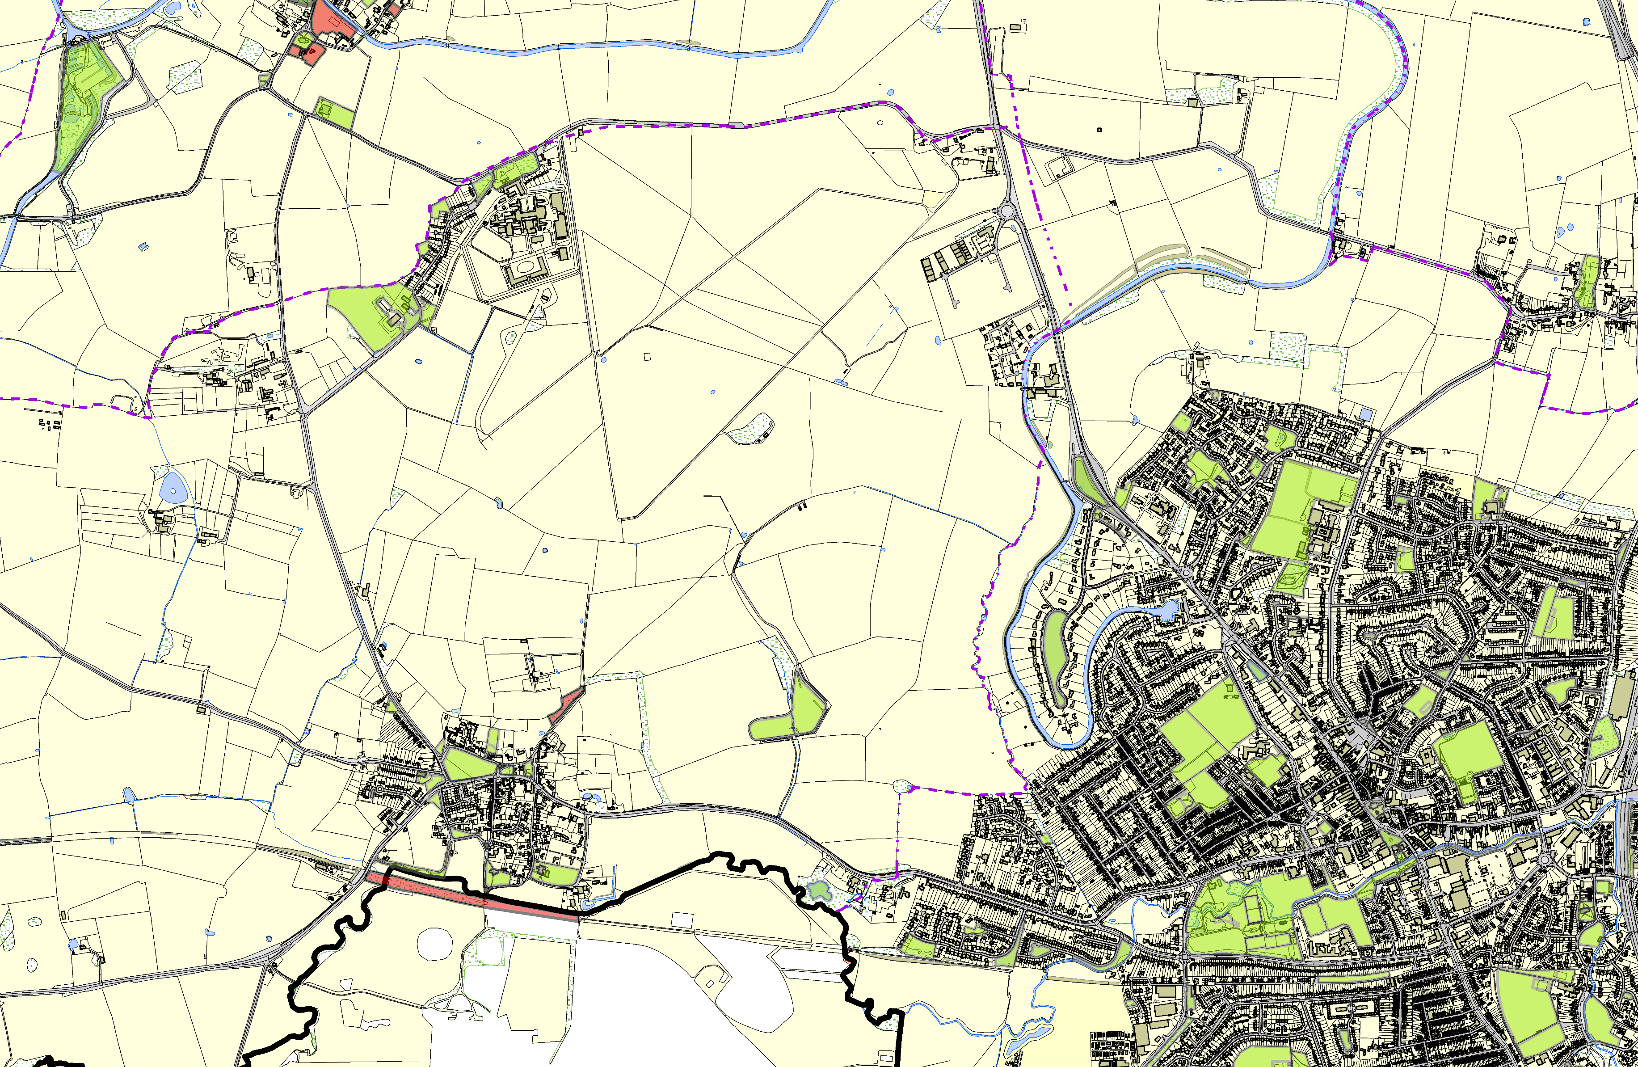
©Crown Copyright. All rights reserved. Harborough District Council 100023843 2014
Burford Green Recreation Ground
Dunmore Road, Market Harborough

