Lubenham OSSR sites, LGS sites and Wildlife Sites Note the LGS sites are proposals only at Sept 2015

St Luke Church - Laughton

LGS/LAUGH/1 - Village Hall Green/ Paddock

Spring Grassland, Gumley
Gartree Green Spaces - Lubenham
Gartree Green Spaces - Lubenham

Marshy Meadow, Gumley
Model Aero Club

Sloping grassland, Laughton

Sweet Chestnut Coppice
Paddle Wood

Laughton Hills Wood

Owell Spinney's Ash

Allotments1Orchard House Ash 1
LGS/LUB/1a - Spinney Lub

Recreation Ground - Lubenham Allotments 2

Legend

Not recommended for LGS Designation Recommended for LGS designation Wildlife Sites
Open Space, Sport and Recreation Sites
OS MM Boundary
DESCTERM
!!!!!!!!!!!!!!!!!!!! County

District
Electoral Parish
War Memorial - Lubenham
Village Hall Play Area - LubenhamVillage GreenLVGillSa/gLeUGB/r1ecen- Three grassed triangles 1
Allotments 4 Paget Road, LubenhamAllotments 3

Grassland to South Acorn Close - Lubenham
LGS/LUB/1c - Three grassed triangles 2

Washpit Lane Green Space - LubenhamSchool Playing Field - Lubenham
LCGhSu/rLcUhyBa/r1dc--LTuhbreenehgarmassed triangles 3 LGS/LUB/1b - Dismantel Railway Line Lubenha

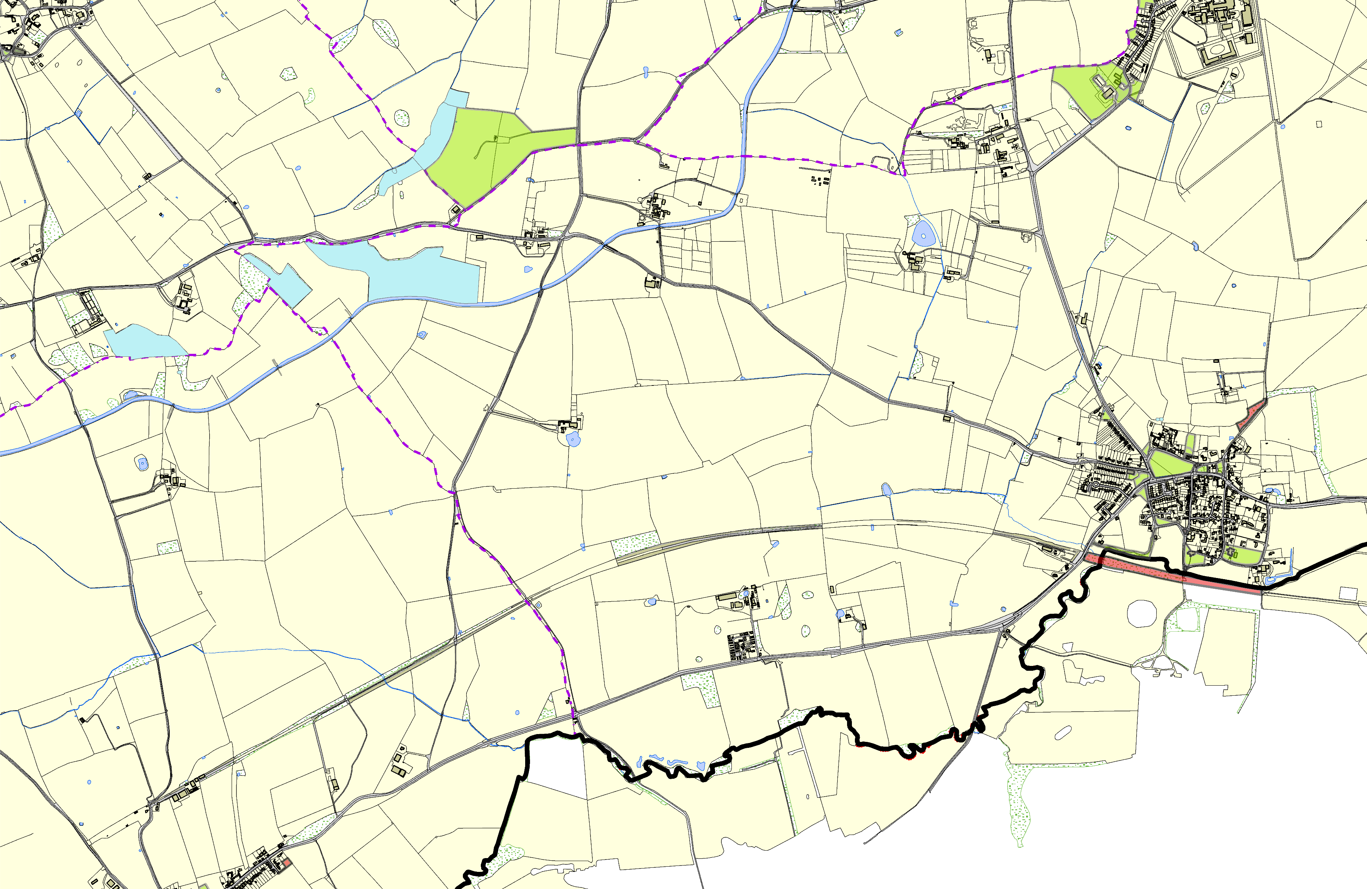
LGS/THEDD/1 - Play Area Theddingworth (shoudl be OSSR site)

Theddingworth Cemetery
©Crown Copyright. All rights reserved. Harborough District Council 100023843 2014

