Lutterworth OSSR sites, LGS sites and Wildlife Sites Note the LGS sites are proposals only at Sept 2015

Lutterworth Golf Course

Legend

Not recommended for LGS Designation Recommended for LGS designation Wildlife Sites
Open Space, Sport and Recreation Sites

OS MM Boundary
DESCTERM
!!!!!!!!!!!!!!!!!!!! County

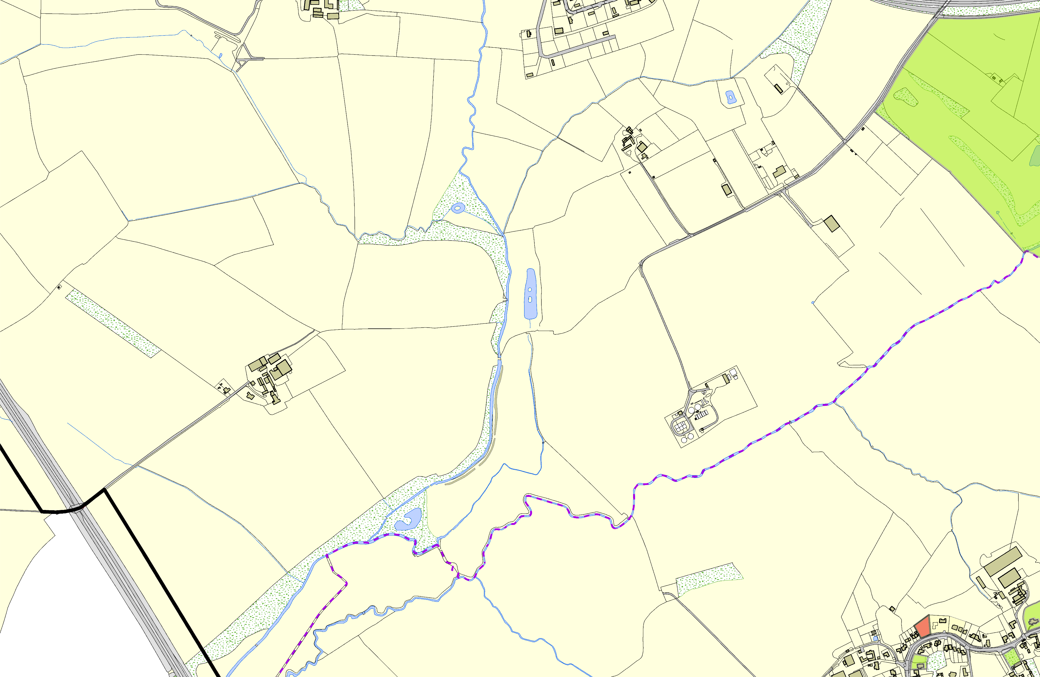

©Crown Copyright. All rights reserved. Harborough District Council 100023843 2014
District Electoral Parish

Churchyard - Cotesbach LGS/COT/1 - Area next to Elmdene

Village Hall - Cotesbach

