Lutterworth OSSR sites, LGS sites and Wildlife Sites Note the LGS sites are proposals only at Sept 2015

Grammar School Rugby Pitches

Almond Way, Lutterworth
Grammar School Tennis Courts - Lutterworth Grammar School
Guthlaxton Avenue, Lutterworth

Lutterworth Country Park

Coventry Road Recreation Road - Lutterworth
Coventry Recreation Bowling Green - Lutterworth Coventry Road Recreation MUGA - Lutterworth
Coventry Road Recreation Ground Play Area

LGS/LUTT/1 - Lutterworth, Bitteswell and magna Park Separation Area

Brookfield Way Play Area - Lutterworth

Lutterworth Cricket Ground

Lutterworth Churchyard
LGS/LUTT/8 - The Memorial Gardens Lutterworth

LGS/LUTT/2 - St Marys Churchyard (should be OSSR s

Church Gate, Lutterworth

LGS/LUCToTv/e7n-trCy oRvoeandtrOy pReonadS/pBarcoeokfield Way junction Lutterworth

LGS/LUTT/6 - Woodway Road Lutterworth 1

LGS/LUTT/6 - Woodway Road Lutterworth 2

Mill Grove Play Area, Lutterworth

Legend

Not recommended for LGS Designation Recommended for LGS designation Wildlife Sites
Open Space, Sport and Recreation Sites

Deverdon Road Allotments - Lutterworth

Coventry Road AGS, Lutterworth
High School Playing Field - Lutterworth

Orchard Road AGS - Lutterworth

AGS next to Primary School, Lutterworth

LGS/LUTT/5 - River Swift Floodplain 2

OS MM Boundary
DESCTERM
!!!!!!!!!!!!!!!!!!!! County

District Electoral Parish
Coventry Road AGS, LutterworthMoorbarns Lane Play Area - Lutterworth

Moorbarns Lane Open Space

Wycliffe Primary School - Lutterworth

Lutterworth Golf Course
LGS/LUTT/5 - River Swift Flood plain 1

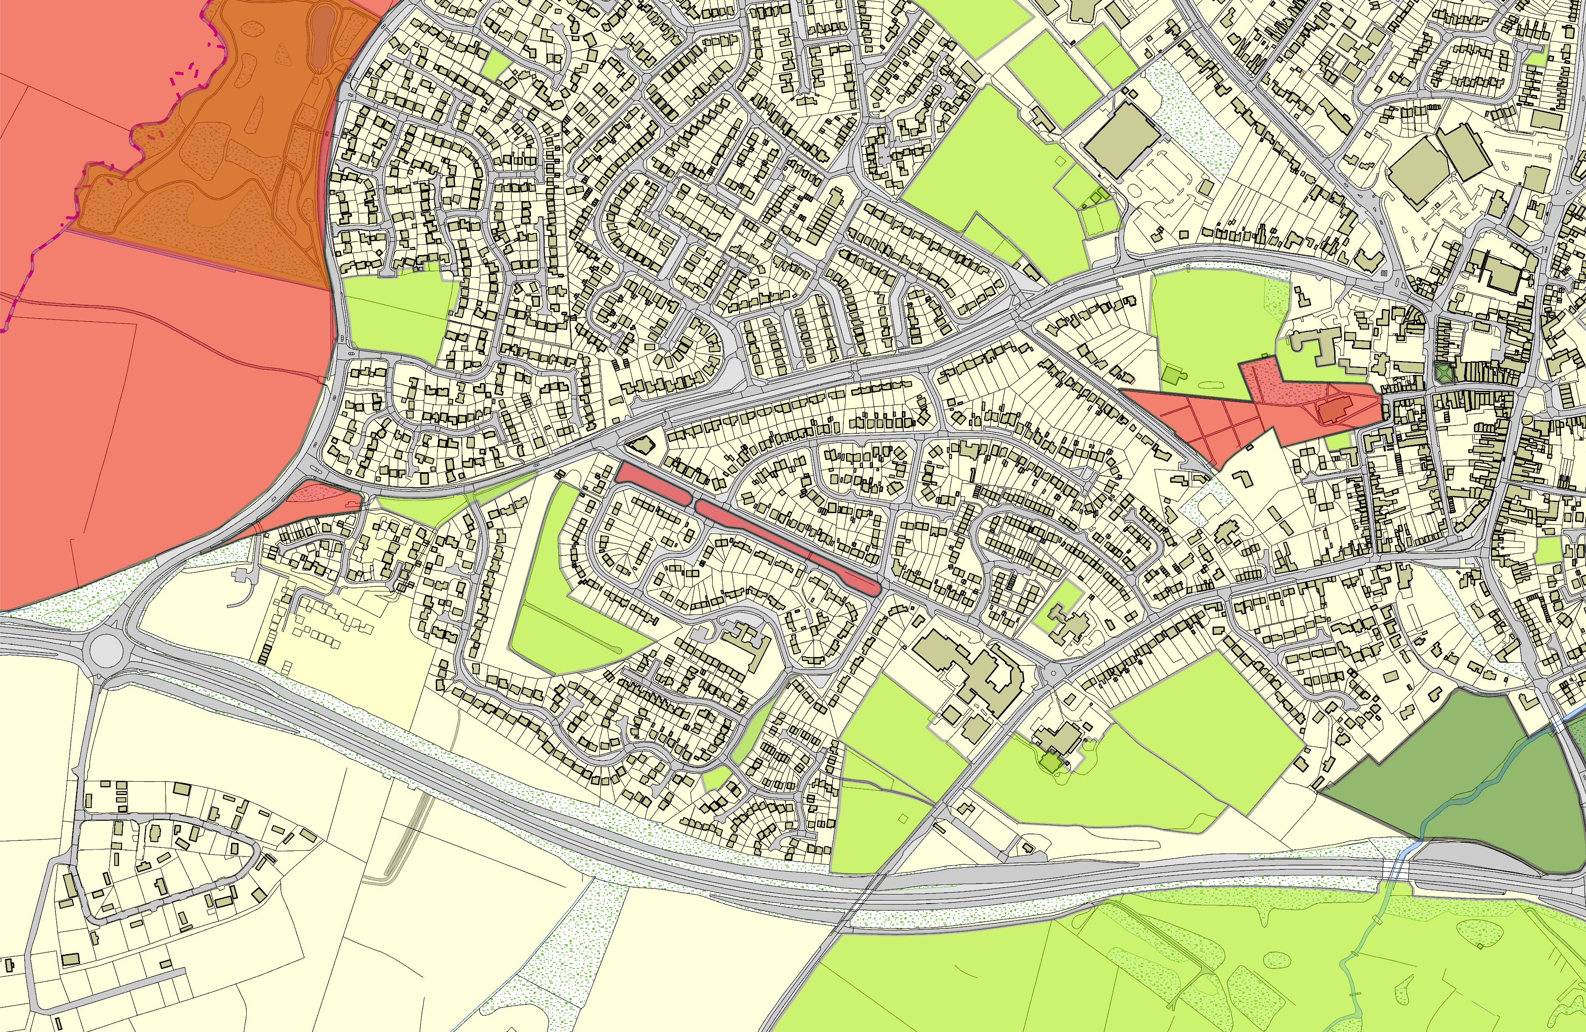
©Crown Copyright. All rights reserved. Harborough District Council 100023843 2014

