Market Harborough OSSR sites, LGS sites and Wildlife Sites Note the LGS sites are proposals only at Sept 2015

St Mary in Arden Church, Great Bowden Road, MH
Stockwell Close, Market Harborough Stockwell Close, Market Harborough

Symingtons Recreation Ground

Goodwood Close Play Area, MH Goodwood Close Open Space, MH
Simborough Way Open Space, MH

Simborough Way Open Space Corridor, MH

Gores Lane

Rolleston Close, Market Harborough

Rectory Lane Bowling Green, MH

Stablegate Way Open Space

Althorp Close Open Space, MH

Ashley Way Open Space, MH

Little Bowden Churchyard, St Nicholas Church, MH

Rectory Lane Open Space, MH

Little Bowden Open Space, MH
Bellfields Recreation Skate Area, MH Bellfield Recreation Ground AGS, MH
Glebe Road Open Space, MH Bellfields Road Recreation Play Area, MH

Little Bowden Recreation Play Area, MH Little Bowden Play Area, MH
Launde Park, MH
Little Bowden Recreation Ground

Scotland Road Field, MH

Little Bowden Allotments, MH

Legend

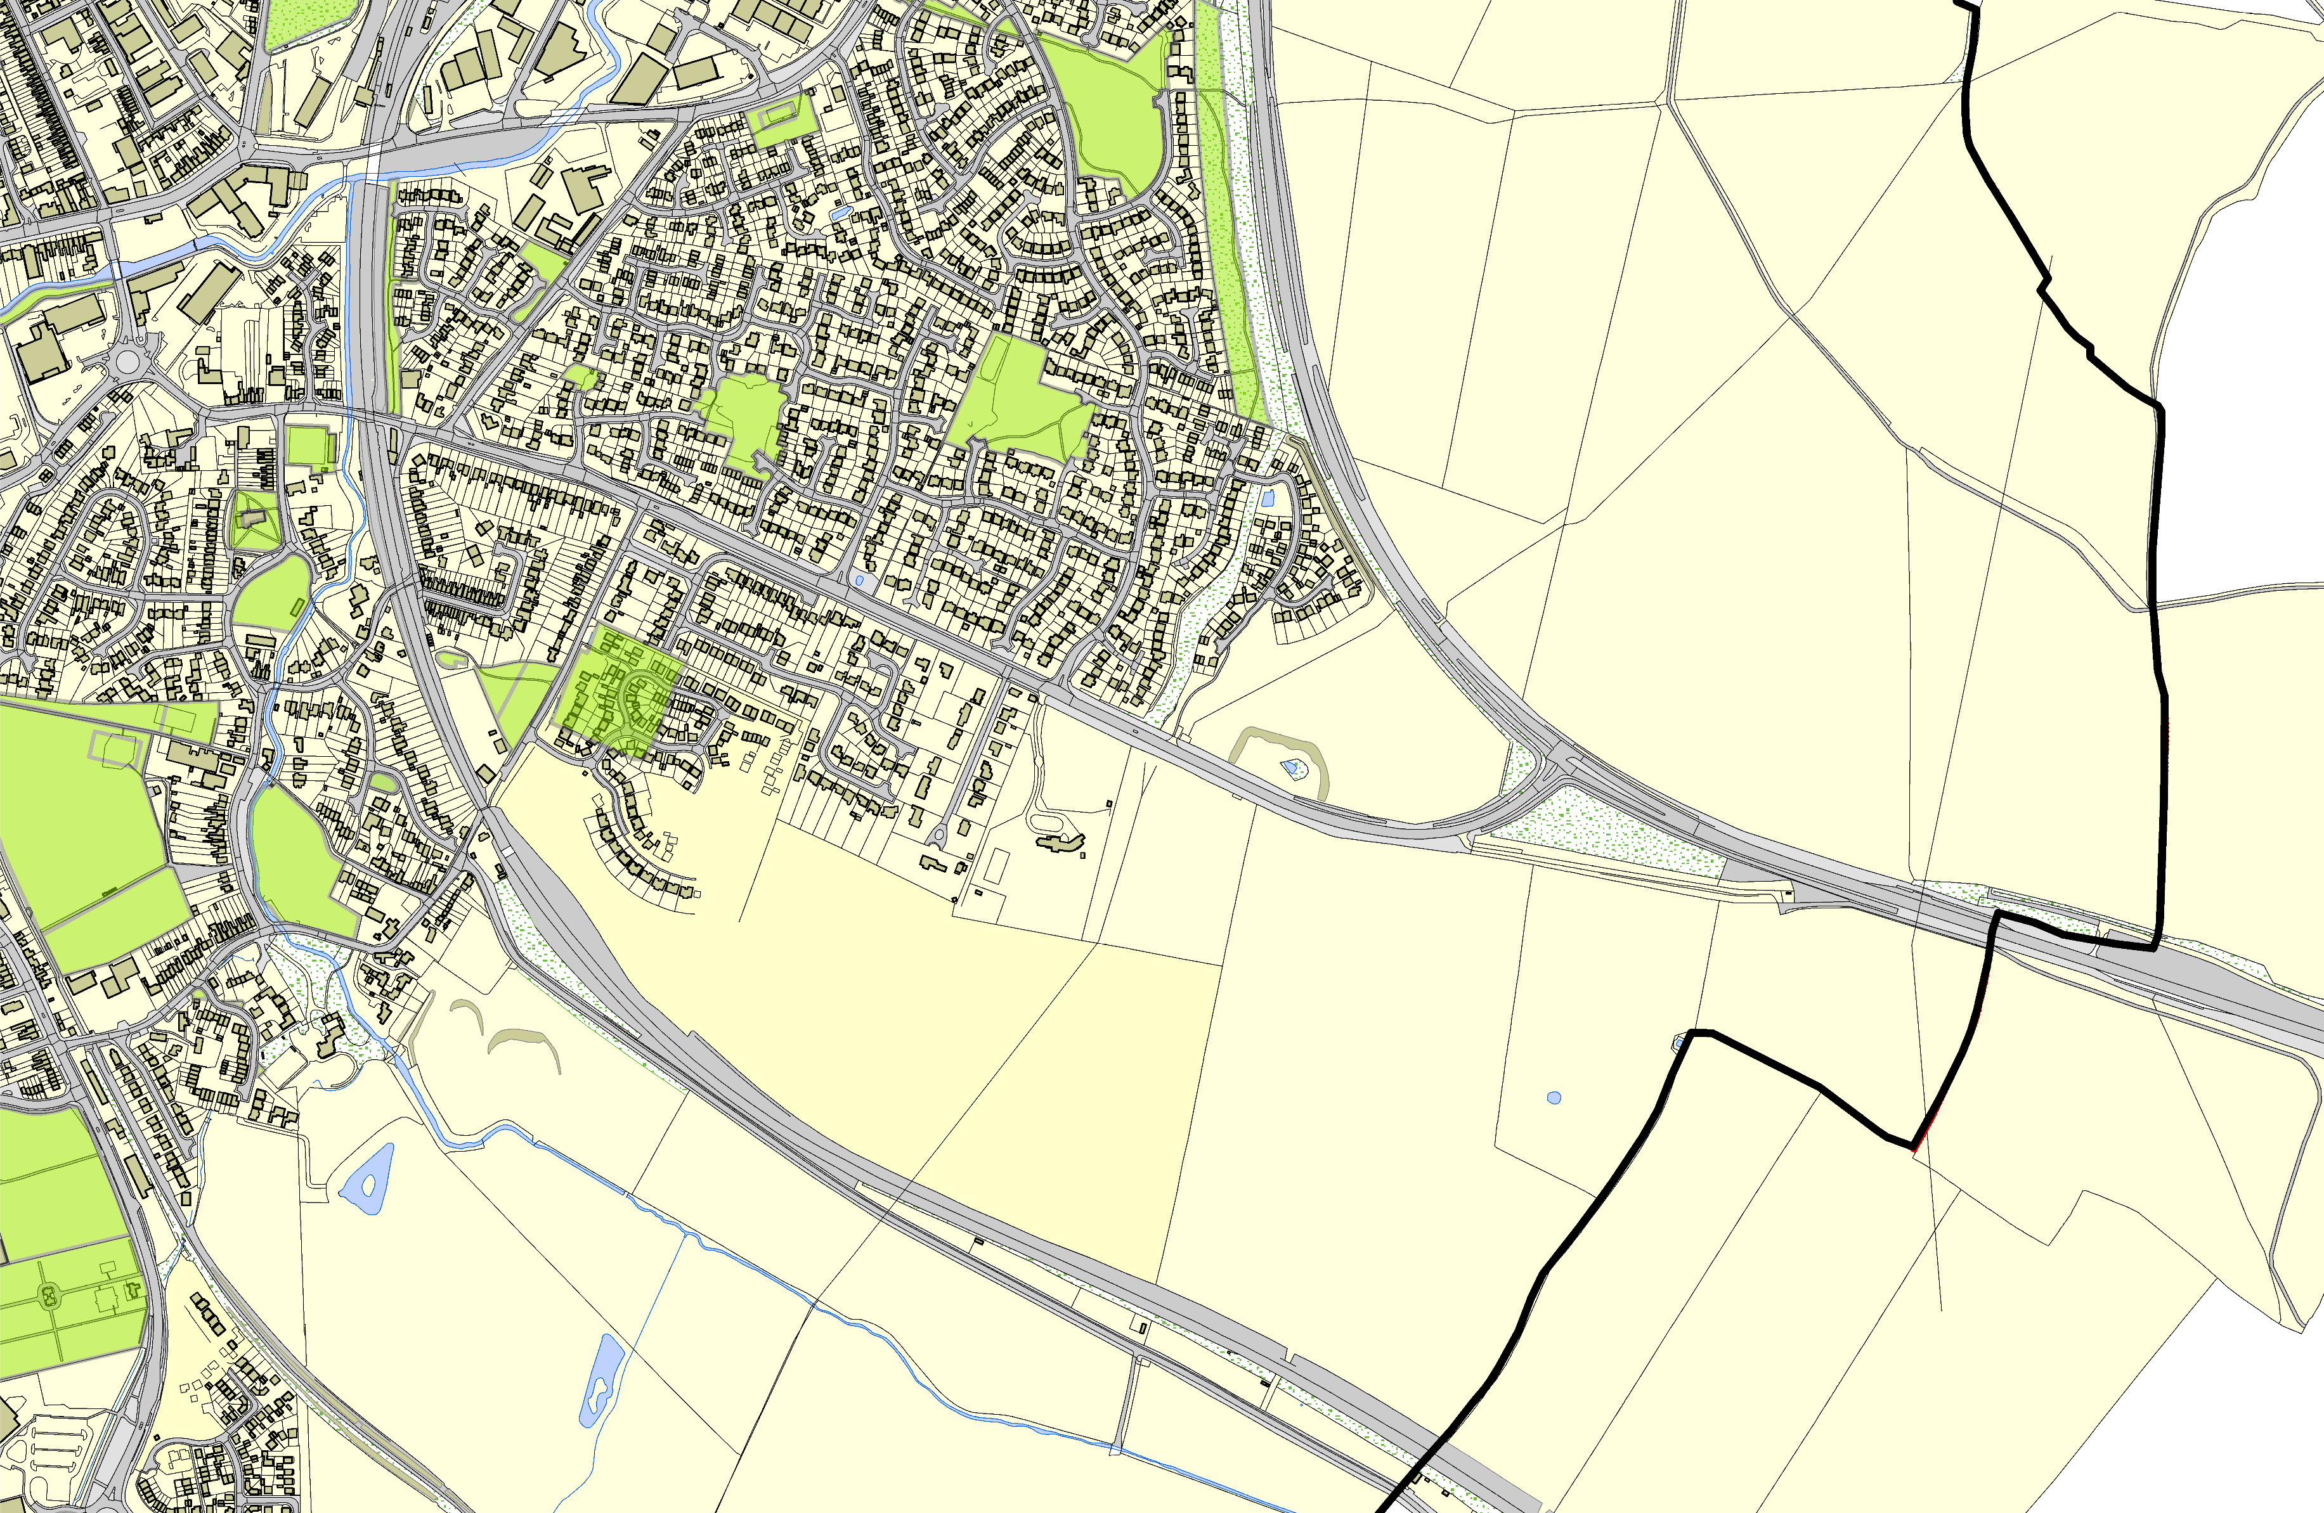
Dunmore Road, Market Harborough Dunmore Road, Market Harborough

Dunmore Road, Market Harborough

Northampton Road Allotments, MH

Northampton Road Cemetery, MH

©Crown Copyright. All rights reserved. Harborough District Council 100023843 2014

Not recommended for LGS Designation Recommended for LGS designation Wildlife Sites
Open Space, Sport and Recreation Sites
OS MM Boundary
DESCTERM
!!!!!!!!!!!!!!!!!!!! County

District Electoral Parish

