# Market Harborough OSSR sites, LGS sites and Wildlife Sites Note the LGS sites are proposals only at Sept 2015

**Legend**

Logan Street Allotments

Market Harborough Primary, Parkfield Road

Symingtons Recreation Ground

## Not recommended for LGS Designation

Recommended for LGS designation Wildlife Sites

Logan Street Recreation Ground, MH Logan Street Recreation Play Area, MH

Church Square, MH

Conservative Club Bowling Club, MH

Riverside Walk [east], Market Harborough

Brookfield Road, MH

St Joseph's Churchyard, MH

The Square

Riverside Walk [east], Market Harborough

Rolleston Close, Market Harborough

## Open Space, Sport and Recreation Sites

**OS MM Boundary**

**DESCTERM**

!!!!!!!!!!!!!!!!!!!! County

Welland Park, MH

Welland Park Bowling Green, MH

Riverside Walk [east], Market HarboroughRiverside Walk [east], Market Harborough Memorial Gardens, MH

Welland Park, MH

Rectory Lane Bowling Green, MH

## Dis rict

Electoral

Rhodes Close, MH

Welland Park Play Area, MH

Welland Park College, Welland Park Road Welland Park STP, MH

Little Bowden Churchyard, St Nicholas Church, MH

Rectory Lane Open Space, MH

Farndale View, MH

## Parish

Willow Crescent, MH Farndale View Balancing Lagoon, MH

Willow Crescent Open Space, MH

Farndon Road/Rugby Close, MH

Welland Park Tennis Courts, MH

Welland Park Road Allotments, MH

Little Bowden Open Space, MH

Little Bowden Recreation Play Area, MH Little Bowden Play Area, MH

Launde Park, MH

Summers Way Open Space, MH Little Bowden Recreation Ground

Scotland Road Field, MH

Farndon Road (North), MH

Naseby Close, MH

Little Bowden Allotments, MH

Burford Green Play Area Burford Green Recreation Ground

Burford Green Outdoor Basketball Initiative, MH

Dunmore Road, Market Harborough Dunmore Road, Market Harborough

Dunmore Road, Market Harborough

Fleetwood Gardens Fleetwood Gardens

Grenville Gardens, MH

Lenthall Square

Northampton Road Allotments, MH

Farndon Road (South), MH

Balfour Gardens, MH

Rowan Avenue, MHGreen Lane, Rear of Tungston Factory, MH

Northampton Road Cemetery, MH

Butler Gardens Amenity Green Space, MH

Watson Avenue AGS, MH

Lindsey Gardens, MH

Northampton Road Sports Ground, MH

Northampton Road Sportsground Play Area

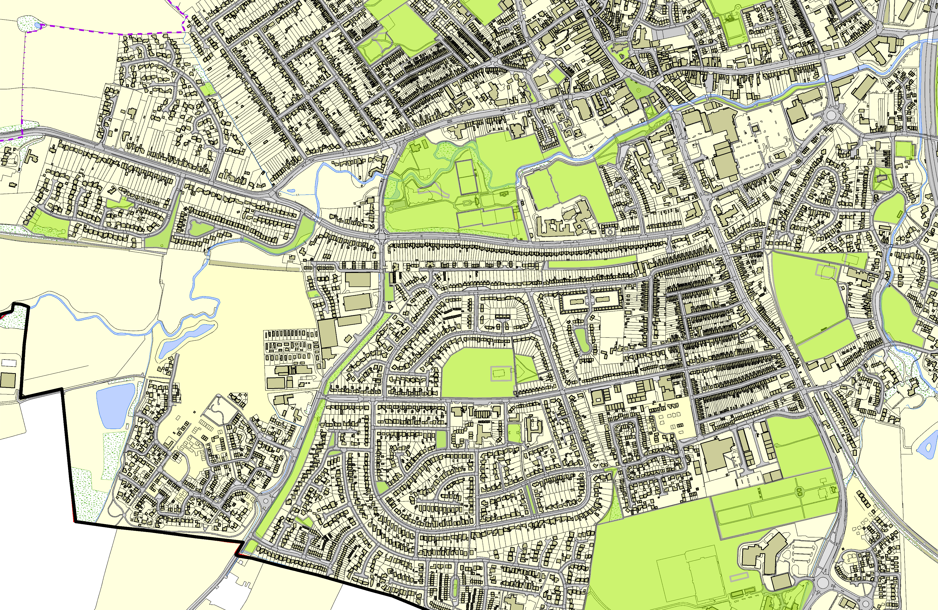

**©Crown Copyright. All rights reserved. Harborough District Council 100023843 2014**