**Legend**

# Market Harborough OSSR sites, LGS sites and Wildlife Sites Note the LGS sites are proposals only at Sept 2015

Upper Green

## Not recommended for LGS Designation Recommended for LGS designation Wildlife Sites

Open Space, Sport and Recreation Sites

**OS MM Boundary**

**DESCTERM**

!!!!!!!!!!!!!!!!!!!! County

## District

Kingston Way, Market Harborough

Davies Close, Market Harborough

Bates Close, MH

## Electoral Parish

Leicester Road Scrubland, MH

Leicester Road, Market Harborough

Leicester Road 'The Woodland', MH Woodlands Open Space, MH

Monroe Close, MH

Coales Gardens, MHMonroe Close, Market Harborough

The Robert Smythe School, Burnmill Road, MH

Scott Close, Market HarboroughRidgeway Primary, The Ridgeway, MH

Victoria Avenue, Market Harborough

Sherrard Road Play Area Sherrard Road Recreation Ground, MH

Ridgeway, MH

Arboretum

Arden Way, MH

Park Drive Open Space, MH

Park Drive, Market Harborough

Meadow Street, MH

St Mary's Allotments, Douglas Drive

The Headlands Recreation Ground, MH The Headland Recreation Ground Play Area

Woodland AGS, MH

Crescent Close, MH

Folly Pond

Broadway Terrace, MH

Middlebrook Green, Market Harborough

Fairfield Road Cricket Ground, MH

Roman Way Recreation Ground Roman Way Play Area, MH

Logan Street Allotments

Doddridge Road B, MH Doddridge Road A, MH

Albany Road, Market Harborough

St Mary in Arden Church, Great Bowden Road, MH

Symingtons Recreation Ground

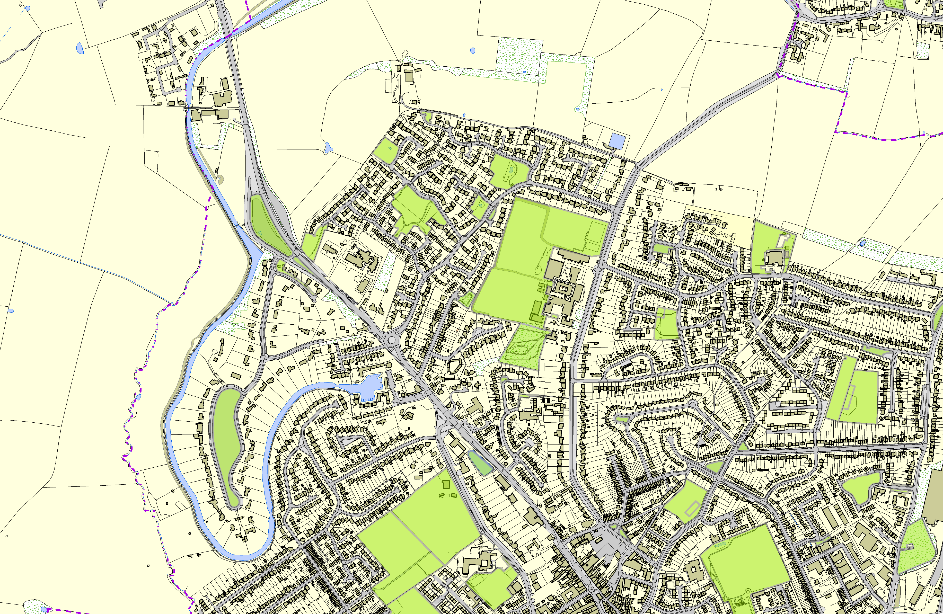

Market Harborough Primary, Parkfield Road

Logan Street Recreation Ground, MH

**©Crown Copyright. All rights reserved. Harborough District Council 100023843 2014**