Medbourne OSSR sites, LGS sites and Wildlife Sites Note the LGS sites are proposals only at Sept 2015

Nevil Holt Sports Field

The Hollow - Medbourne Tennis Couts - Medbourne

Sportsground - MedbourneLGS/MED/7a,b and c - Land adjacent to sports field Medbourne
Basketball - Medbourne
Tennis Court off Rectory Lane - MedbourneLGS/MED/2 - Paddock next to Rectory Lane Medbourne Play Area - Medbourne

Neville Holt Quarry, Neville Holt

LGS/MED/8 - Springbank Medbourne
LGS/MED/3 - Paddock land south of footpath at top of Rectory Lane Medbourne

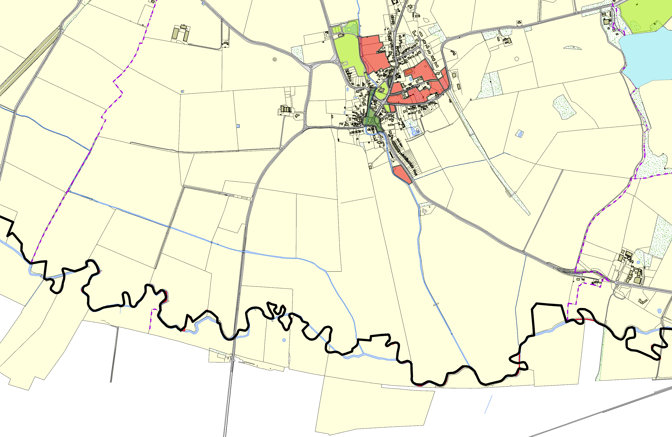
LGS/MED/1 - Old Rectory Gardens Medbourne
Churchyard - Medbourne LGS/MED/4 a and b - Old Hall and manor Gardens Medbourne

Bowls Green - MedbourneLGS/MED/5 - Old Green Medbourne LGS/MED/6a and 6b - Tow path and Gardens Medbourne

LGS/MED/9 - Field at Drayton Road Medbourne

Legend

Not recommended for LGS Designation Recommended for LGS designation Wildlife Sites
Open Space, Sport and Recreation Sites
OS MM Boundary
DESCTERM
!!!!!!!!!!!!!!!!!!!! County

District Electoral Parish
©Crown Copyright. All rights reserved. Harborough District Council 100023843 2014

