Medbourne OSSR sites, LGS sites and Wildlife Sites Note the LGS sites are proposals only at Sept 2015

Legend

The Hollow - Medbourne Tennis Couts - Medbourne

Sportsground - Medbourne

Basketball - Medbourne

LGS/MED/7a,b and c - Land adjacent to sports field Medbourne

Not recommended for LGS Designation Recommended for LGS designation Wildlife Sites
Open Space, Sport and Recreation Sites
OS MM Boundary
DESCTERM
!!!!!!!!!!!!!!!!!!!! County

District Electoral

Play Area - Medbourne

Tennis Court off Rectory Lane - MedbourneLGS/MED/2 - Paddock next to Rectory Lane Medbourne

Parish

LGS/MED/3 - Paddock land south of footpath at top of Rectory Lane Medbourne
LGS/MED/8 - Springbank Medbourne

LGS/MED/1 - Old Rectory Gardens Medbourne

Churchyard - Medbourne

LGS/MED/4 a and b - Old Hall and manor Gardens Medbourne

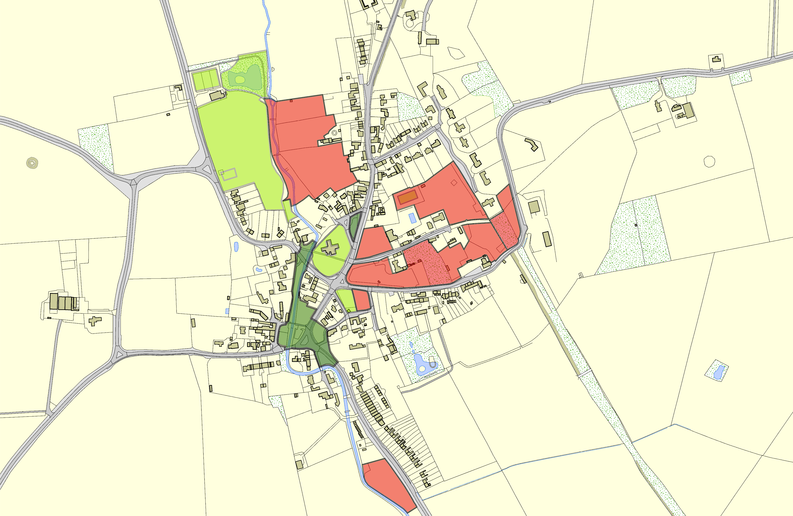

Bowls Green - MedbourneLGS/MED/5 - Old Green Medbourne

LGS/MED/6a and 6b - Tow path and Gardens Medbourne

LGS/MED/9 - Field at Drayton Road Medbourne

©Crown Copyright. All rights reserved. Harborough District Council 100023843 2014

