Misterton with Walcote OSSR sites, LGS sites and Wildlife Sites Note the LGS sites are proposals only at Sept 2015
LGS/LUTT/3 - Rye Hills Lutterworth Marshy Grassland, Misterton; Area 1

St Leonards Churchyard - Misterton with Walcote

Bufton Allotments - Misterton with Walcote Bufton Playground - Misterton with Walcote
Franks Road Allotments - Misterton with Walcote Old School Playing Field - Misterton with Walcote
Walcote Memorial Garden - Misterton with Walcote

Legend

Shawell Woods

Shawell Woods

Not recommended for LGS Designation Recommended for LGS designation Wildlife Sites
Open Space, Sport and Recreation Sites
OS MM Boundary
DESCTERM
!!!!!!!!!!!!!!!!!!!! County

District
Electoral Parish

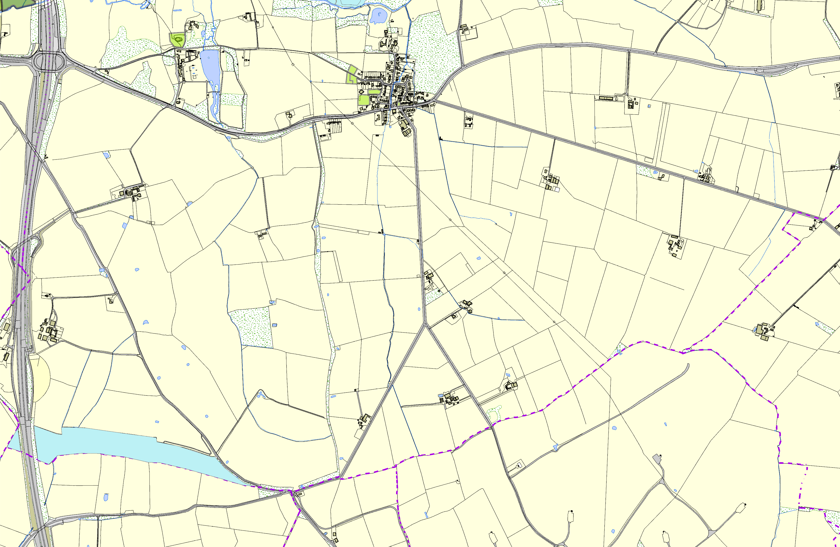
©Crown Copyright. All rights reserved. Harborough District Council 100023843 2014

