Misterton with Walcote OSSR sites, LGS sites and Wildlife Sites Note the LGS sites are proposals only at Sept 2015

Winterfield, Misterton - Spring

Winterfield, Misterton - Reedbed Winterfield, Misterton - Spinney

Marshy Grassland, Misterton; Area 1

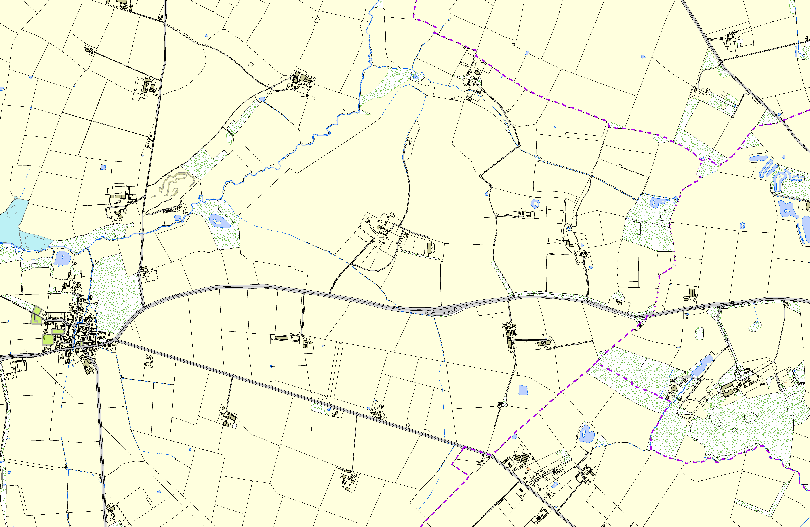
Bufton Allotments - Misterton with Walcote Bufton Playground - Misterton with Walcote
Franks Road Allotments - Misterton with Walcote Old School Playing Field - Misterton with Walcote
Walcote Memorial Garden - Misterton with Walcote

©Crown Copyright. All rights reserved. Harborough District Council 100023843 2014

Legend

Not recommended for LGS Designation Recommended for LGS designation Wildlife Sites
Open Space, Sport and Recreation Sites
OS MM Boundary
DESCTERM
!!!!!!!!!!!!!!!!!!!! County

District Electoral Parish

