Mowsley OSSR sites, LGS sites and Wildlife Sites Note the LGS sites are proposals only at Sept 2015

Laughton and Mowsley Cricket Club Ground

Laughton Hills Wood

Kicklewell Spinney

Legend

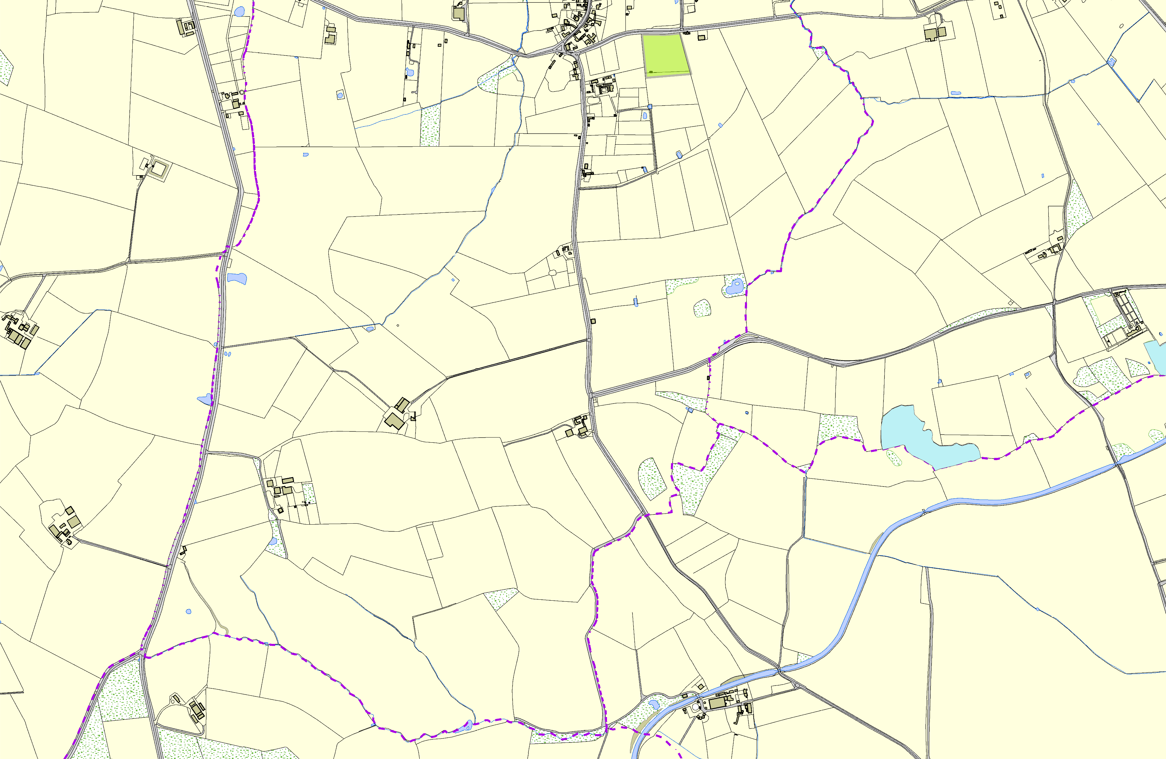

©Crown Copyright. All rights reserved. Harborough District Council 100023843 2014
Not recommended for LGS Designation Recommended for LGS designation Wildlife Sites
Open Space, Sport and Recreation Sites

OS MM Boundary
DESCTERM
!!!!!!!!!!!!!!!!!!!! County
District Electoral Parish

