Mowsley OSSR sites, LGS sites and Wildlife Sites Note the LGS sites are proposals only at Sept 2015

Legend

Not recommended for LGS Designation Recommended for LGS designation Wildlife Sites
Open Space, Sport and Recreation Sites
OS MM Boundary
DESCTERM
!!!!!!!!!!!!!!!!!!!! County

District Electoral Parish

Folly Field Play Area - Mowsley

St Nicholas Primary School Playing Fields - Mowsley

St Luke Church - Laughton

Saint Nicholas Churchyard - (closed) - Mowsley Mowsley Parish Burial Ground

LGS/LAUGH/1 - Village Hall Green/ Paddock Laughton Village Green

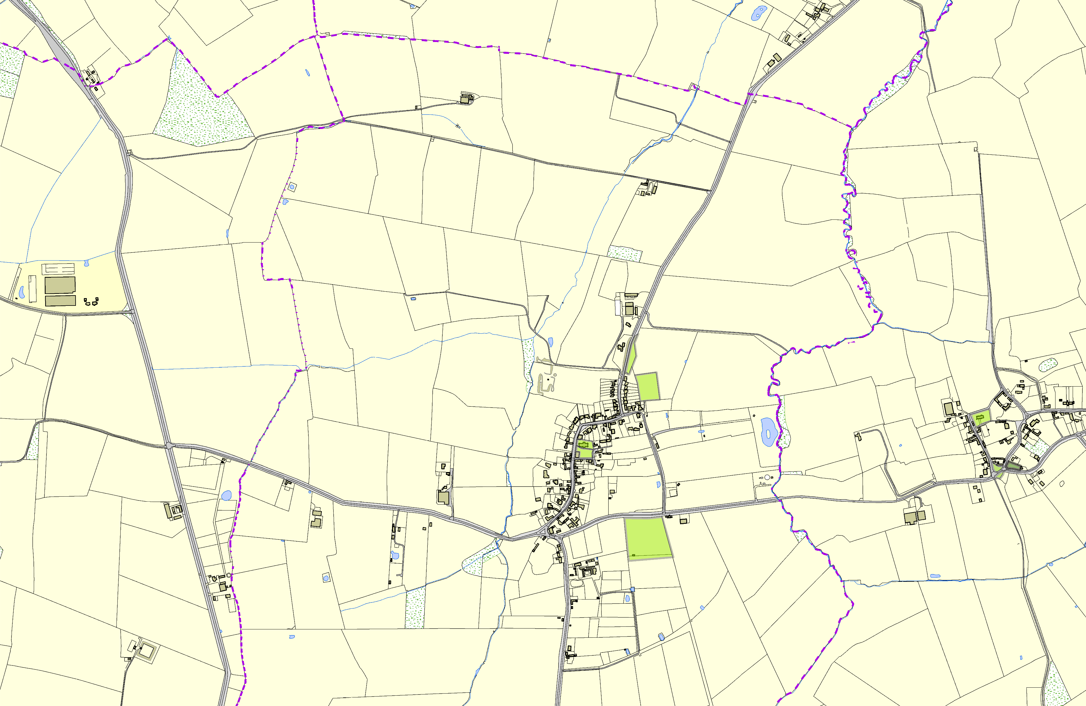

Laughton and Mowsley Cricket Club Ground

©Crown Copyright. All rights reserved. Harborough District Council 100023843 2014

