North Kilworth OSSR sites, LGS sites and Wildlife Sites Note the LGS sites are proposals only at Sept 2015

Brickfield Spinney, Kilworth Road - Husbands Bosworth

Kilworth Marina - Husbands Bosworth

LGS/NK/3 - The Village green North Kilworth Sports Field in North Kilworth
North Kilworth Bogs Bowls Club - North Kilworth
LGS/NK/M2il-leSntiuAmndGrerwee'snC- NofoErthPKriimlwaorrythSchool Field (should be OSSR site) All Weather Courts in North Kilworth
Childrens Playground in North Kilworth
St Andrews Church - North Kilworth

North Kilworth Grand Union Canal

LGS/NK/1 - Golf Club Land North Kilworth (should be OSSR site)

Kilworth Springs Golf Club

Legend

Welford Arm, Grand Union Canal

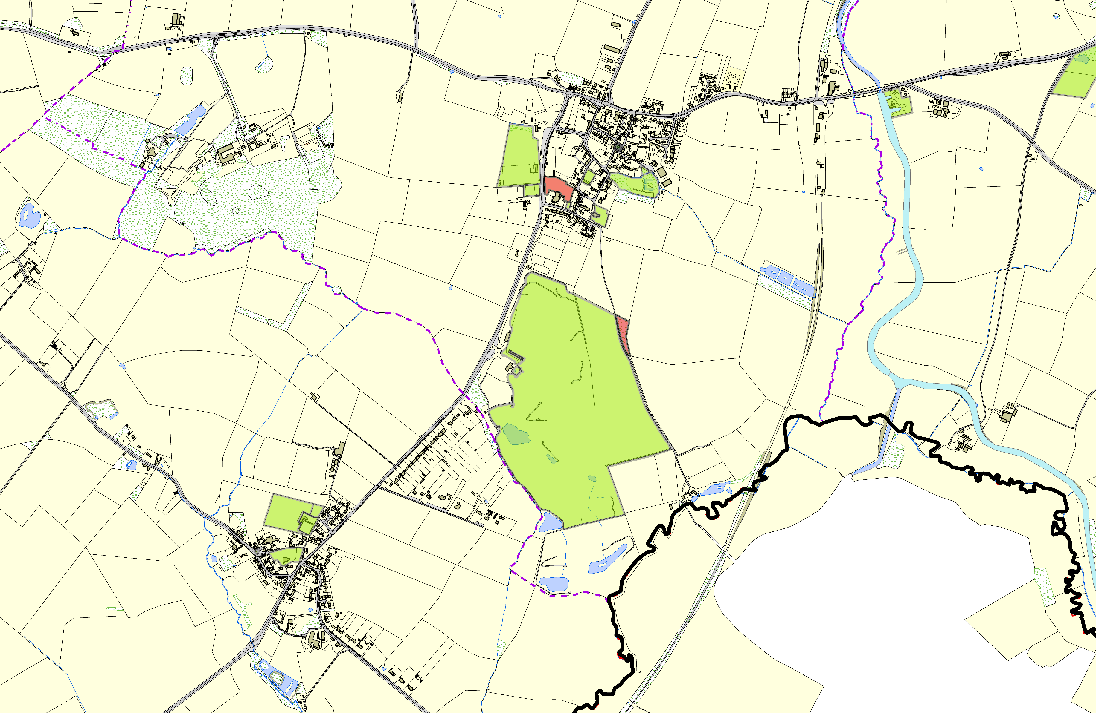

Childrens Play Equipment Area - South Kilworth Playing Field, Leys Crescent - South Kilworth
Bowling Green - South Kilworth

Village Green, Church Lane - South Kilworth
Churchyard - South Kilworth

©Crown Copyright. All rights reserved. Harborough District Council 100023843 2014

Not recommended for LGS Designation Recommended for LGS designation Wildlife Sites
Open Space, Sport and Recreation Sites
OS MM Boundary
DESCTERM
!!!!!!!!!!!!!!!!!!!! County

District Electoral Parish

