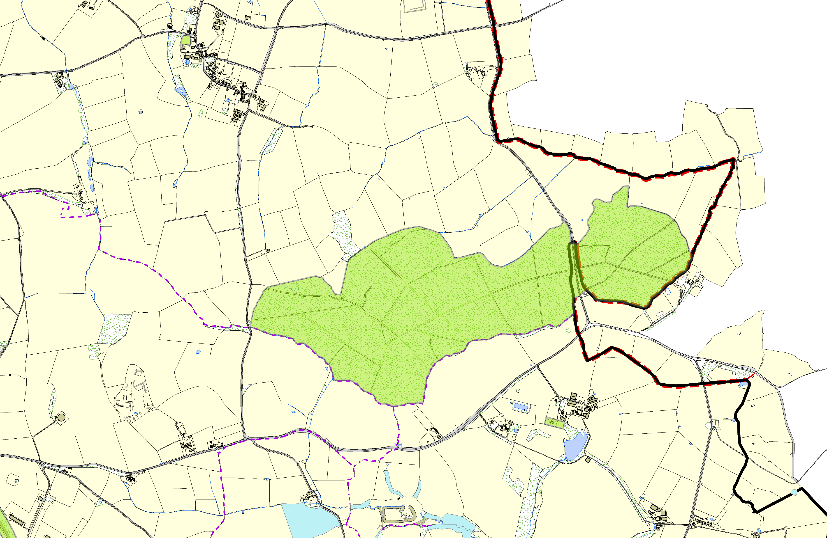
Owston OSSR sites, LGS sites and Wildlife Sites Note the LGS sites are proposals only at Sept 2015

Tilton Railway Cutting |  | St Andrews Church - Owston and Newbold | Owston Woods  Sauvey Woodlands area 8  Sauvey Woodlands area 7 Sauvey Woodlands area 1  Sauvey Woodlands area 4  Brook Farm Meadow Sauvey Woodlands area 5 Sauvey Woodlands area 6  Sauvey Woodlands area 3 |  | Withcote Chapel | Legend  Not recommended for LGS Designation Recommended for LGS designation Wildlife Sites  Open Space, Sport and Recreation Sites  OS MM Boundary  DESCTERM  !!!!!!!!!!!!!!!!!!!! County  istrict Mature Ash Tree 1, Withcote Lodge  Electoral Parish
 | ©Crown Copyright. All rights reserved. Harborough District Council 100023843 2014

