Peatling Magna OSSR sites, LGS sites and Wildlife Sites Note the LGS sites are proposals only at Sept 2015

Legend

Willoughby Waterleys Pond 2

LGS/PM/1 - Home Farm Cottage field LPGoSnd/P, MPe/2at-liHngomMeagFnaarm Orchard

All Saints Parish Church - Peatling Magna

Not recommended for LGS Designation Recommended for LGS designation Wildlife Sites
Open Space, Sport and Recreation Sites
OS MM Boundary
DESCTERM
!!!!!!!!!!!!!!!!!!!! County

District

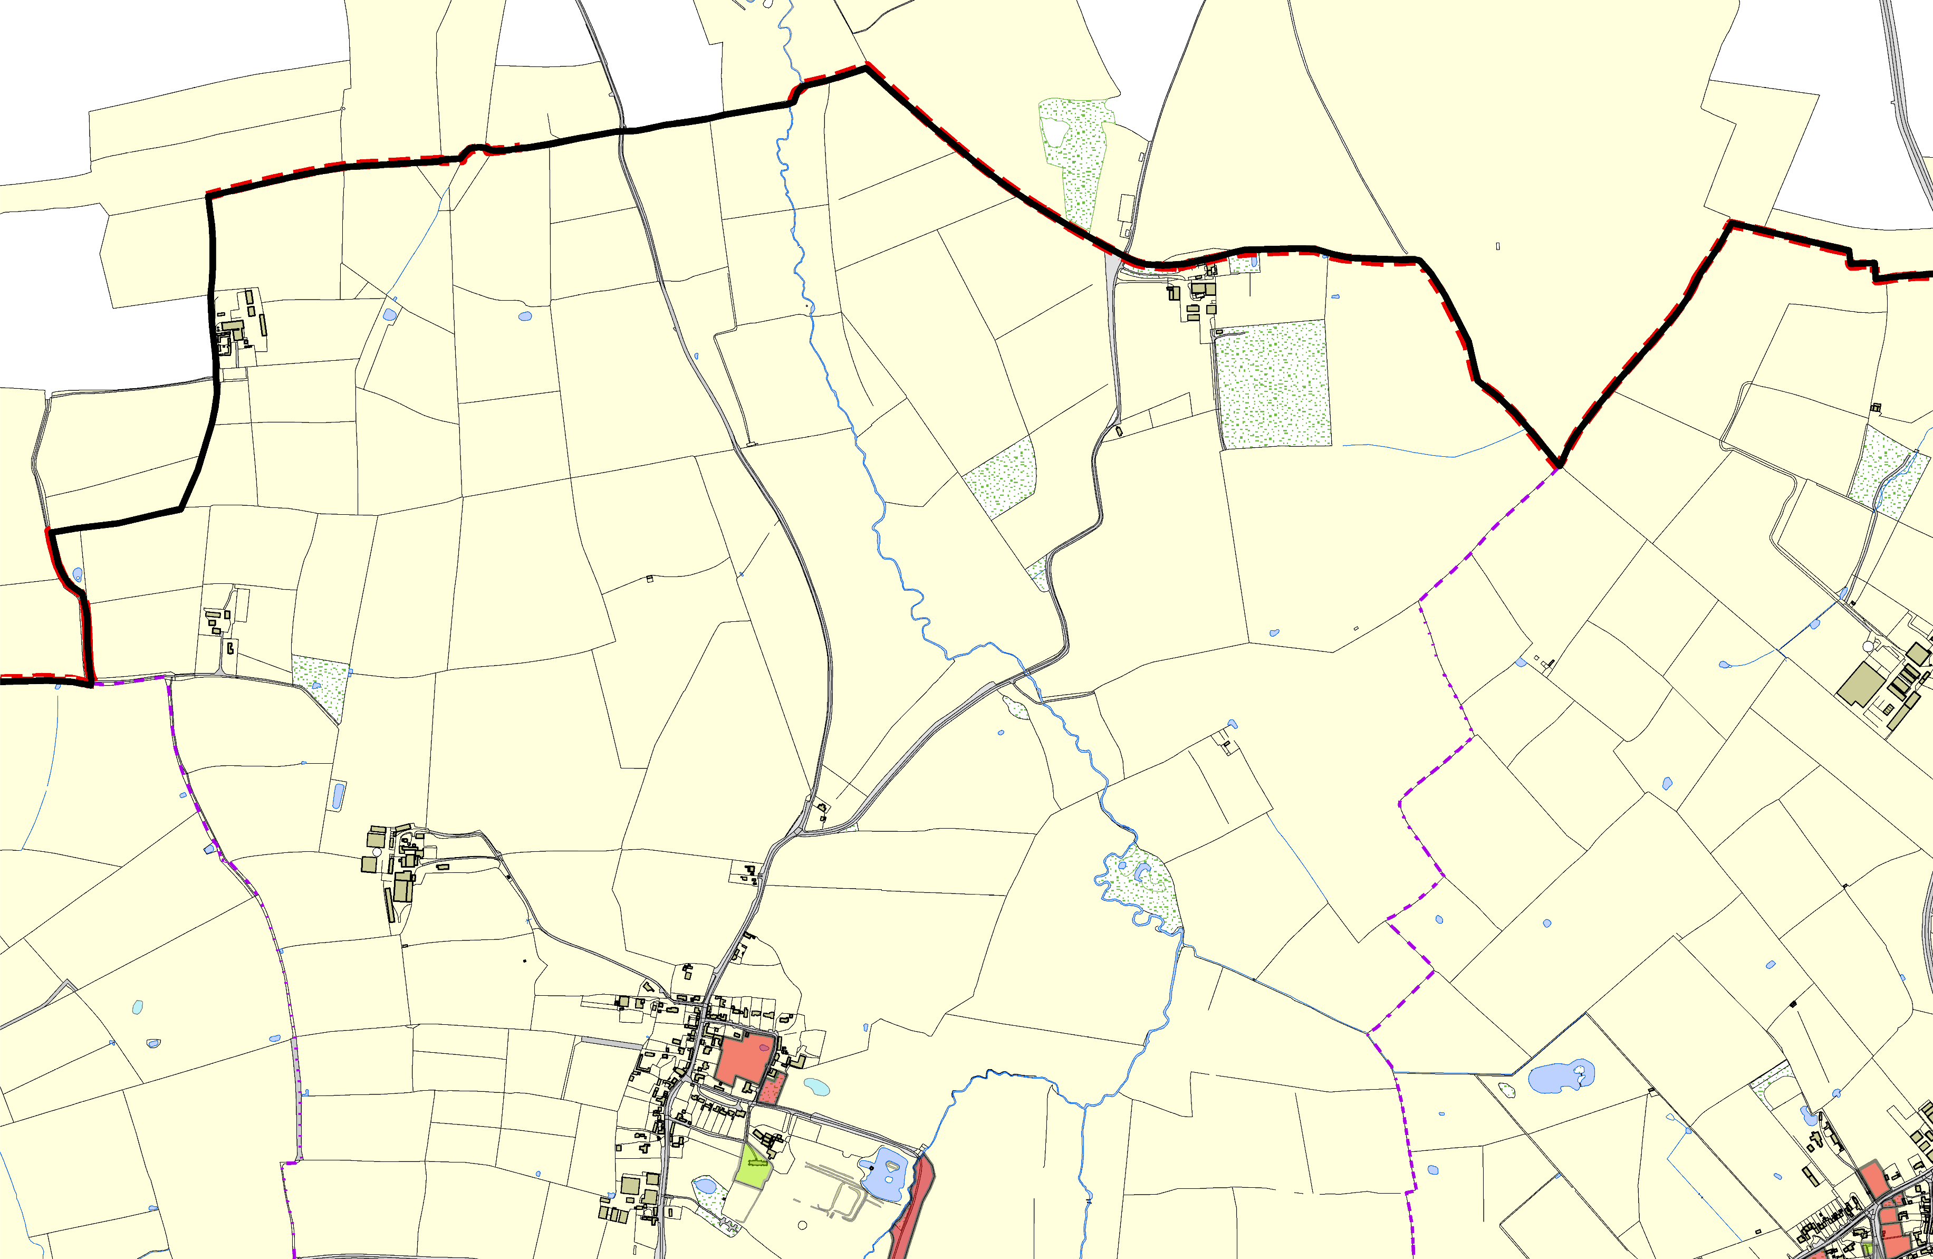

©Crown Copyright. All rights reserved. Harborough District Council 100023843 2014

LGS/PM/3 - Windmill Hill Peatling Magna

Electoral Parish
LGS/ARN
LGLGS/SA/RA LGS/AR
Arnesby Village HallLGS/A LGS/ARN/9 - West

