Peatling Magna OSSR sites, LGS sites and Wildlife Sites Note the LGS sites are proposals only at Sept 2015

Legend

LGS/PM/1 - Home Farm Cottage field

Pond, Peatling Magna LGS/PM/2 - Home Farm Orchard

Not recommended for LGS Designation Recommended for LGS designation Wildlife Sites
Open Space, Sport and Recreation Sites
OS MM Boundary
DESCTERM
!!!!!!!!!!!!!!!!!!!! County

District Electoral Parish

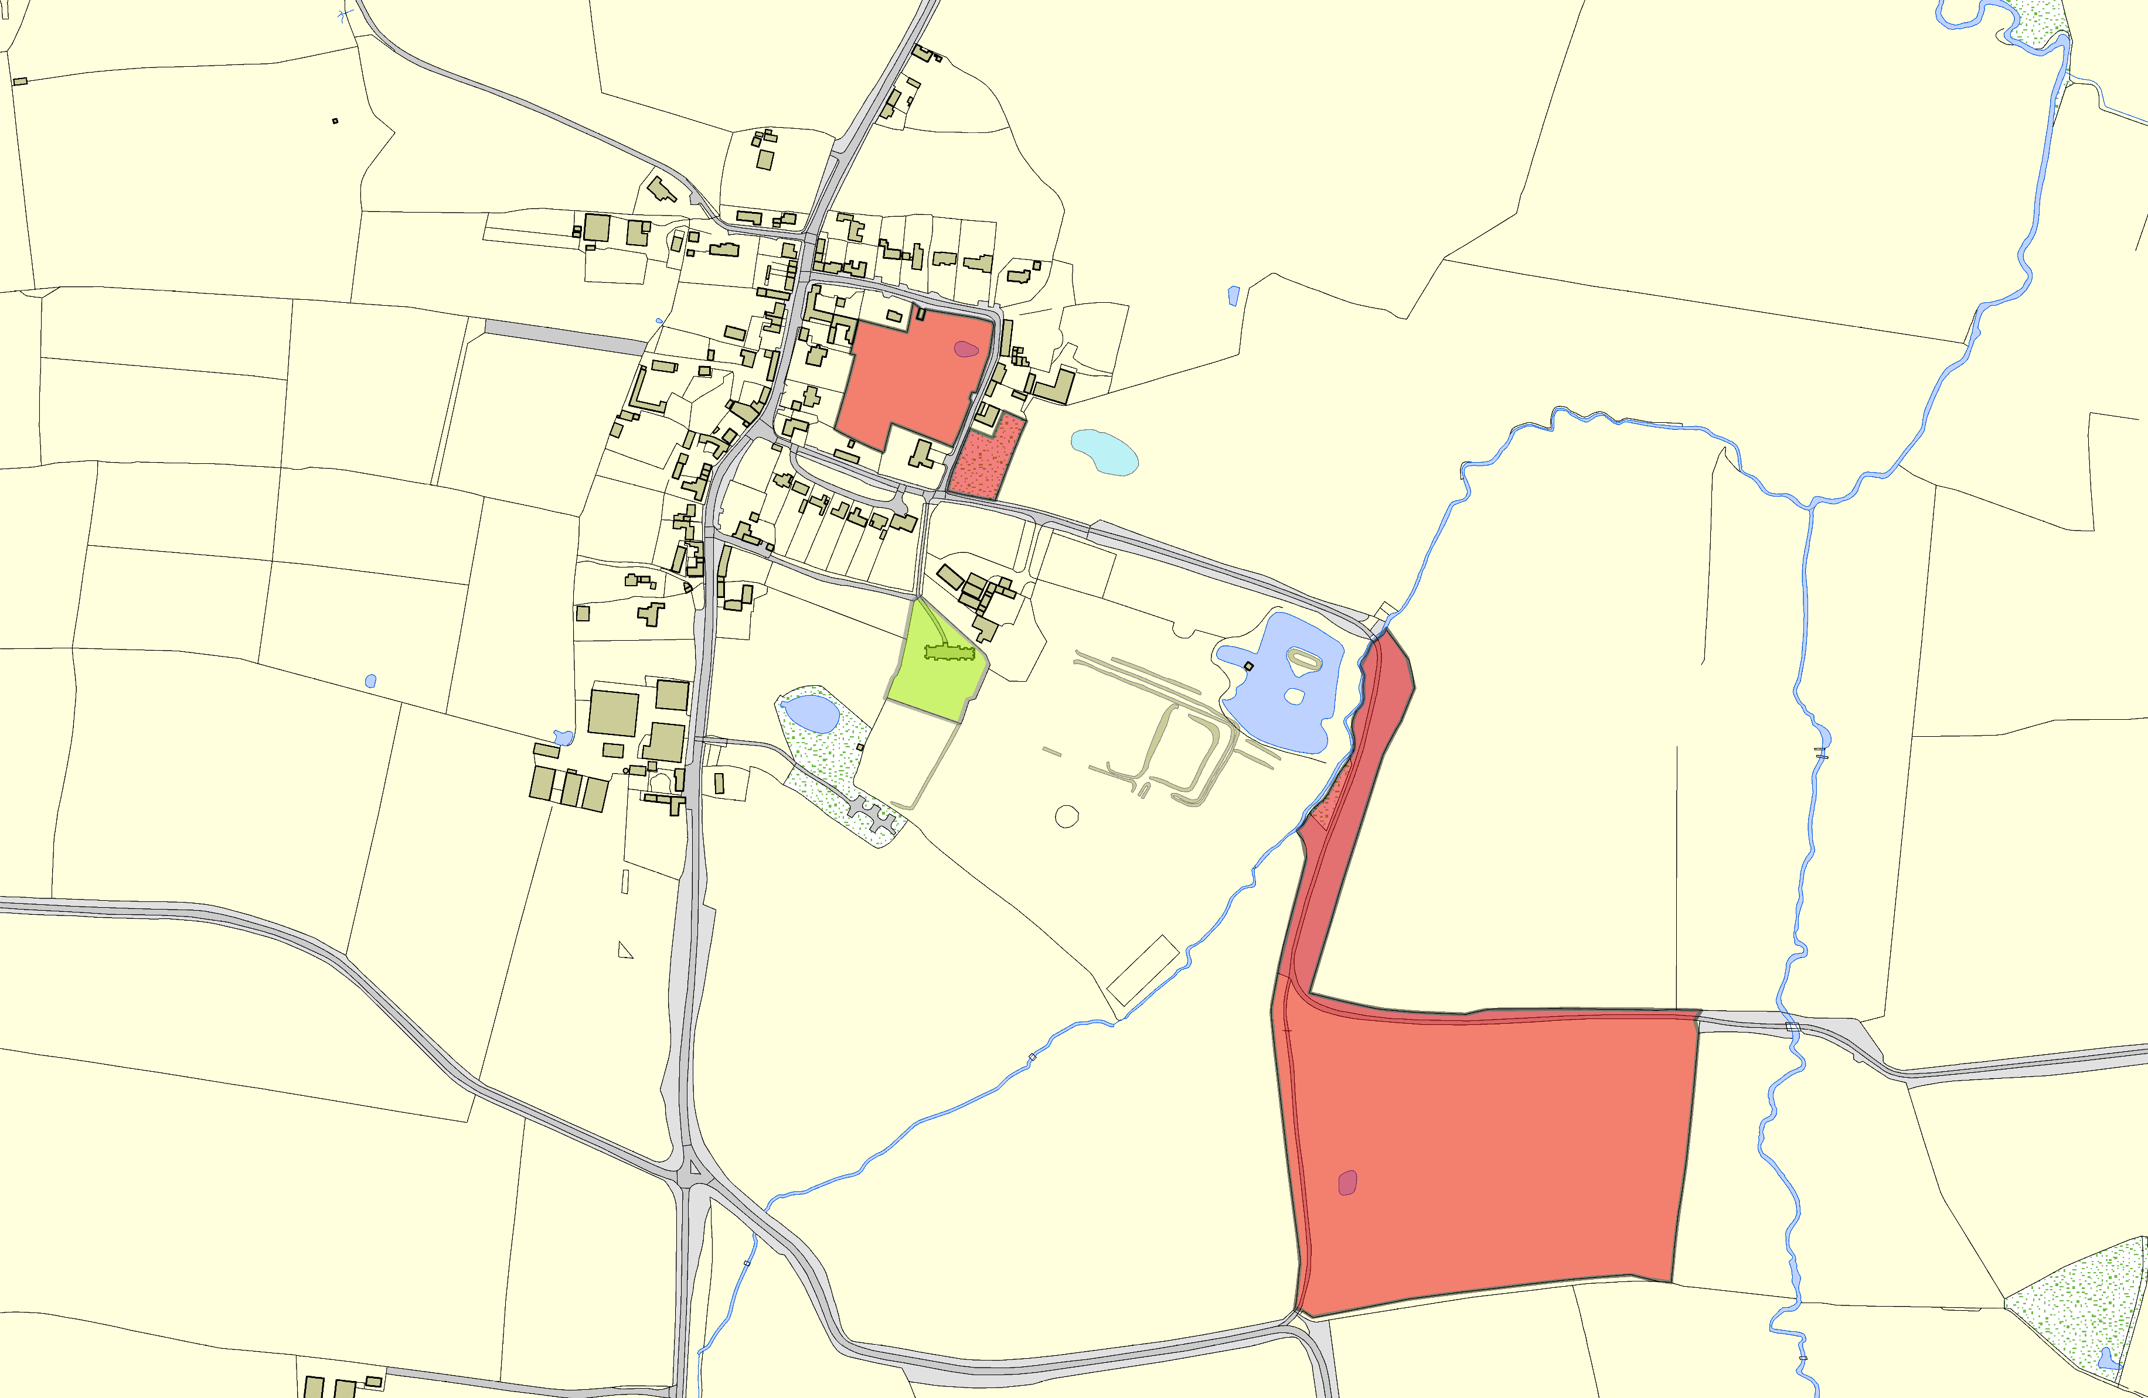

All Saints Parish Church - Peatling Magna

LGS/PM/3 - Windmill Hill Peatling Magna

©Crown Copyright. All rights reserved. Harborough District Council 100023843 2014

