Peatling Magna OSSR sites, LGS sites and Wildlife Sites Note the LGS sites are proposals only at Sept 2015

LGS/PM/3 - Windmill Hill Peatling Magna LGS/PM/4 - Field adjacent to Tythe Barn Peatli

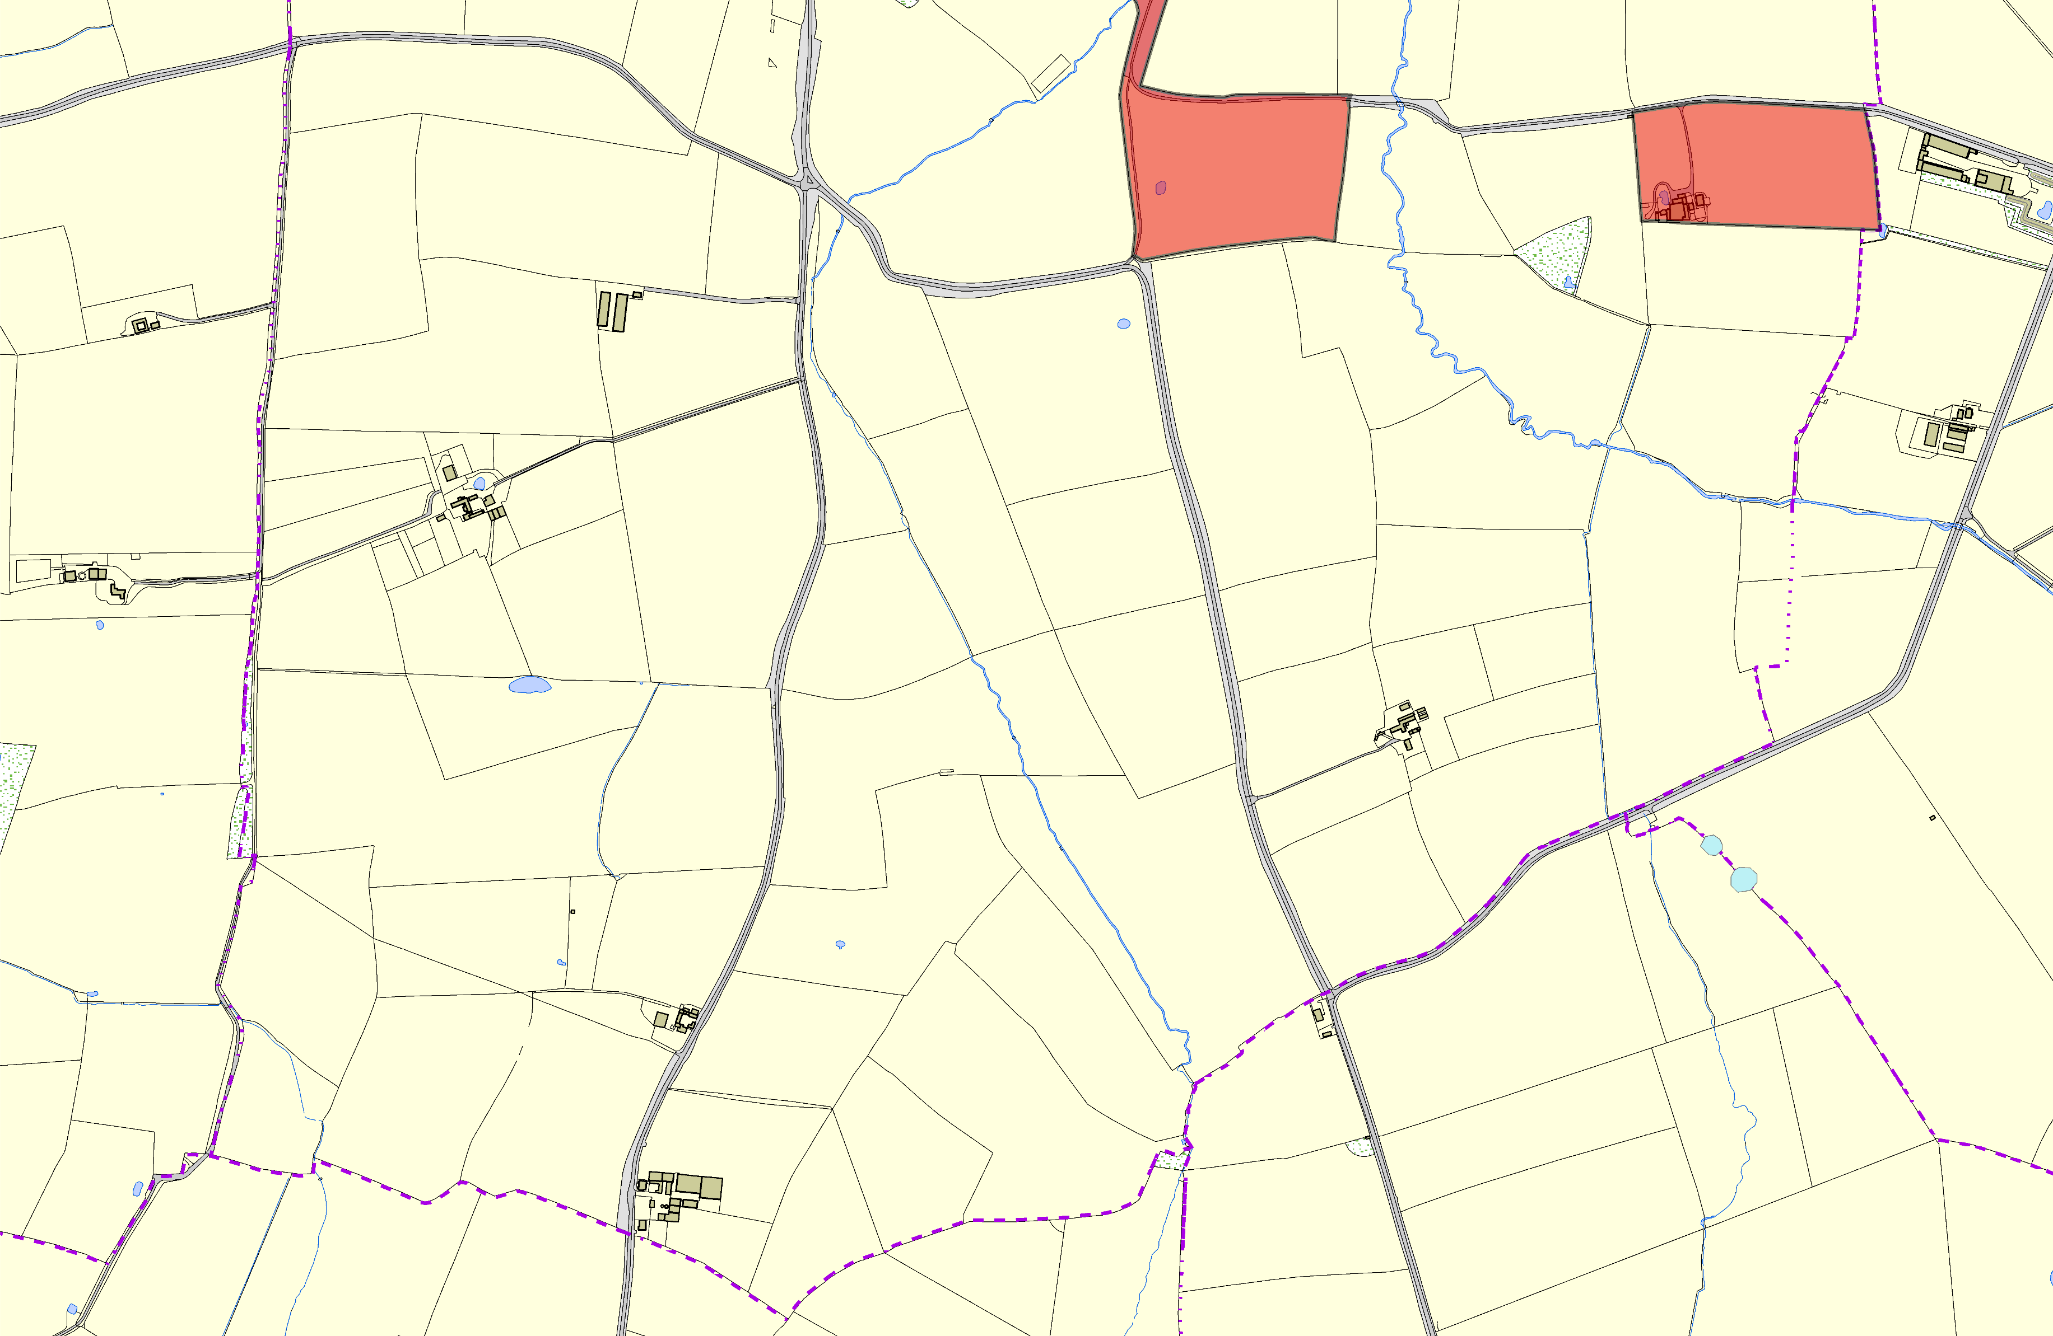

©Crown Copyright. All rights reserved. Harborough District Council 100023843 2014
Legend
Boundary Ash 2, Bruntingthorpe

Not Broeuncdoarmy Amsh 1e, nBrdunetindgthfoorpre LGS Designation Recommended for LGS designation Wildlife Sites
Open Space, Sport and Recreation Sites
OS MM Boundary
DESCTERM
!!!!!!!!!!!!!!!!!!!! County
District Electoral Parish

