Peatling Parva OSSR sites, LGS sites and Wildlife Sites Note the LGS sites are proposals only at Sept 2015

Bank Hedge

Bifurcated Base Ash

Mill Dam Stream 2, Peatling Parva
Mill Dam Stream 1, Peatling Parva

St Mary's Church - Bruntingthorpe

Peatling Parva Churchyard

Fishing Ponds - Peating Parva

Public House Play Area - Peatling Parva Public House Recreation area - Peatling Parva
Legend

Not recommended for LGS Designation

Peatling Road / Main Street AGS- Peatling Parva Peatling Road / Main Street AGS- Peatling Parva

Fishing Ponds - Peating Parva

Recommended for LGS designation Wildlife Sites
Open Space, Sport and Recreation Sites
OS MM Boundary
DESCTERM
!!!!!!!!!!!!!!!!!!!! County

District Electoral Parish

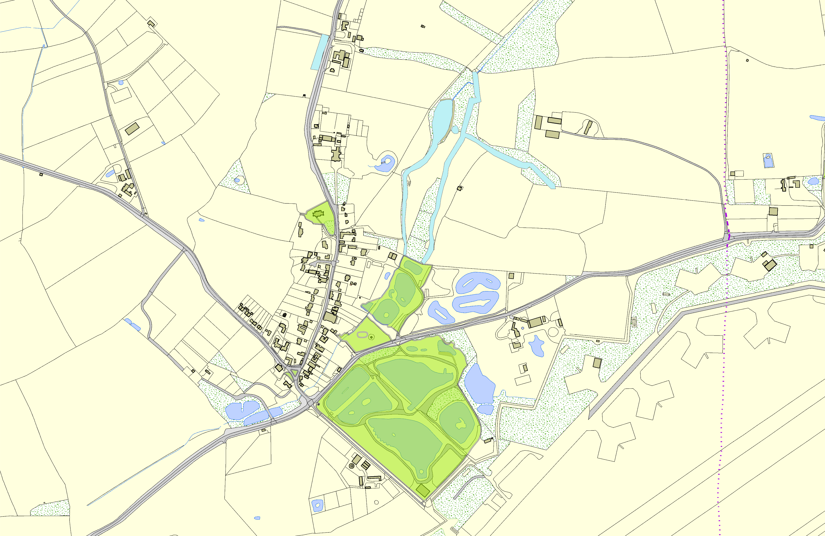©Crown Copyright. All rights reserved. Harborough District Council 100023843 2014

