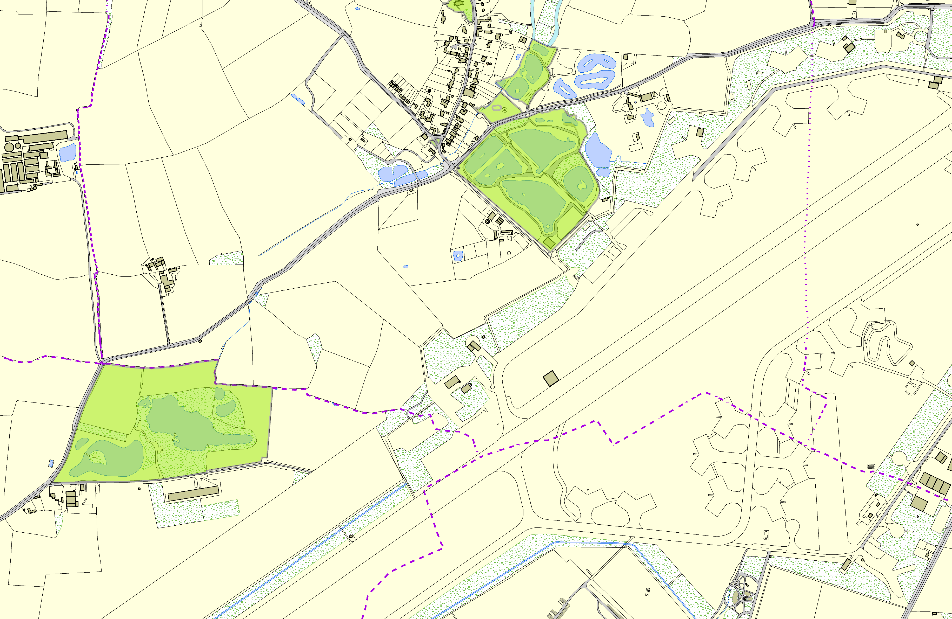Peatling Parva OSSR sites, LGS sites and Wildlife Sites Note the LGS sites are proposals only at Sept 2015

 | Mill Farm Fishery - Gilmorton | Peatling Parva Churchyard  Mill Dam Stream 2, Peatling Parva  Mill Dam Stream 1, Peatling Parva  Fishing Ponds - Peating Parva  Public House Play Area - Peatling Parva Public House Recreation area - Peatling Parva  Peatling Road / Main Street AGS- Peatling Parva Peatling Road / Main Street AGS- Peatling Parva  Fishing Ponds - Peating Parva |  | Legend  Not recommended for LGS Designation Recommended for LGS designation Wildlife Sites  Open Space, Sport and Recreation Sites  OS MM Boundary  DESCTERM  !!!!!!!!!!!!!!!!!!!! County  District Electoral Parish
 | ©Crown Copyright. All rights reserved. Harborough District Council 100023843 2014

