Peatling Parva OSSR sites, LGS sites and Wildlife Sites Note the LGS sites are proposals only at Sept 2015

Bank Hedge

Bifurcated Base Ash Mill Dam Stream 2, Peatling Parva
Mill Dam Stream 1, Peatling Parva
Legend

Not recommended for LGS Designation Recommended for LGS designation Wildlife Sites
Open Space, Sport and Recreation Sites
St Mary's Church - Bruntingthorpe

Peatling Parva Churchyard

Fishing Ponds - Peating Parva

OS MM Boundary
DESCTERM
!!!!!!!!!!!!!!!!!!!! County

District Electoral Parish

Bruntingthorpe Village GreenLGS/B

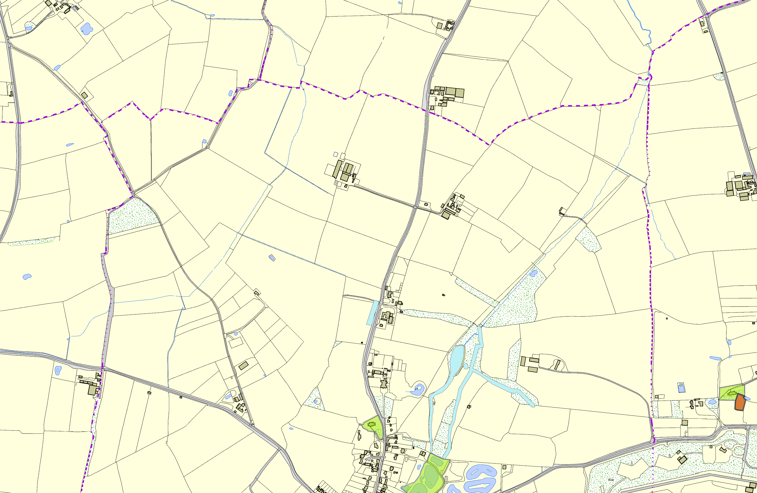©Crown Copyright. All rights reserved. Harborough District Council 100023843 2014

