Saddington OSSR sites, LGS sites and Wildlife Sites Note the LGS sites are proposals only at Sept 2015

Legend

Fleckney Band Hall LGS/FLECK/2 - Amenity Area, Priest meadow Estate
Forge Close, Fleckney Cemetery and Churchyard - Fleckney

Kibworth Football Pitches, Fleckney Road

Not recommended for LGS Designation
Recommended for LGS designation Wildlife Sites

Edward Road, Fleckney Edward Road, Fleckney

Fleckney Village Green Fleckny Duckpond

Open Space, Sport and Recreation Sites

Open Area Industrial Estate - Fleckney

OS MM Boundary
DESCTERM
Edward Road Play Area - Flekcney
Crossleys, Fleckney

!!!!!!!!!!!!!!!!!!!! County

District

Lodge Road, Fleckney

Flood Relief Area - Fleckney The Meer, Fleckney

Flood Relief Area 2 - Fleckney

Electoral Parish
Lodge Road Sports Facilities - FleckneySaddington Road, Fleckney

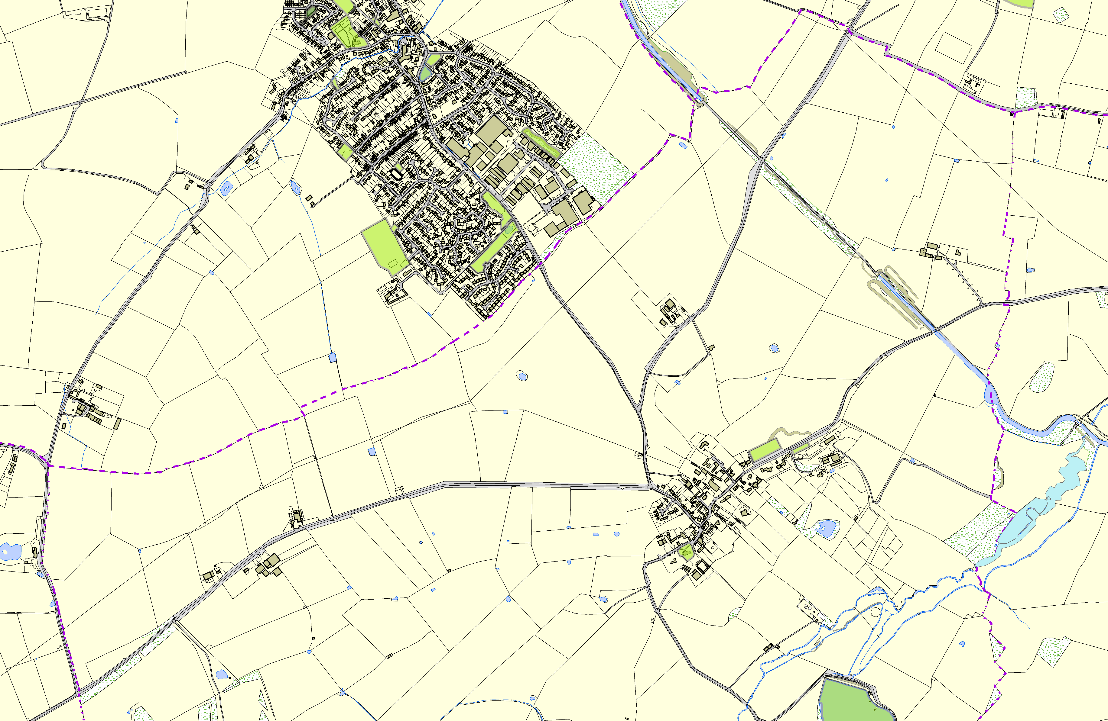

Saddington AllotmentsSaddington Cemetery

Langton Brook and Grass Banks

Stream Spinney

Saddington Churchyard

Saddington Reservoir

©Crown Copyright. All rights reserved. Harborough District Council 100023843 2014

