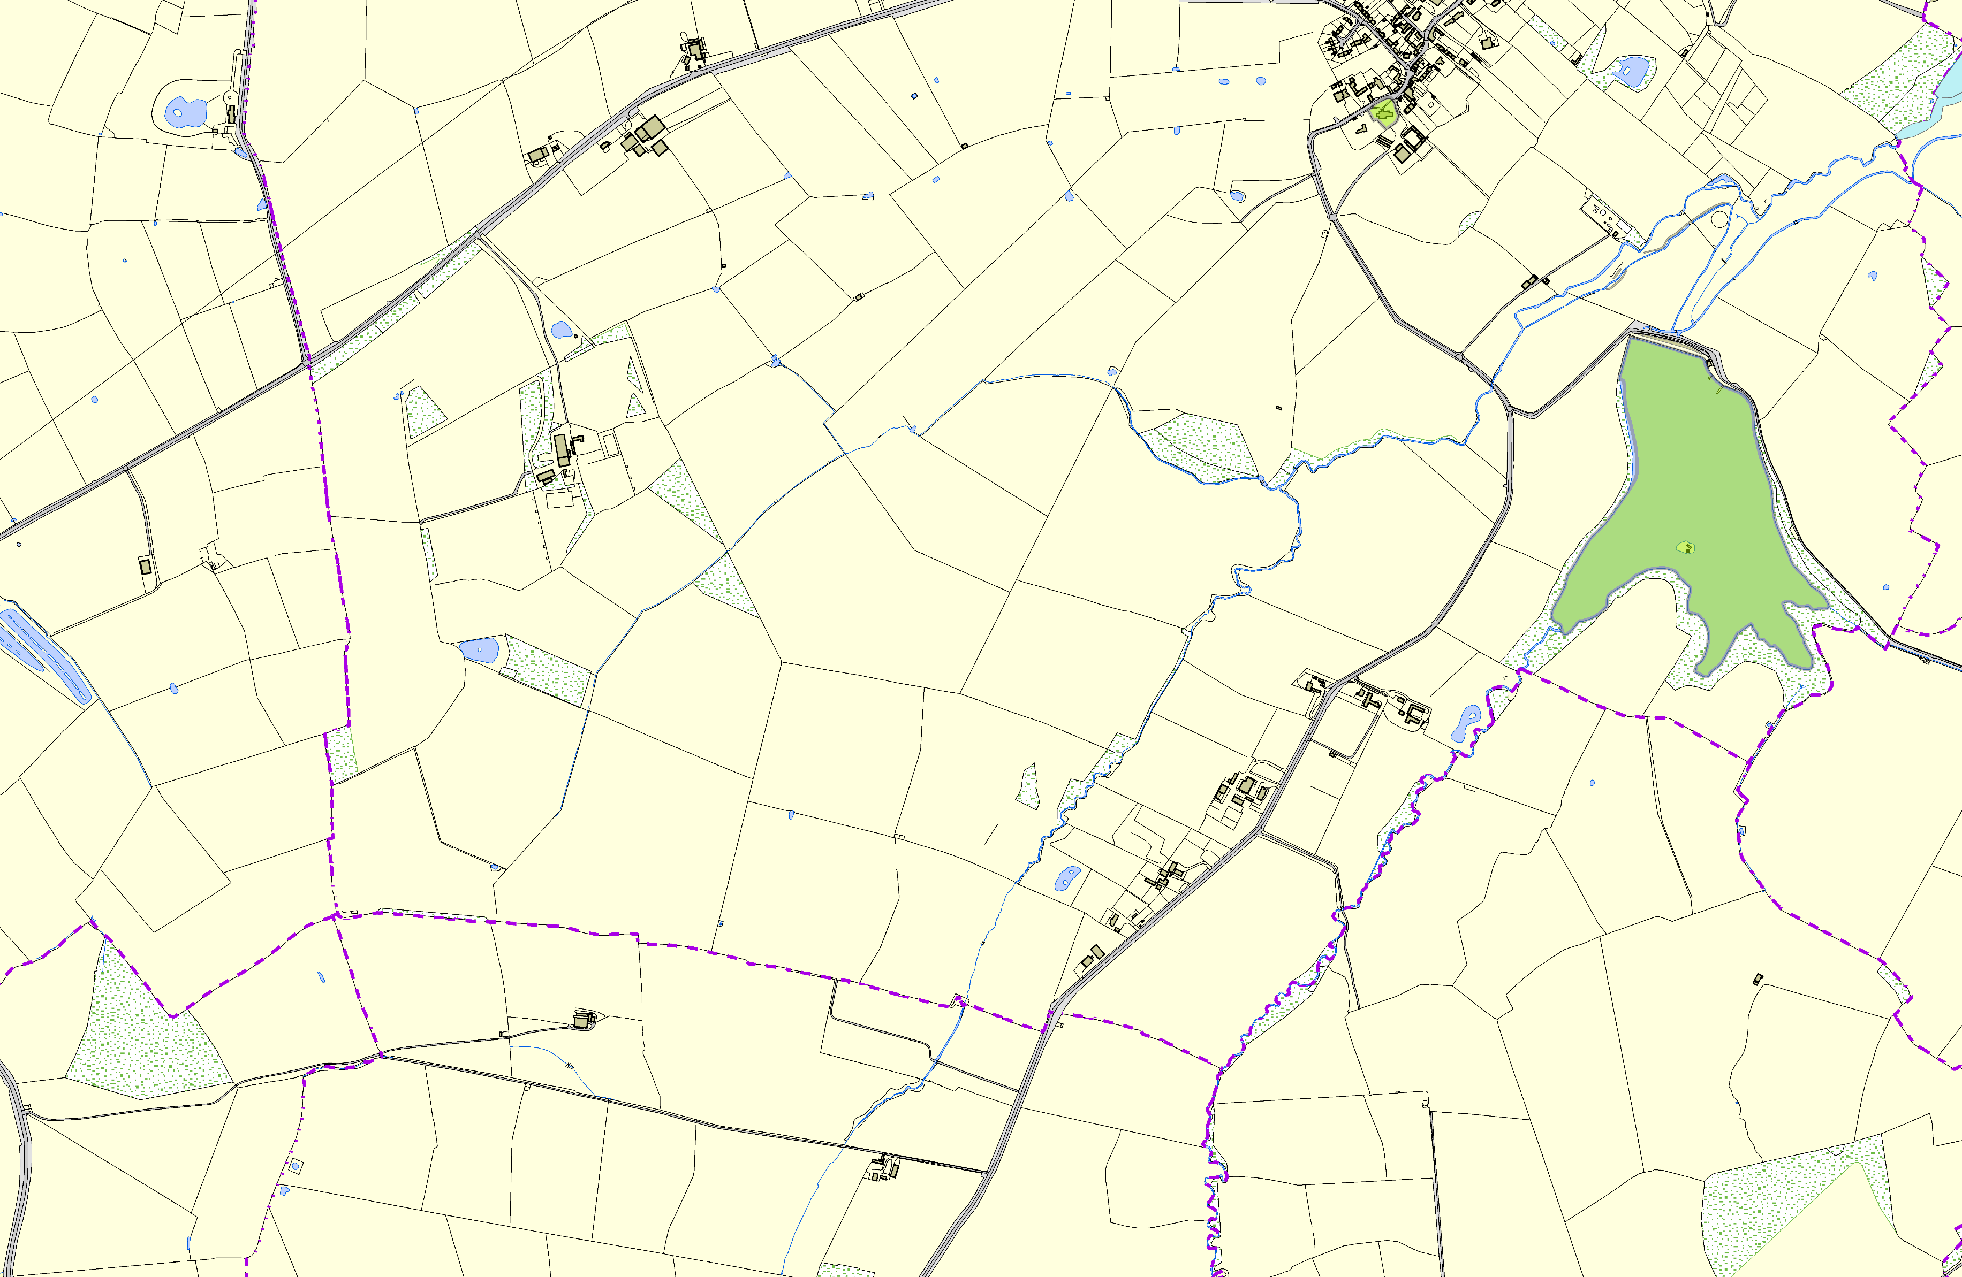Saddington OSSR sites, LGS sites and Wildlife Sites Note the LGS sites are proposals only at Sept 2015

Legend
Not recommended for LGS Designation |  |  |  | Stream Spinney
Recommended for LGS designation |  | Saddington Churchyard |  | Langton Brook and Grass Banks
Wildlife Sites
Open Space, Sport and Recreation Sites
OS MM Boundary
DESCTERM
!!!!!!!!!!!!!!!!!!!! County
District
Electoral
Parish |  |  | Saddington Reservoir
 | ©Crown Copyright. All rights reserved. Harborough District Council 100023843 2014

