Scraptoft OSSR sites, LGS sites and Wildlife Sites Note the LGS sites are proposals only at Sept 2015

Legend
Natural Burial Site - Scraptoft

Not recommended for LGS Designation Recommended for LGS designation Wildlife Sites
Open Space, Sport and Recreation Sites
OS MM Boundary
DESCTERM
!!!!!!!!!!!!!!!!!!!! County

District

War Field Nature Reserve - Scraptoft

Electoral

De Montfort Sports Grounds 1

Scraptoft RUFC

LGS/SCRAP/4 - Scratoft Rugby Club Field

Parish

LGS/SCRAP/1 - The Mount Scraptoft

LGS/SCRAP/2 - Scraptoft Woodland

Hall Lake - Scraptoft
Facers Lane, ScraptoftMitchell Grove, Scraptoft
Coulter Close, Scraptoft

LGS/SCRAP/5 - Stocks Road Scraptoft

Facers Lane, Scraptoft
Edith Cole Memorial Park - ScraptoftLAGllSS/SaiCntRsACPh/u6rc- hCyhaurdrc-hSLcarnadptSofctraptoft

Covert Lane, Scraptoft

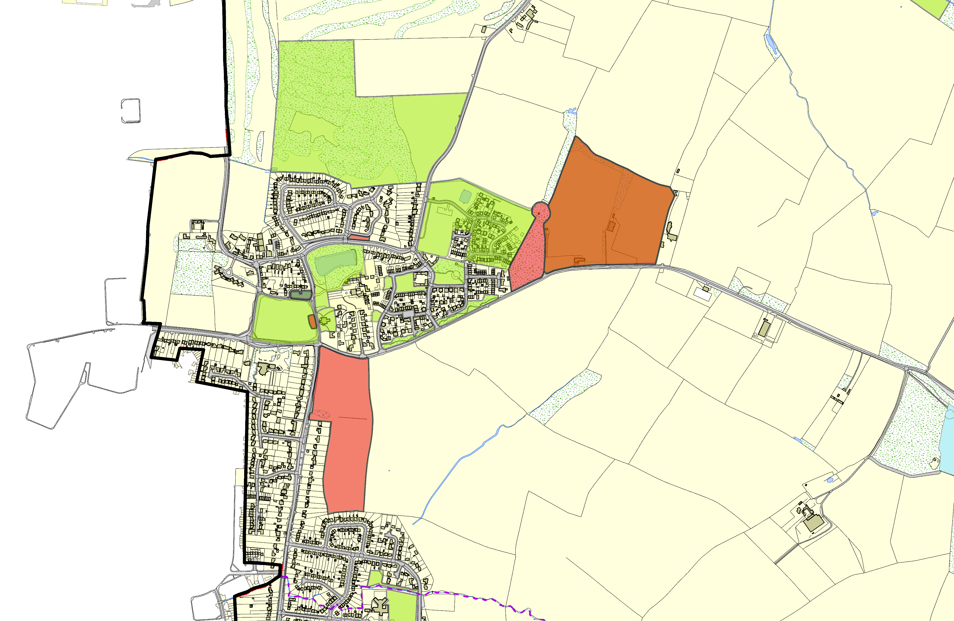
Covert Lane, Scraptoft

Pond at Four Acres, Scraptoft
LGS/SCRAP/3 - Glebe Land Scraptoft

Four Acres, Scraptoft

Pulford Drive, Scaptoft

Fernvale School - Thurnby and Bushby

©Crown Copyright. All rights reserved. Harborough District Council 100023843 2014

