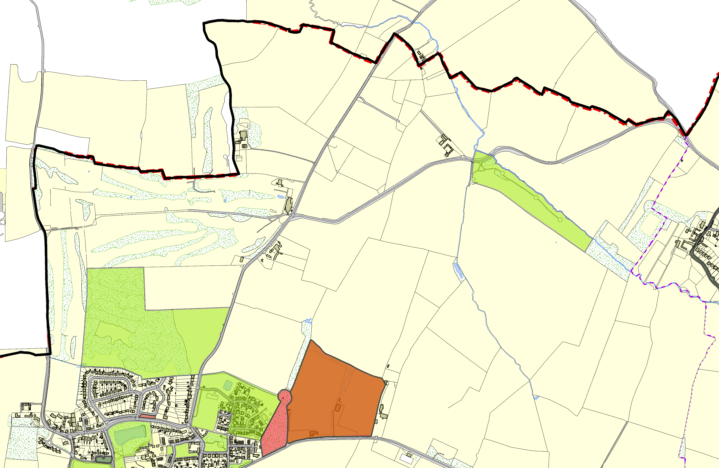Scraptoft OSSR sites, LGS sites and Wildlife Sites Note the LGS sites are proposals only at Sept 2015

Legend  Not recommended for LGS Designation Recommended for LGS designation Wildlife Sites  Open Space, Sport and Recreation Sites  OS MM Boundary  DESCTERM  !!!!!!!!!!!!!!!!!!!! County  District Electoral Parish  War Field Nature Reserve - Scraptoft  De Montfort Sports Grounds 1 LGS/SCRAP/1 - The Mount Scraptoft  Hall Lake - Scraptoft Mitchell Grove, Scraptoft Facers Lane, Scraptoft  Coulter Close, Scraptoft  LGS/SCRAP/5 - Stocks Road Scraptoft  Edith Cole Memorial Park - Scraptoft Covert Lane, Scraptoft |  | Scraptoft RUFC LGS/SCRAP/4 - Scratoft Rugby Club Field  LGS/SCRAP/2 - Scraptoft Woodland |  | Natural Burial Site - Scraptoft | LGS/KEY/1a,1b,1c - Snows Lane - Sunken Lane Keyham
 | ©Crown Copyright. All rights reserved. Harborough District Council 100023843 2014

