Scraptoft OSSR sites, LGS sites and Wildlife Sites Note the LGS sites are proposals only at Sept 2015

Legend
De Montfort Sports Grounds 1 LGS/SCRAP/1 - The Mount Scraptoft

Scraptoft RUFC

LGS/SCRAP/4 - Scratoft Rugby Club Field

Not ecommended for LGS Designation
Hall Lake - Scraptoft
Facers Lane, ScraptoftMitchell Grove, Scraptoft
Recommended for LGS designCaotuiltoernClose, Scraptoft LGS/SCRAP/5 - Stocks Road Scraptoft

LGS/SCRAP/2 - Scraptoft Woodland

Wildlife Sites

Facers Lane, Scraptoft
Covert Lane, Scraptoft

dith Cole Memorial Park - ScraptoftLAGllSS/SaiCntRsACPh/u6rc- hCyhaurdrc-hSLcarnadptSofctraptoft
E

Open Space, Sport and Recreation Sites
Covert Lane, Scraptoft

OS MM Boundary
DESCTERM
!!!!!!!!!!!!!!!!!!!! County

District Electoral Parish

LGS/SCRAP/3 - Glebe Land Scraptoft

Pond at Four Acres, Scraptoft

Four Acres, Scraptoft

Pulford Drive, Scaptoft

Fernvale School - Thurnby and Bushby

Somerby Road Open Space - Thurnby and Bushby

LGS/THUR/4 - Embankments on Station Road 2
LGSLL/TGGHSSU//TTRHH/5UUR-RG//54re--eGEnrmsebeTanenslfkoTmredlefWonrtadsyoWTnahSyutrTanthbiouynrn1Rb(yosah2dou(1sldhobueldObSeSORSsSiteR) site)

LGS/THUR/8 - Dismtantled Railway Line Thurnby
LGS/THUR/8 - Dismantled Railway line - unsuitable area for LGS

Wadkins Badger Area, Thurnby

LGS/THUR/6 - Anthony Drive and Fiona Drive Green space (should be OSSR site)

LGS/THUR/2 - Greens in front of 694 to 702 Uppingham Road 1
Wadkins- Thurnby and Bushby

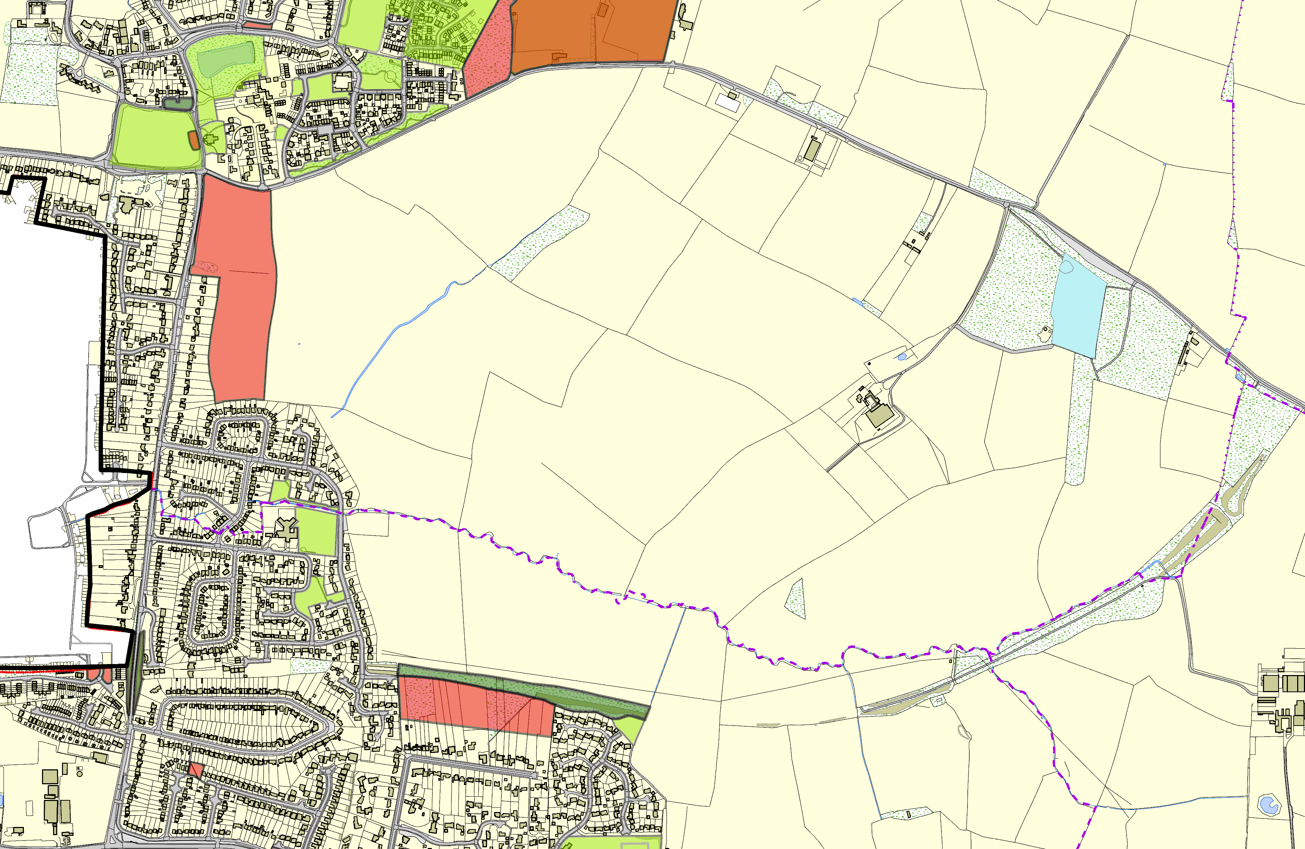©Crown Copyright. All rights reserved. Harborough District Council 100023843 2014

