Legend

Shangton OSSR sites, LGS sites and Wildlife Sites Note the LGS sites are proposals only at Sept 2015

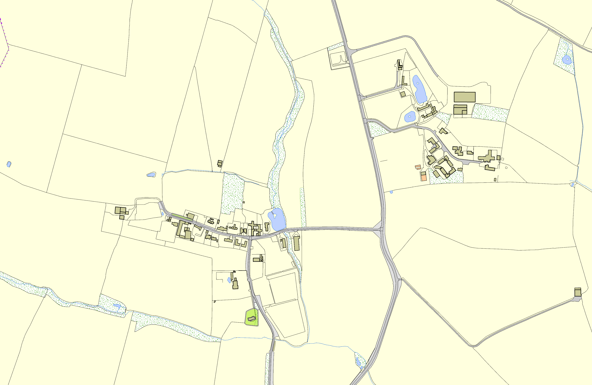
Not recommended for LGS Designation Recommended for LGS designation Wildlife Sites
Open Space, Sport and Recreation Sites

OS MM Boundary
DESCTERM
!!!!!!!!!!!!!!!!!!!! County
District Electoral Parish

Verge in Shangton

Churchyard - Shangton

©Crown Copyright. All rights reserved. Harborough District Council 100023843 2014

