Legend

Shawell OSSR sites, LGS sites and Wildlife Sites Note the LGS sites are proposals only at Sept 2015

Not recommended for LGS Designation Recommended for LGS designation Wildlife Sites
Open Space, Sport and Recreation Sites
OS MM Boundary
DESCTERM
!!!!!!!!!!!!!!!!!!!! County

District Electoral Parish

Shawell Woods

Shawell Woods

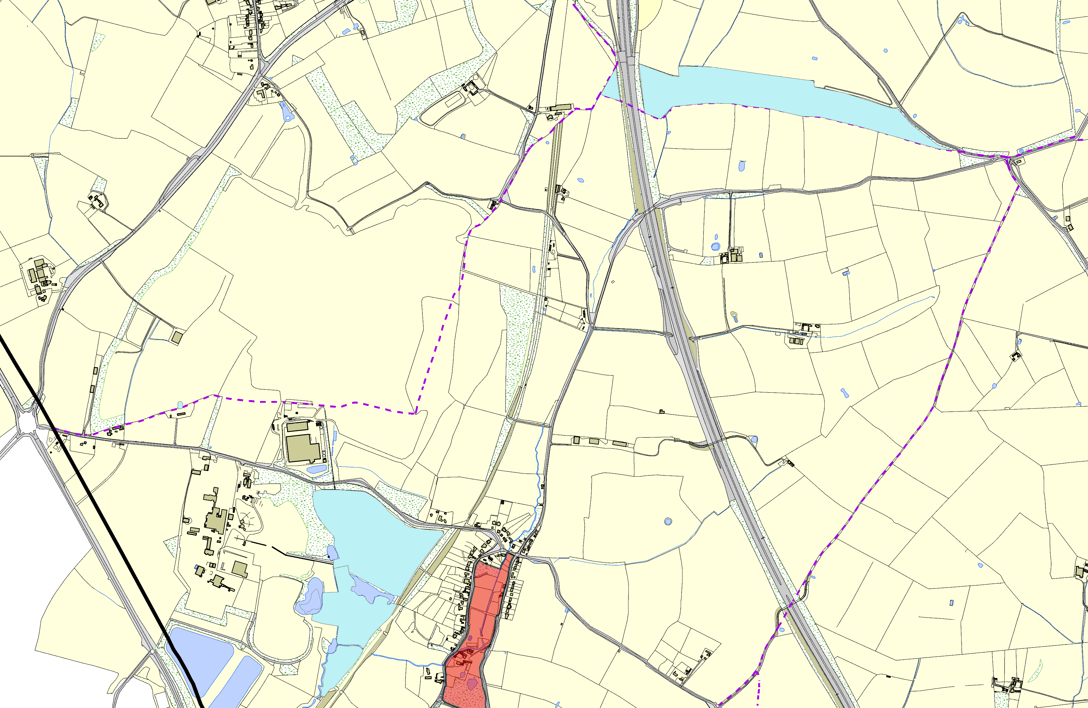

Green Lane Spinney Hedgerows, Site C

Shawell Pits, Shawell; Area 1

Shawell Pits, Shawell; Area 2

LGS/SHAW/1a,b1,b2,c,d1,d2,e,f,g,h - Central Village LGS Shawell

Shawell Pits, Shawell; Area 3

©Crown Copyright. All rights reserved. Harborough District Council 100023843 2014

