Shearsby OSSR sites, LGS sites and Wildlife Sites Note the LGS sites are proposals only at Sept 2015

Shearsby Churchyard

Thorpe Hill Farm, Shearsby; Mature Ash E

Shearsby Village Green

Thorpe Hill Farm, Shearsby; Mature Ash G

Thorpe Hill Farm, Shearsby; Field A

Thorpe Hill Farm, Shearsby; Mature Ash D

Mill Lane Allorments - Shearsby
Thorpe Hill Farm, Shearsby; Mature Tree F

Legend

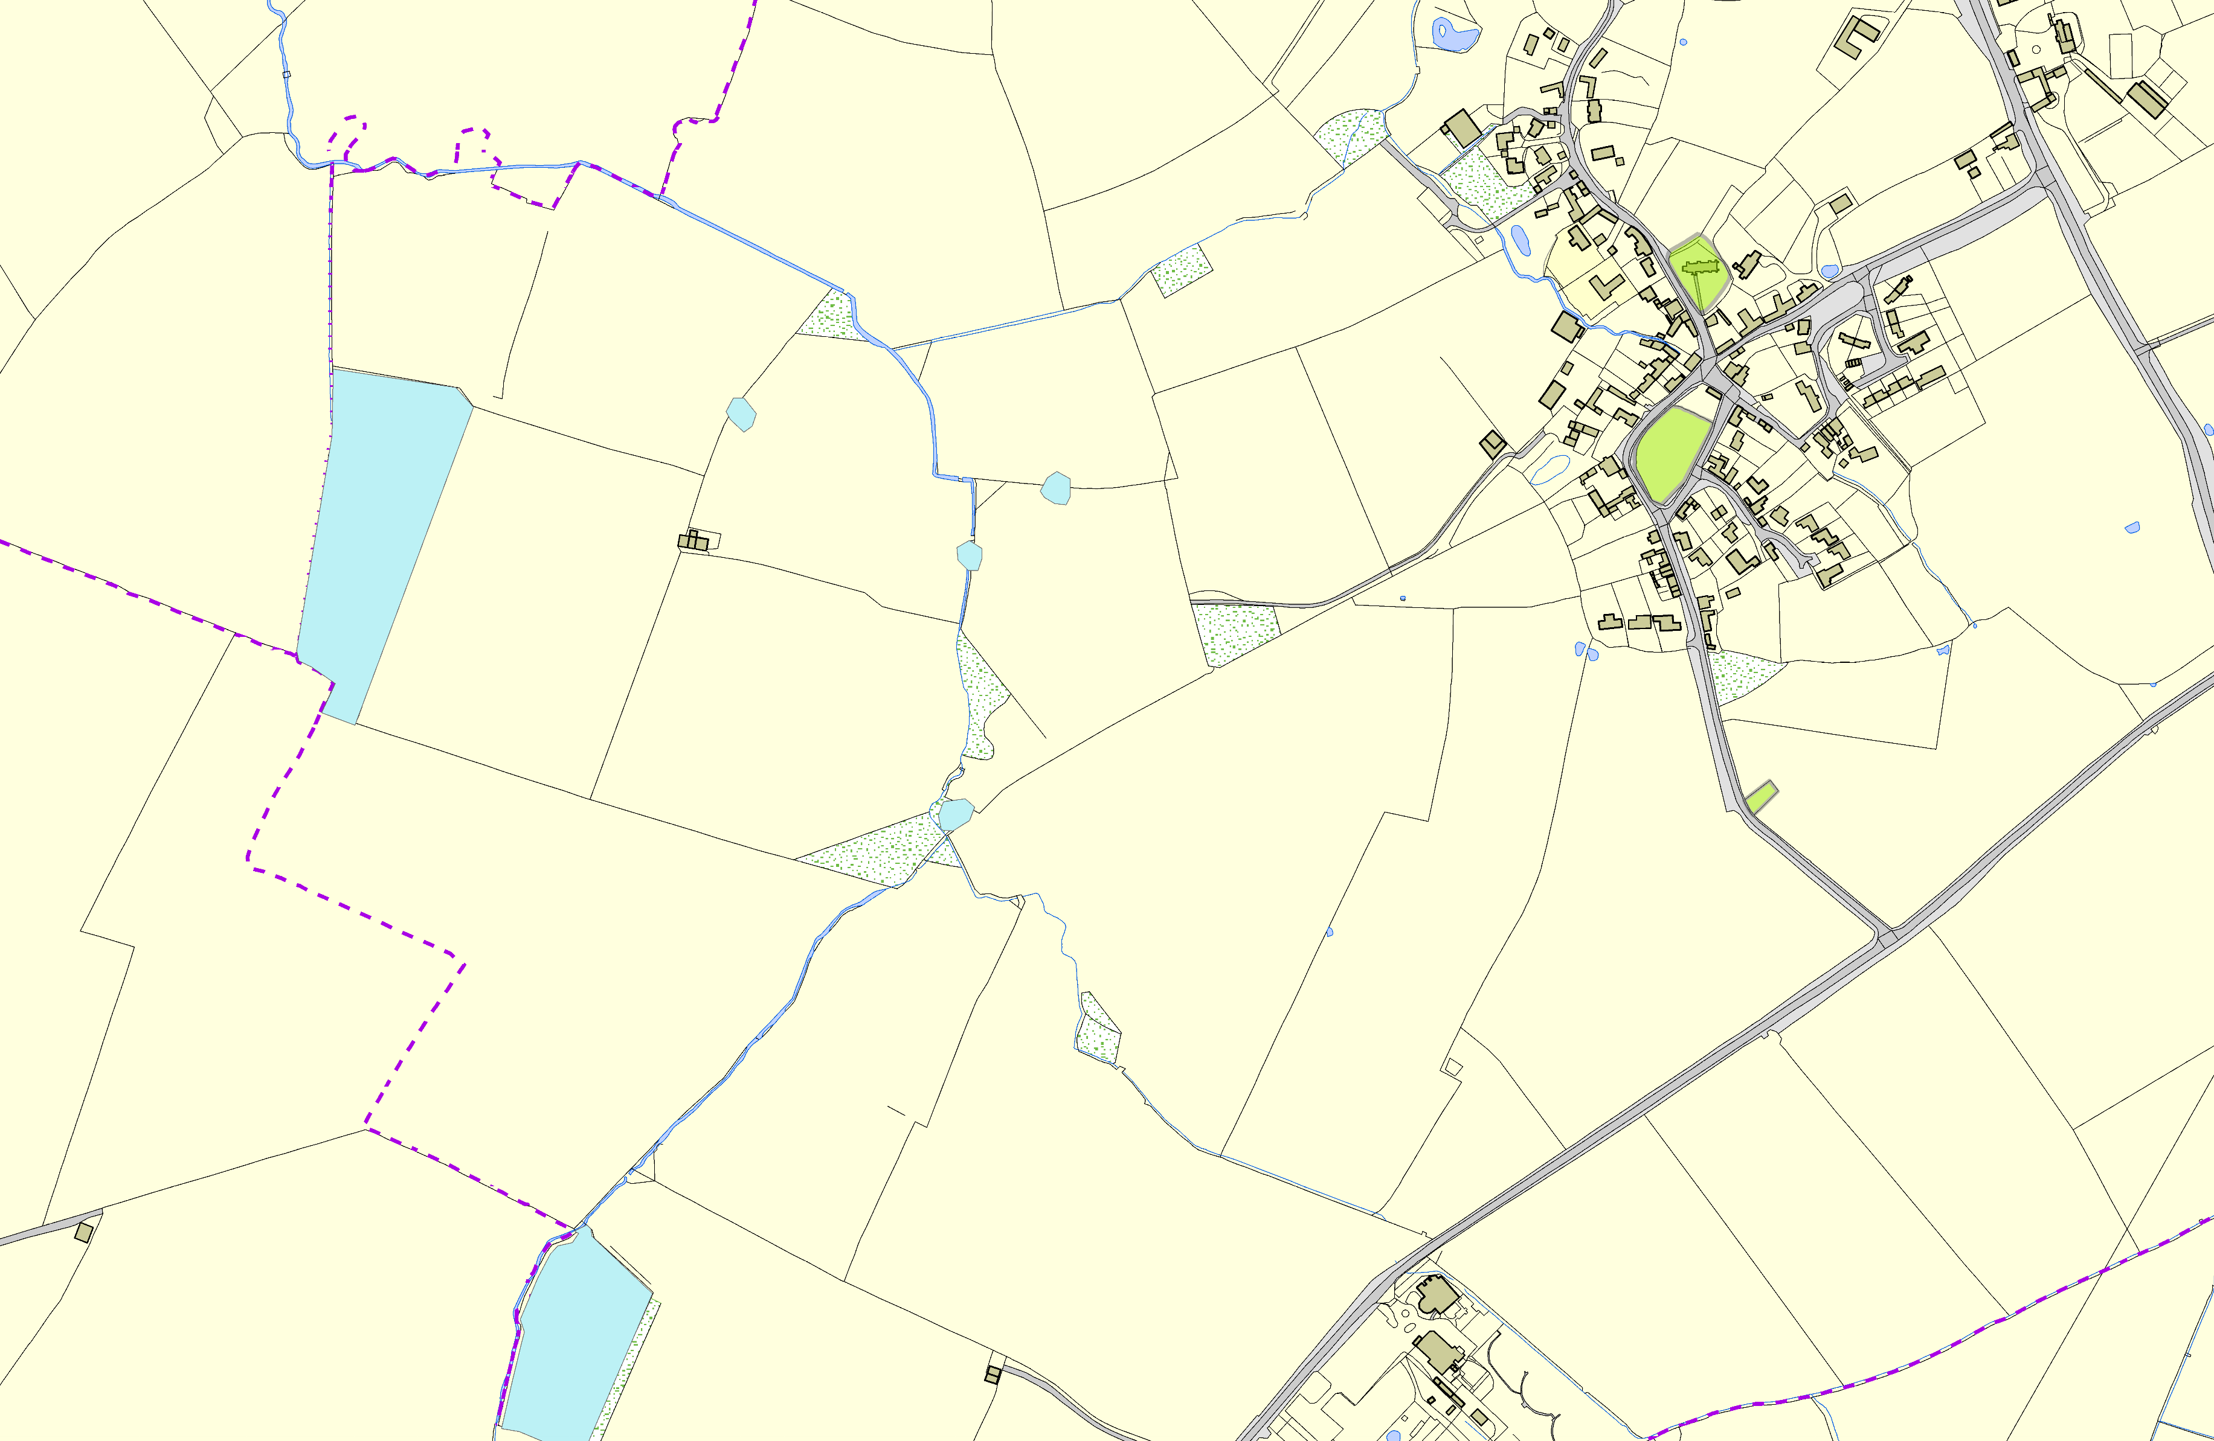

Thorpe Hill Farm, Shearsby; Grassland B

©Crown Copyright. All rights reserved. Harborough District Council 100023843 2014

Not recommended for LGS Designation Recommended for LGS designation Wildlife Sites
Open Space, Sport and Recreation Sites
OS MM Boundary
DESCTERM
!!!!!!!!!!!!!!!!!!!! County

District Electoral Parish

