Skeffington OSSR sites, LGS sites and Wildlife Sites Note the LGS sites are proposals only at Sept 2015

Hunters Avenue, Skeffington Skeffington Churchyard

Leighfield Forest

Skeffington Graveyard

Leighfield Forest

Leighfield Forest

Grassland, Skeffington

Mature Ash, Skeffington

Legend

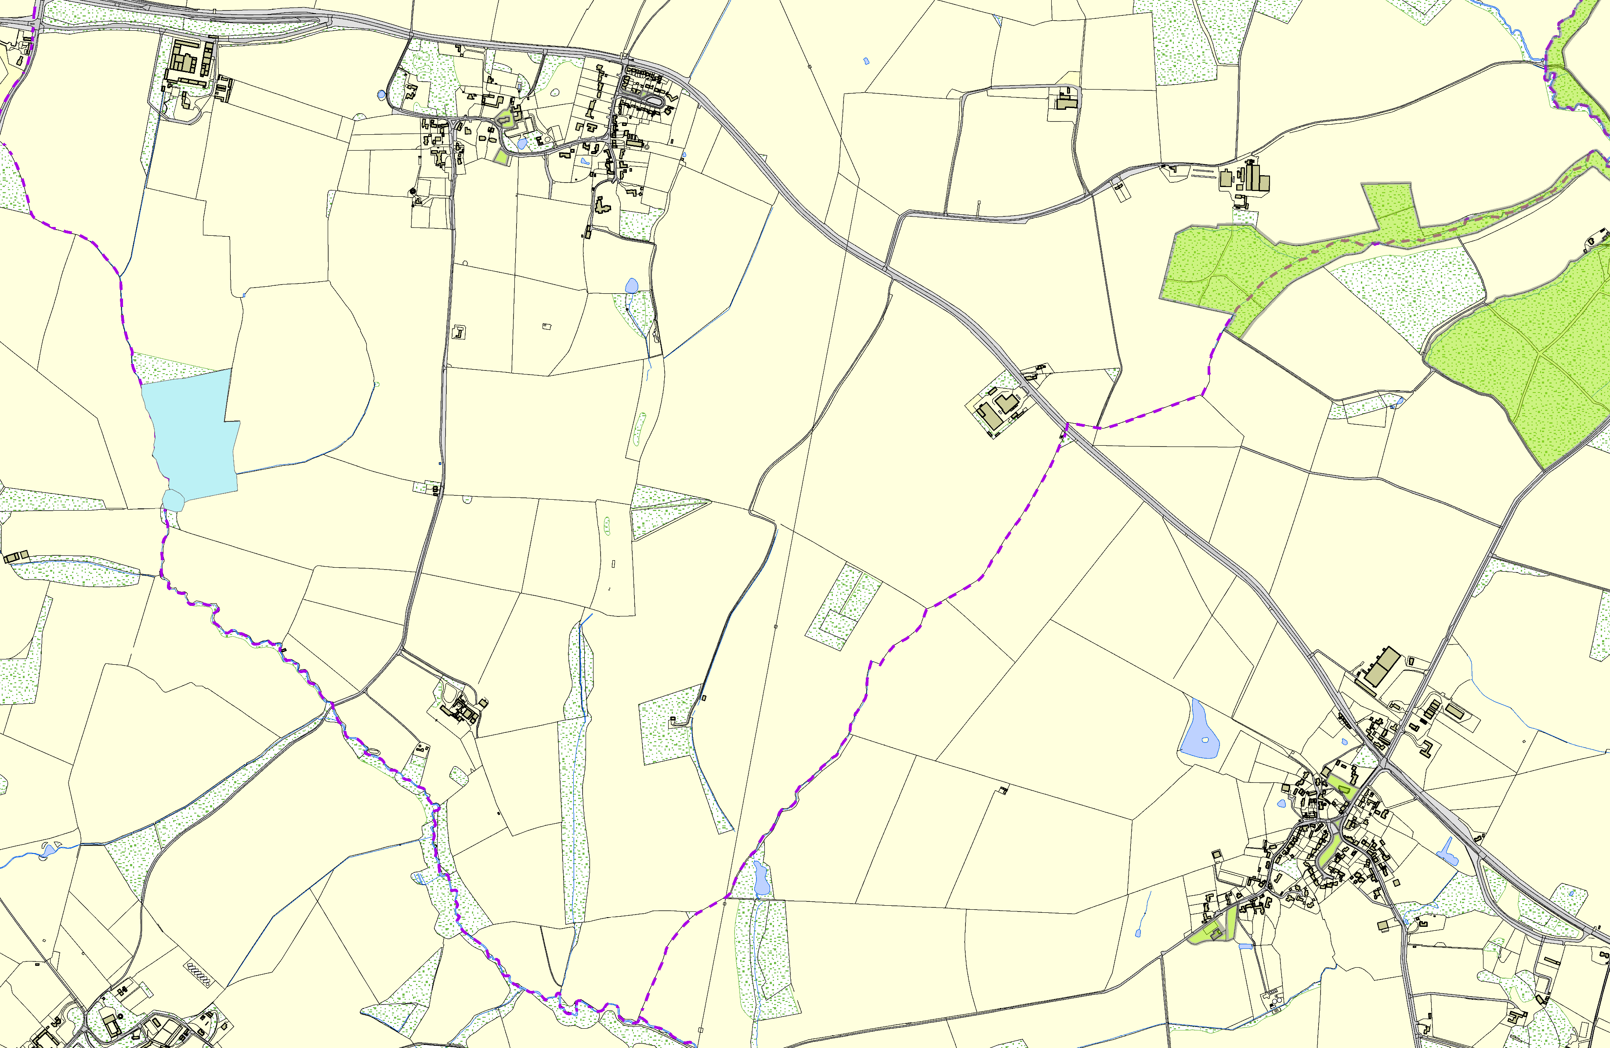Not recommended for LGS Designation Recommended for LGS designation Wildlife Sites
Open Space, Sport and Recreation Sites
OS MM Boundary
DESCTERM
!!!!!!!!!!!!!!!!!!!! County

District
Electoral Parish
©Crown Copyright. All rights reserved. Harborough District Council 100023843 2014

Thomas Beckett Church - Tugby & Keythorpe Tugby & Keythorpe Village Green

Wellfield Green - Tugby & Keythorpe

Tugby & Keythorpe Allotments The Tugby Centre - Main Street

