Skeffington OSSR sites, LGS sites and Wildlife Sites Note the LGS sites are proposals only at Sept 2015

Legend

Harebell Meadow & Pond (Meadow)

Not recommended for LGS Designation
Recommended for LGS designation
Rectangle Wood, Tilton on the Hill

Wildlife Sites
Ancient Woodland, Tilton on the Hill

Open Space, Sport and Recreation Sites
OS MM BAnocieunt Wnooddlaandr, Tyilton on the Hill
DESCTERM
!!!!!!!!!!!!!!!!!!!! County

District Electoral Parish

Skeffington Gravel Pit
Leighfield Forest

Hunters Avenue, Skeffington Skeffington Churchyard

Skeffington Graveyard

Leighfield Forest

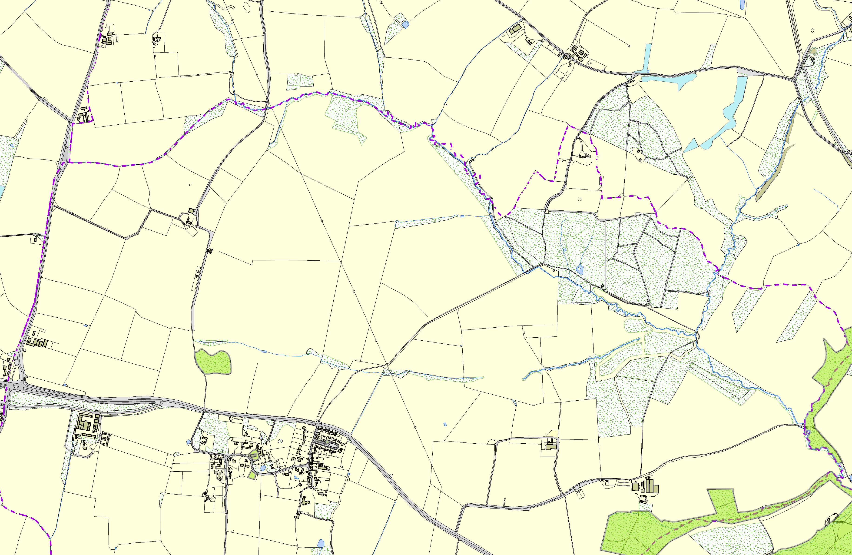
©Crown Copyright. All rights reserved. Harborough District Council 100023843 2014
Leighfield Forest

