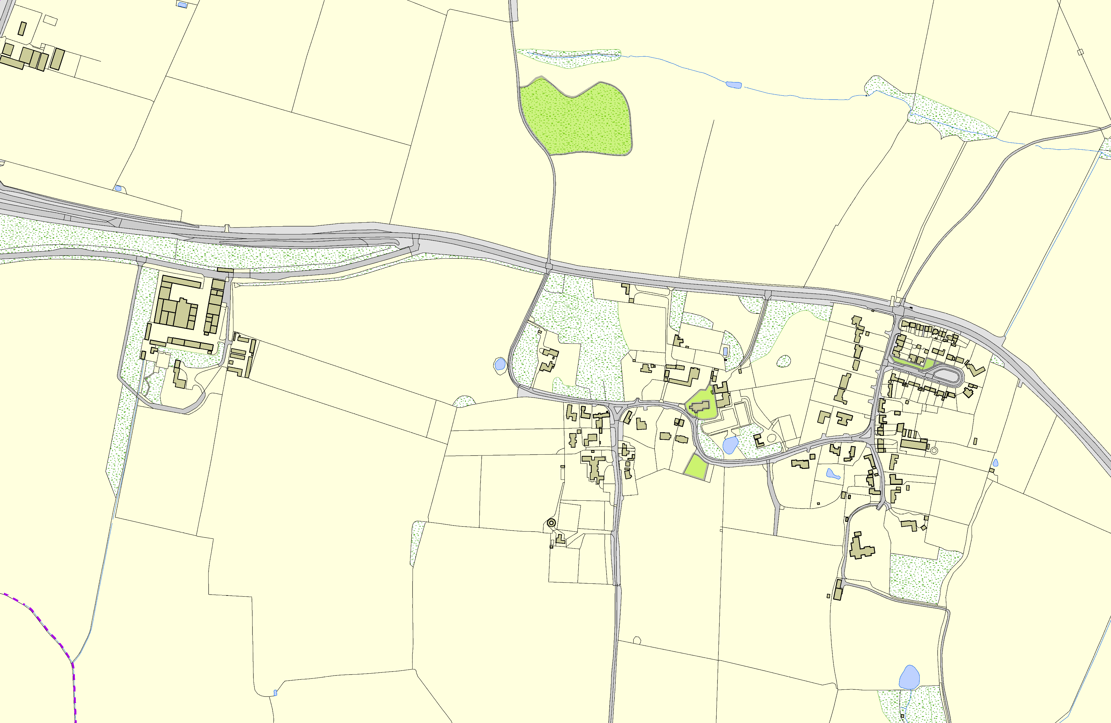Skeffington OSSR sites, LGS sites and Wildlife Sites Note the LGS sites are proposals only at Sept 2015

Legend |  |  | Skeffington Churchyard  Skeffington Graveyard
Not recommended for LGS Designation |  |  | Skeffington Churchyard  Skeffington Graveyard
Recommended for LGS designation |  |  | Skeffington Churchyard  Skeffington Graveyard
Wildlife Sites |  |  | Skeffington Churchyard  Skeffington Graveyard
Open Space, Sport and Recreation Sites |  | Skeffington Gravel Pit | Skeffington Churchyard  Skeffington Graveyard
OS MM Boundary |  |  | Skeffington Churchyard  Skeffington Graveyard
DESCTERM |  |  | Skeffington Churchyard  Skeffington Graveyard
!!!!!!!!!!!!!!!!!!!! County |  |  | Skeffington Churchyard  Skeffington Graveyard
District |  |  | Skeffington Churchyard  Skeffington Graveyard
Electoral |  |  | Skeffington Churchyard  Skeffington Graveyard
Parish |  |  | Skeffington Churchyard  Skeffington Graveyard
 |  |  | Skeffington Churchyard  Skeffington Graveyard | Hunters Avenue, Skeffington
 | ©Crown Copyright. All rights reserved. Harborough District Council 100023843 2014

