Legend

Smeeton Westerby OSSR sites, LGS sites and Wildlife Sites Note the LGS sites are proposals only at Sept 2015

Kibworth High School - Playing Fields

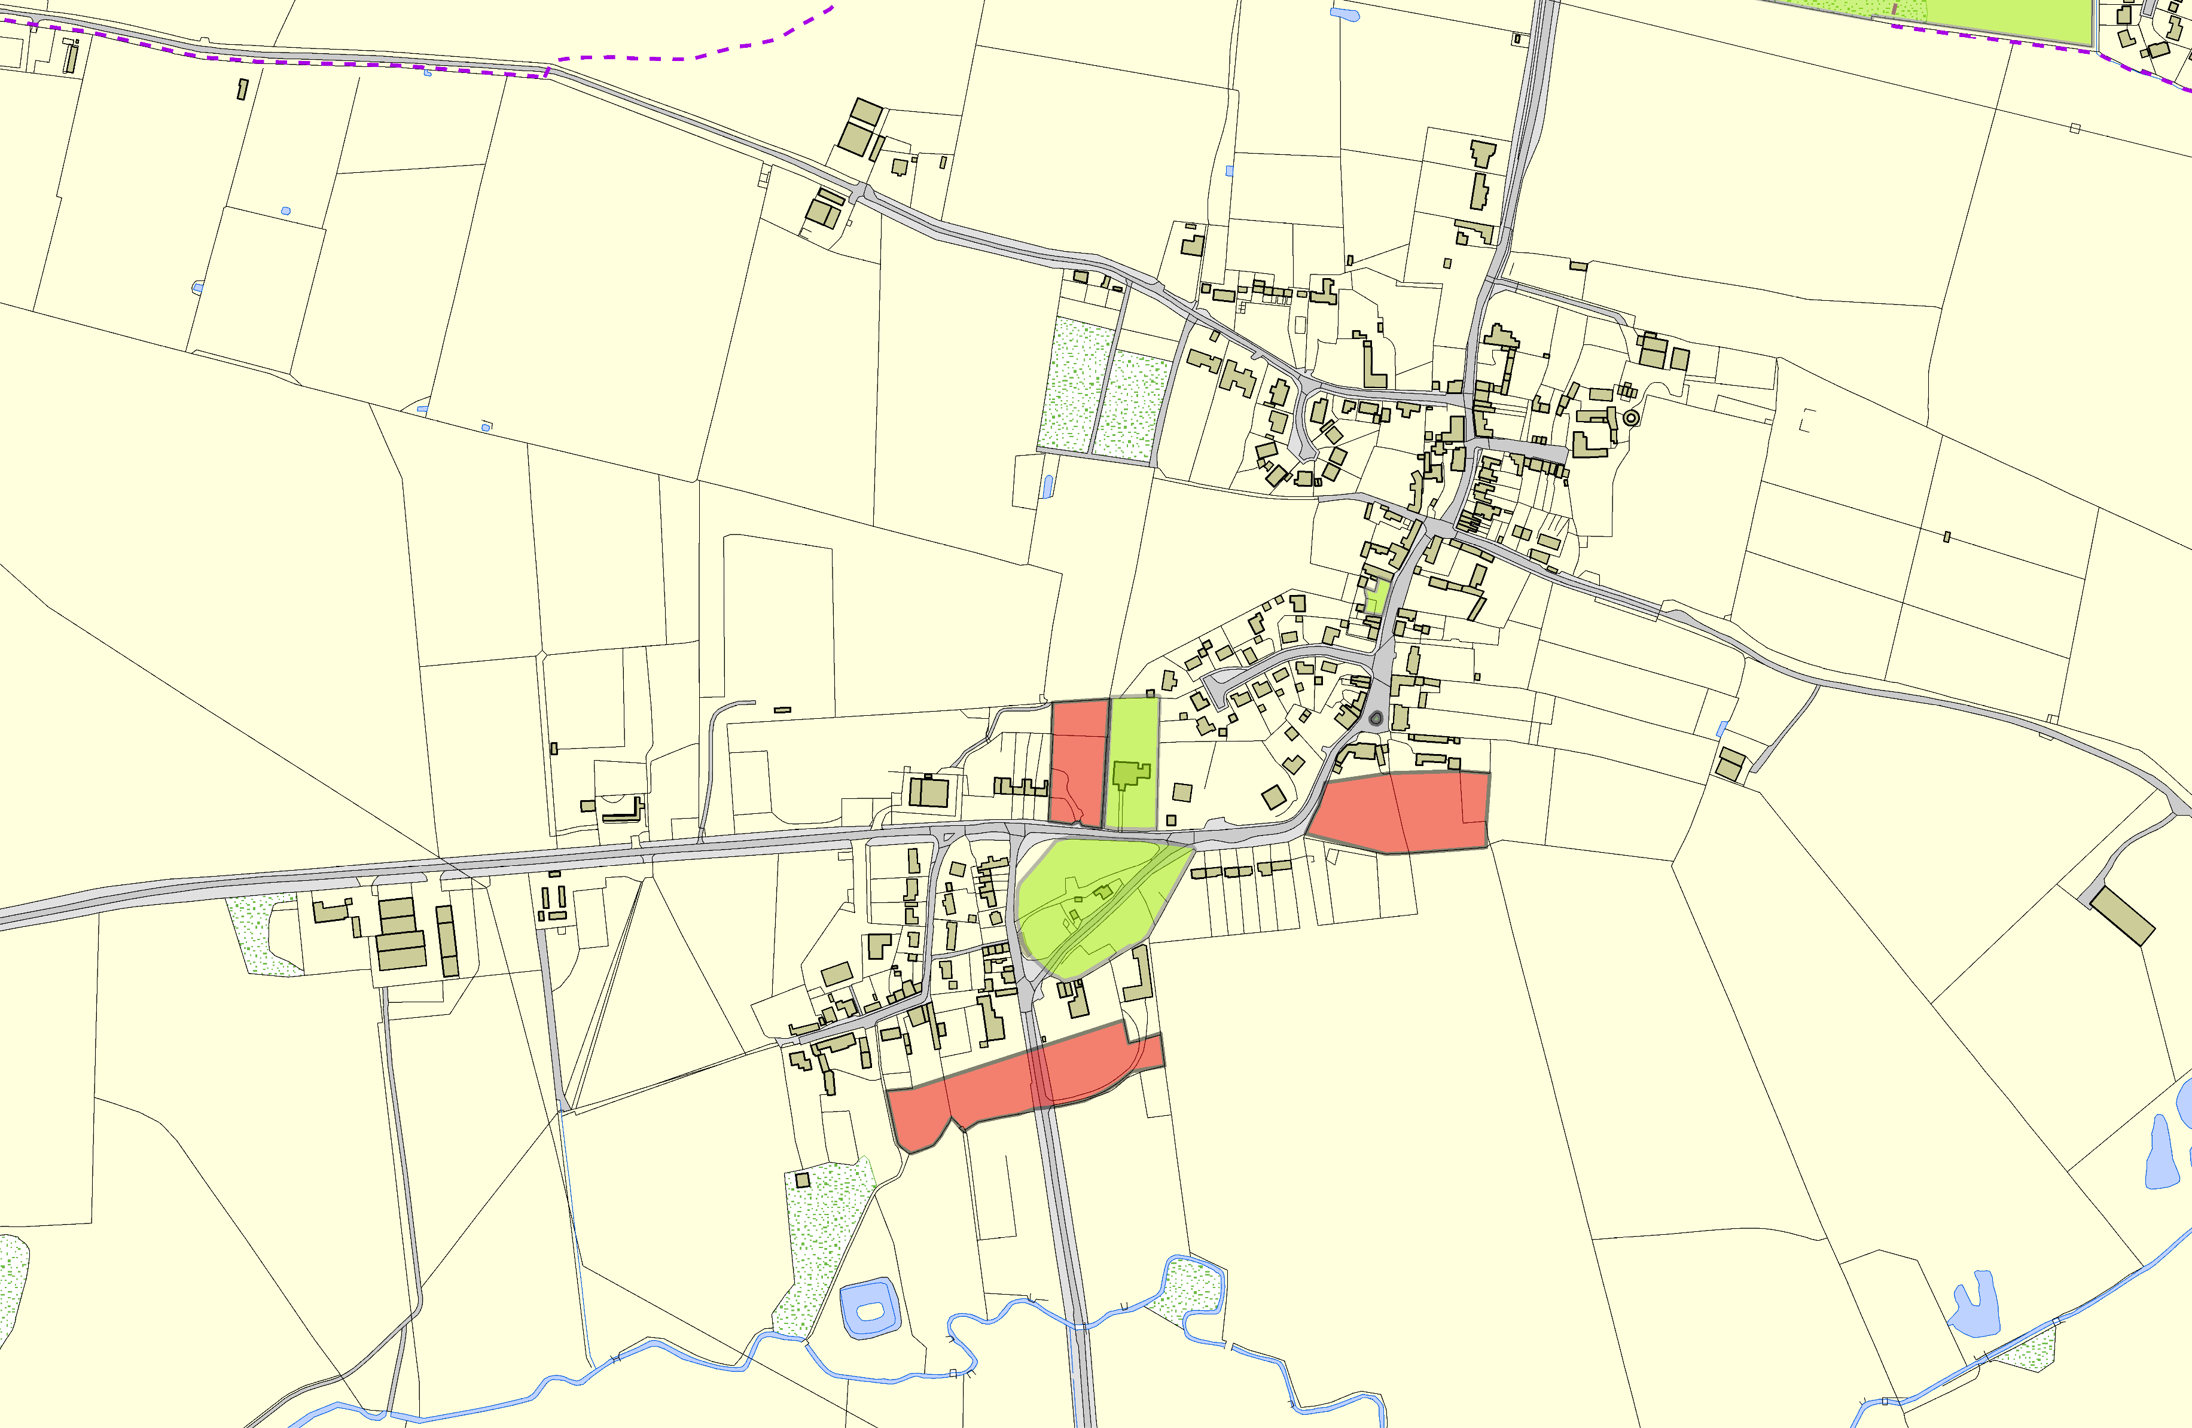

Not recommended for LGS Designation Recommended for LGS designation Wildlife Sites
Open Space, Sport and Recreation Sites
OS MM Boundary
DESCTERM
!!!!!!!!!!!!!!!!!!!! County

District Electoral Parish
Village Green in Smeeton Westerby

LGS/SMEW/4 - Traffic Island Smeetong Westerby

LCGhSu/rMchSyEaWrd/i2n-SPmaededtocnkWnexstetrobCy hurch Smeeton Westerby

LGS/MSEW/3 a and b - Gardens at Wrenbury Farm Smeeton Westerby

Allotments - Smeeton Westerby

LGS/SMEW/1 a and b - Gardens at Highfields on Gumley Road

©Crown Copyright. All rights reserved. Harborough District Council 100023843 2014

