Slawston OSSR sites, LGS sites and Wildlife Sites Note the LGS sites are proposals only at Sept 2015

All Saints Churchyard - Slawston Main Street Village Green - Slawston
Blaston Road Village Green - Slawston

Back of Medbourne Road Open Space - Slawston

Legend

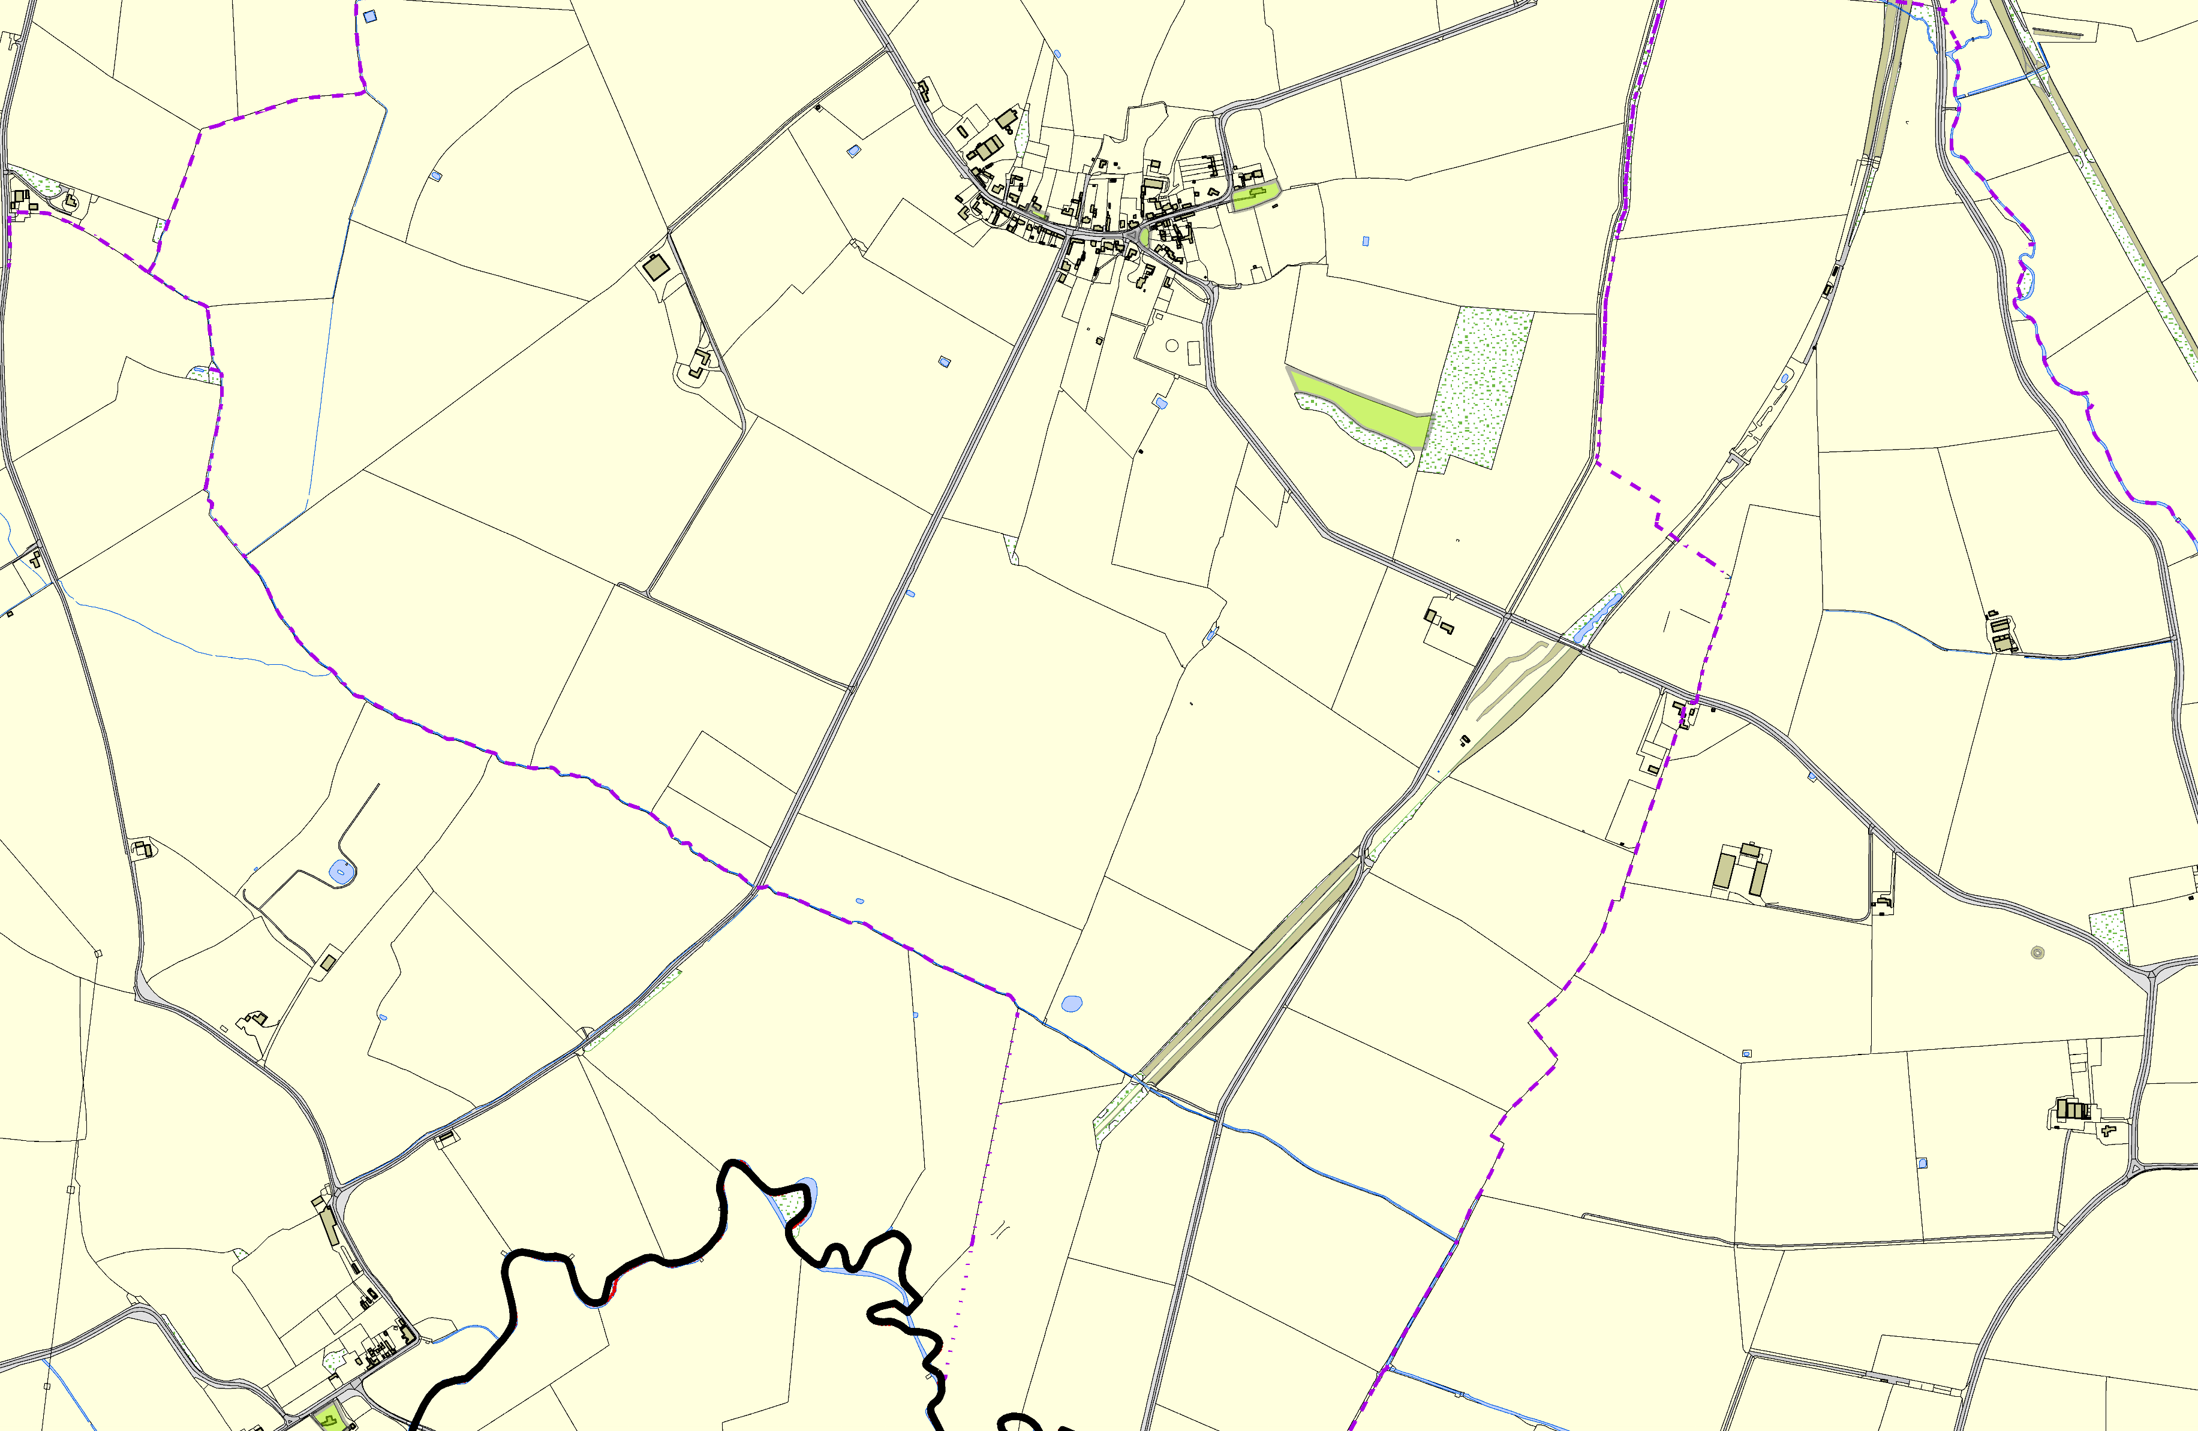

St Andrew Church - Welham
©Crown Copyright. All rights reserved. Harborough District Council 100023843 2014

Not recommended for LGS Designation Recommended for LGS designation Wildlife Sites
Open Space, Sport and Recreation Sites
OS MM Boundary
DESCTERM
!!!!!!!!!!!!!!!!!!!! County

District Electoral Parish

