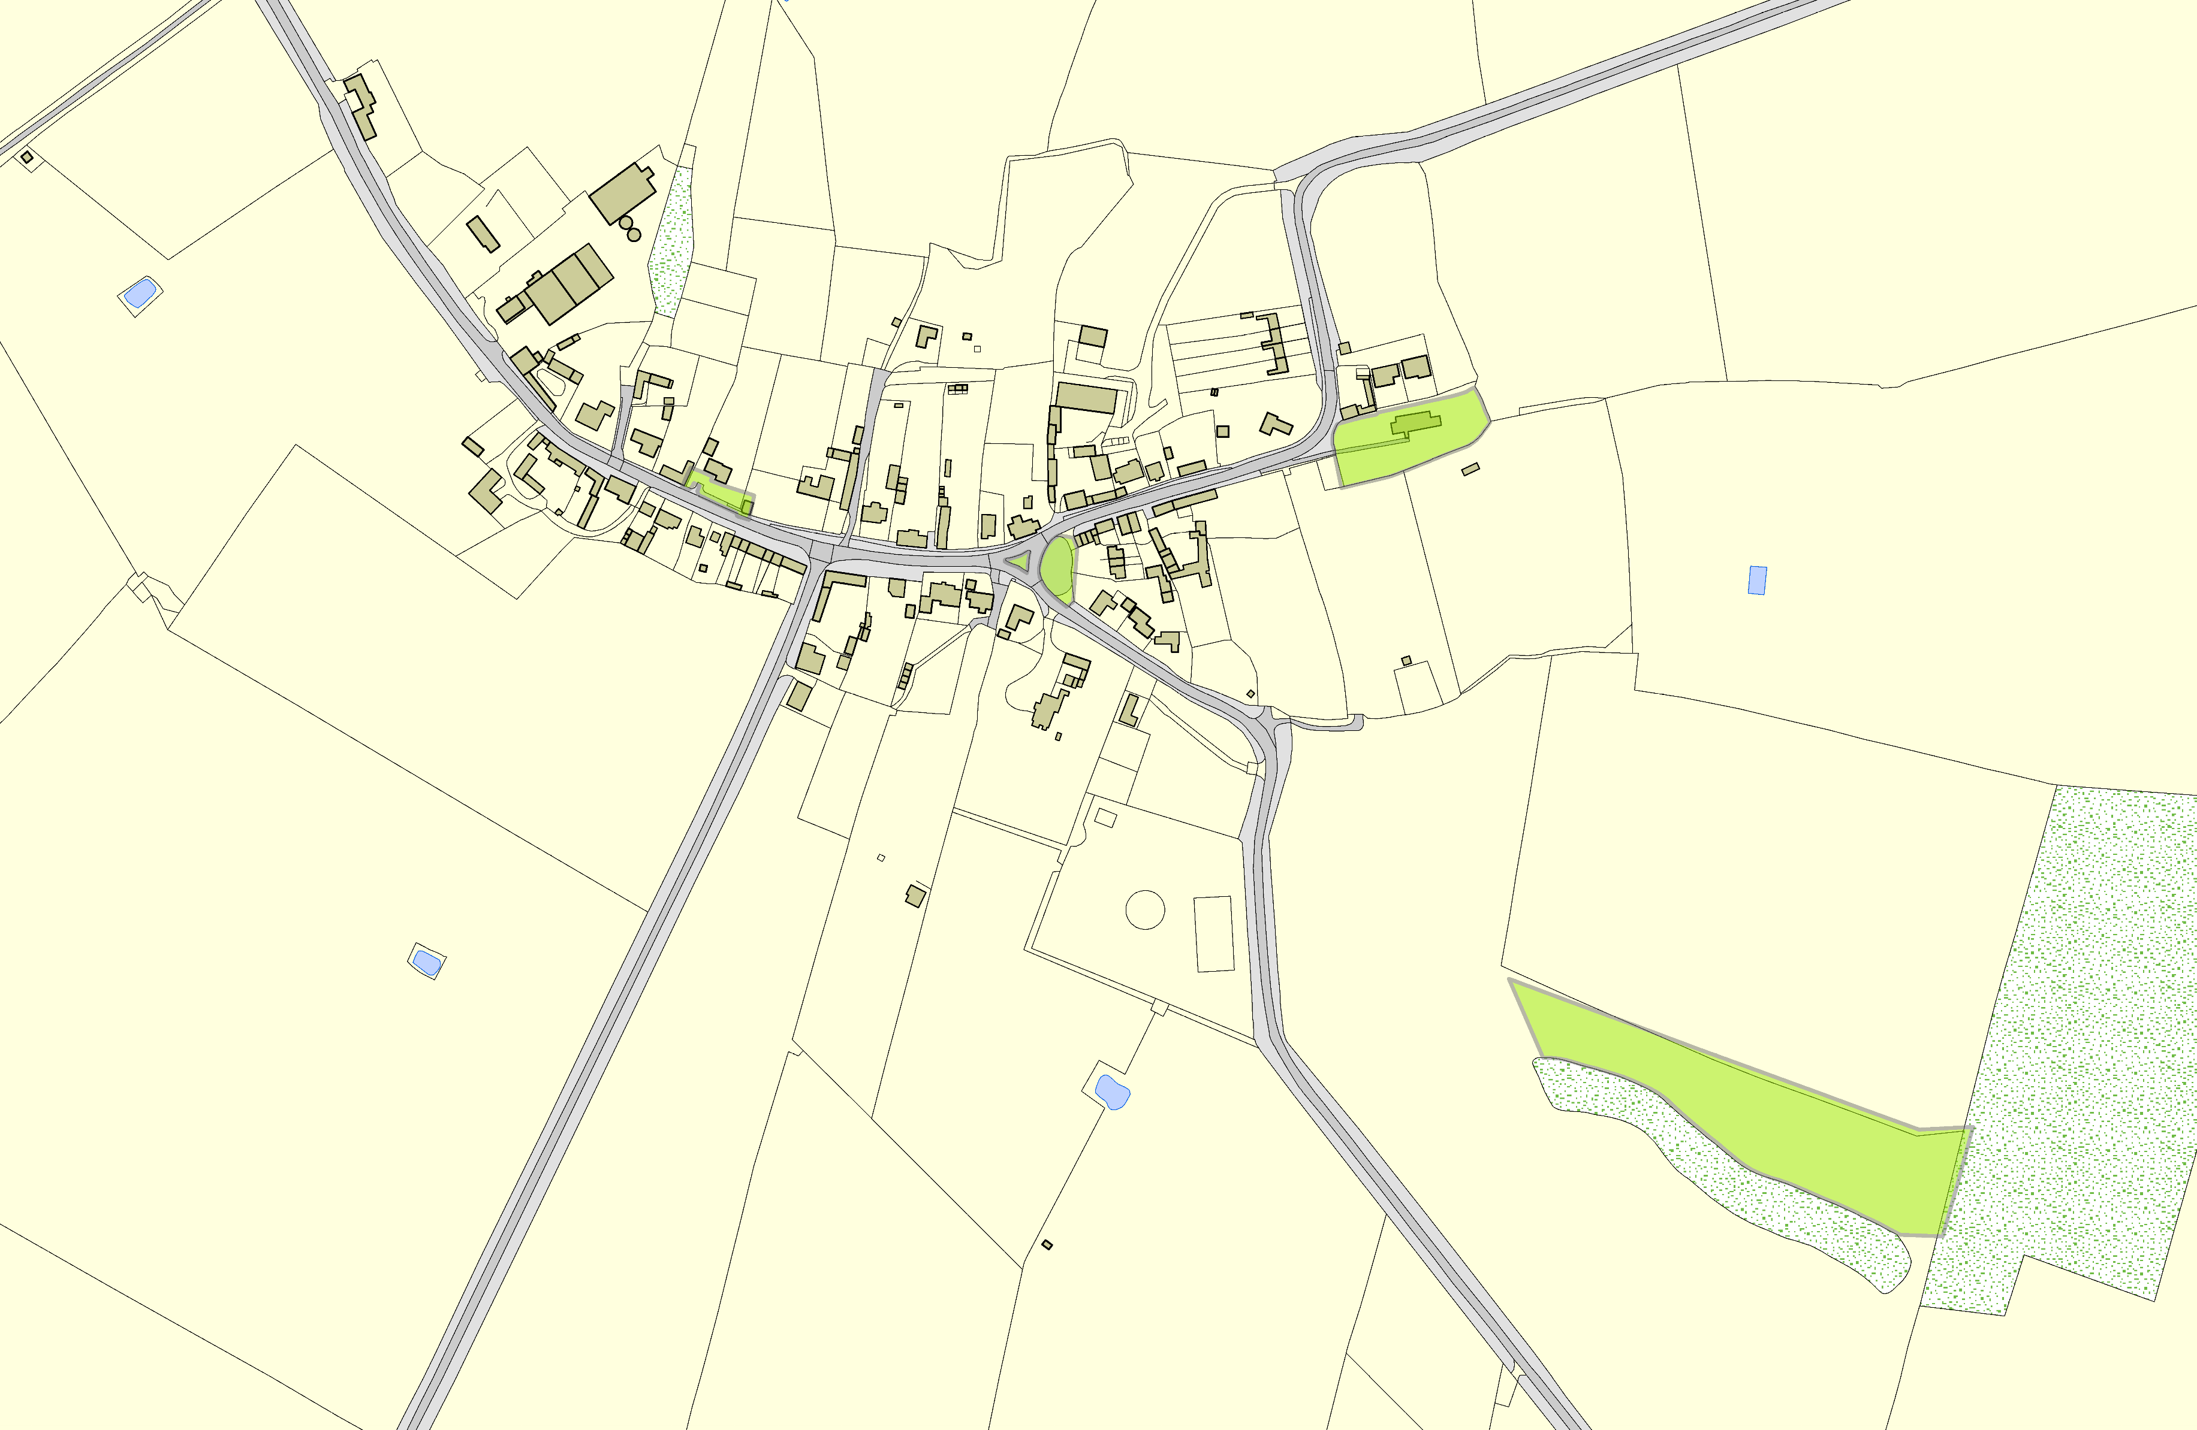Slawston OSSR sites, LGS sites and Wildlife Sites Note the LGS sites are proposals only at Sept 2015

 | Main Street Village Green - Slawston | Blaston Road Village Green - Slawston Blaston Road Village Green - Slawston |  | All Saints Churchyard - Slawston | Legend  Not recommended for LGS Designation Recommended for LGS designation Wildlife Sites  Open Space, Sport and Recreation Sites  OS MM Boundary  DESCTERM  !!!!!!!!!!!!!!!!!!!! County  District Electoral Parish  Back of Medbourne Road Open Space - Slawston
 | ©Crown Copyright. All rights reserved. Harborough District Council 100023843 2014

