Slawston OSSR sites, LGS sites and Wildlife Sites Note the LGS sites are proposals only at Sept 2015

Legend

St Michael & All Angels Churchyard, Cranoe

Not recommended for LGS Designation Recommended for LGS designation Wildlife Sites
Open Space, Sport and Recreation Sites
OS MM Boundary
DESCTERM
!!!!!!!!!!!!!!!!!!!! County

District Electoral Parish

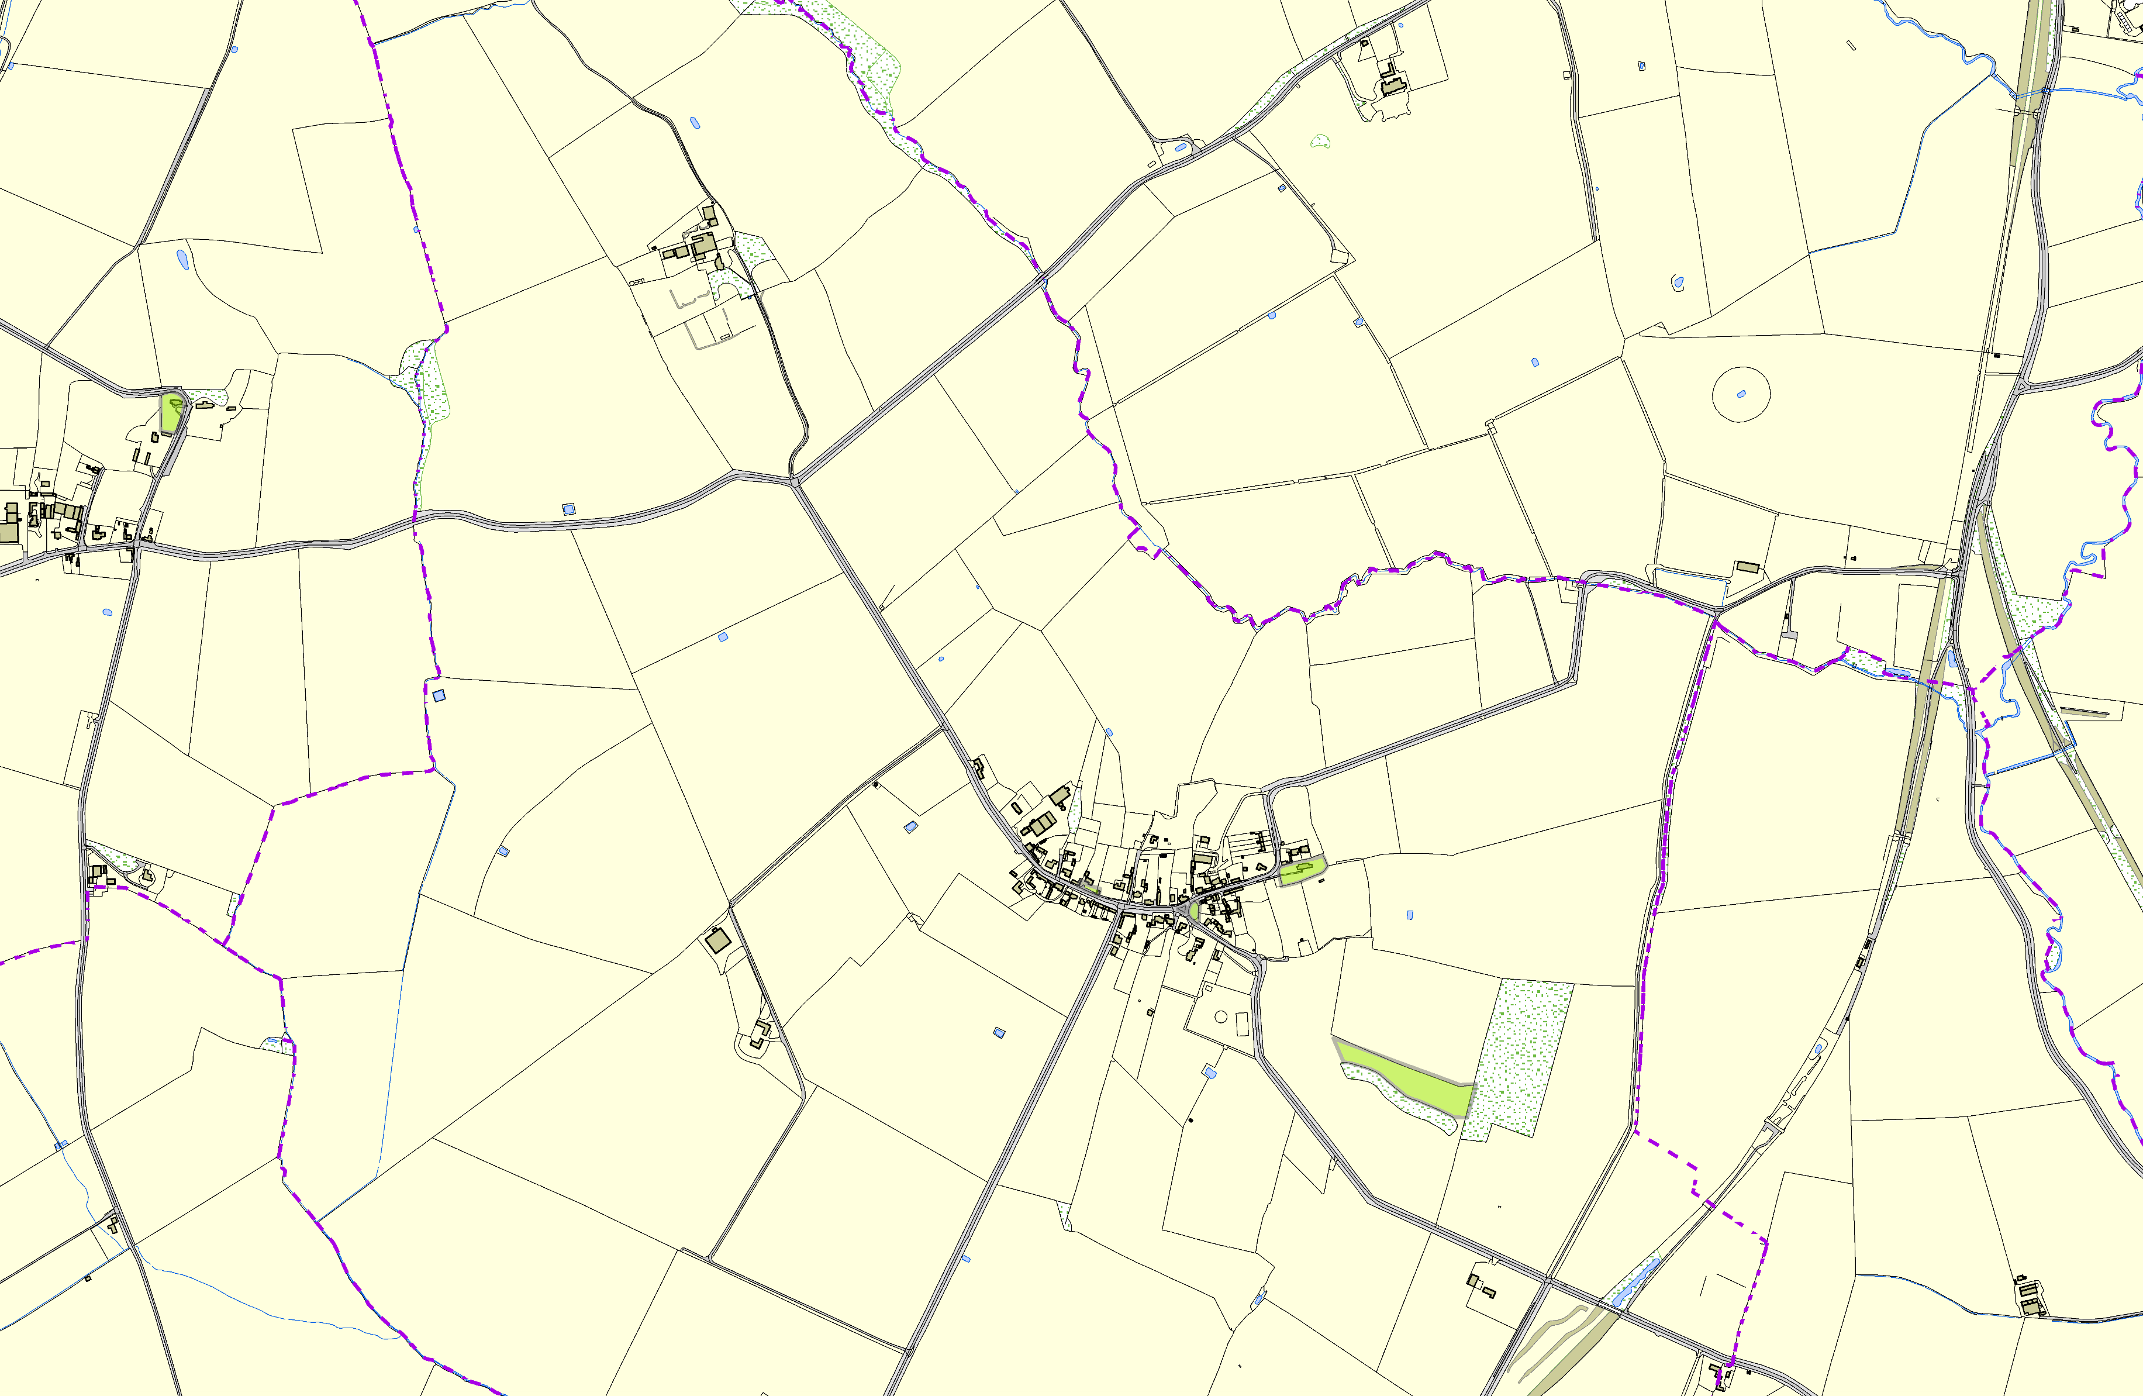

All Saints Churchyard - Slawston Main Street Village Green - Slawston
Blaston Road Village Green - Slawston

Back of Medbourne Road Open Space - Slawston

©Crown Copyright. All rights reserved. Harborough District Council 100023843 2014

