Slawston OSSR sites, LGS sites and Wildlife Sites Note the LGS sites are proposals only at Sept 2015

Hallaton Recreation Ground
Hallaton Play Area

Glebe Farm Hallaton; Area B

Common Land - Goadby Road Hallaton
Hackluits Pond

Glebe Farm Hallaton; Area C

Glebe Farm Hallaton; Area AHallaton Cemetery
Land to End of Hazel Grove North End - Hallaton Hallaton Allotments
Hog Lane Paly Park - Hallaton

Hallaton Churchyard
Hall Woodland - Hallaton

The Cross Amenity Green Space - Hallaton

Legend

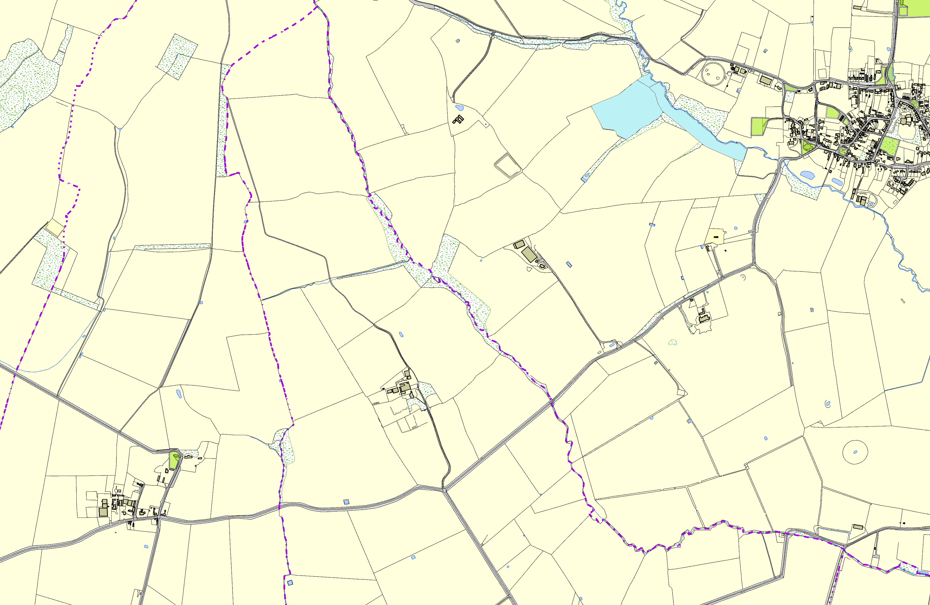

St Michael & All Angels Churchyard, Cranoe

©Crown Copyright. All rights reserved. Harborough District Council 100023843 2014

Not recommended for LGS Designation Recommended for LGS designation Wildlife Sites
Open Space, Sport and Recreation Sites
OS MM Boundary
DESCTERM
!!!!!!!!!!!!!!!!!!!! County

District Electoral Parish

