South Kilworth OSSR sites, LGS sites and Wildlife Sites Note the LGS sites are proposals only at Sept 2015

Legend

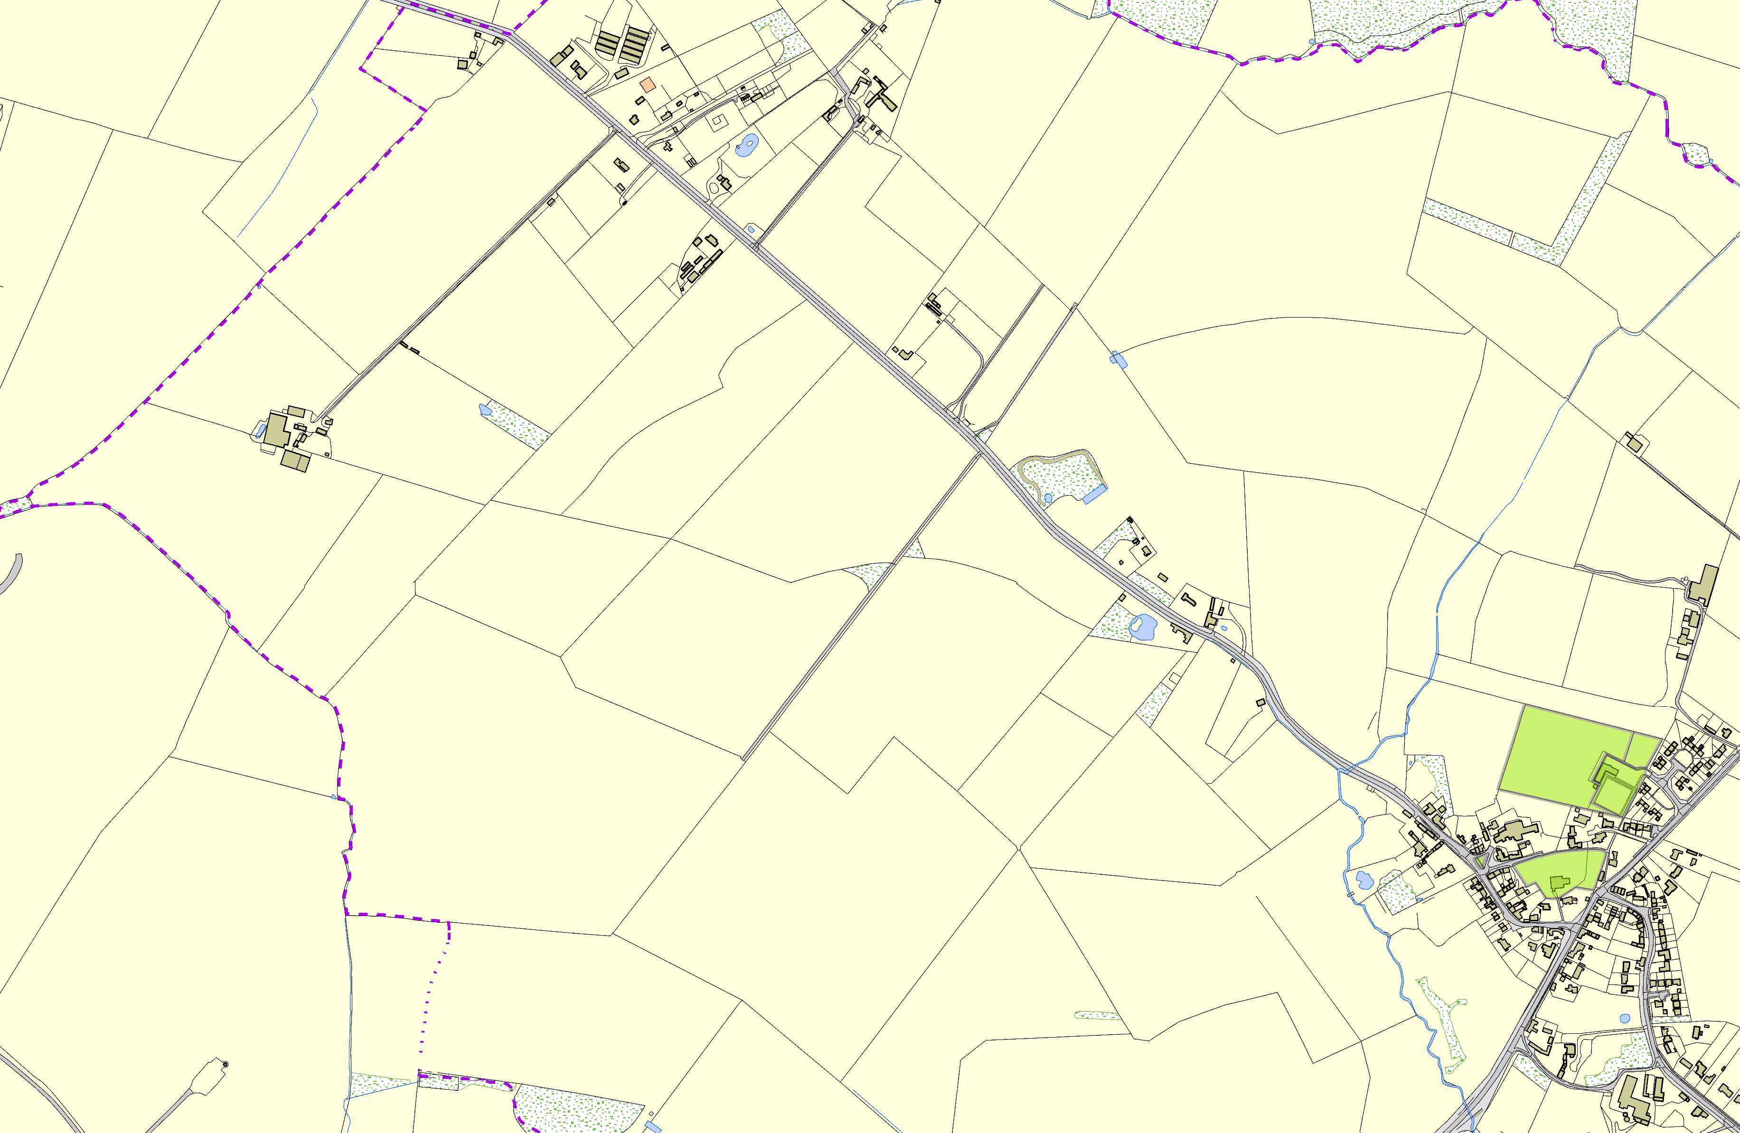

Not recommended for LGS Designation Recommended for LGS designation Wildlife Sites
Open Space, Sport and Recreation Sites
OS MM Boundary
DESCTERM
!!!!!!!!!!!!!!!!!!!! County

District Electoral Parish

Playing Field, Leys Crescent - South Kilworth

Bowling Green - South Kilworth

Village Green, Church Lane - South Kilworth
Churchyard - South Kilworth

©Crown Copyright. All rights reserved. Harborough District Council 100023843 2014

