South Kilworth OSSR sites, LGS sites and Wildlife Sites Note the LGS sites are proposals only at Sept 2015
Bowling Green - South Kilworth Playing Field, Leys Crescent - South Kilworth

Kilworth Springs Golf Club

Village Green, Church Lane - South Kilworth
Churchyard - South Kilworth

Legend

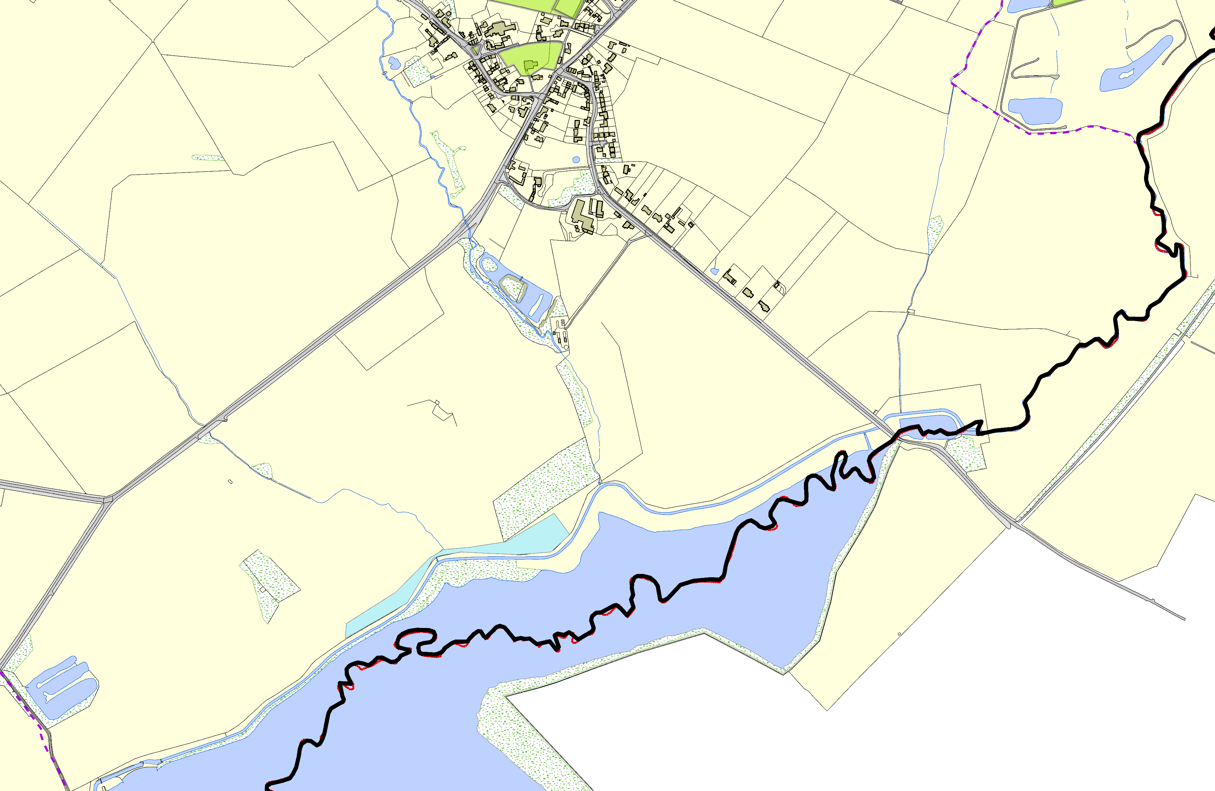

Stanford Reservoir Reedbed, South Kilworth

©Crown Copyright. All rights reserved. Harborough District Council 100023843 2014

Not recommended for LGS Designation Recommended for LGS designation Wildlife Sites
Open Space, Sport and Recreation Sites
OS MM Boundary
DESCTERM
!!!!!!!!!!!!!!!!!!!! County

District Electoral Parish

