South Kilworth OSSR sites, LGS sites and Wildlife Sites Note the LGS sites are proposals only at Sept 2015

Legend

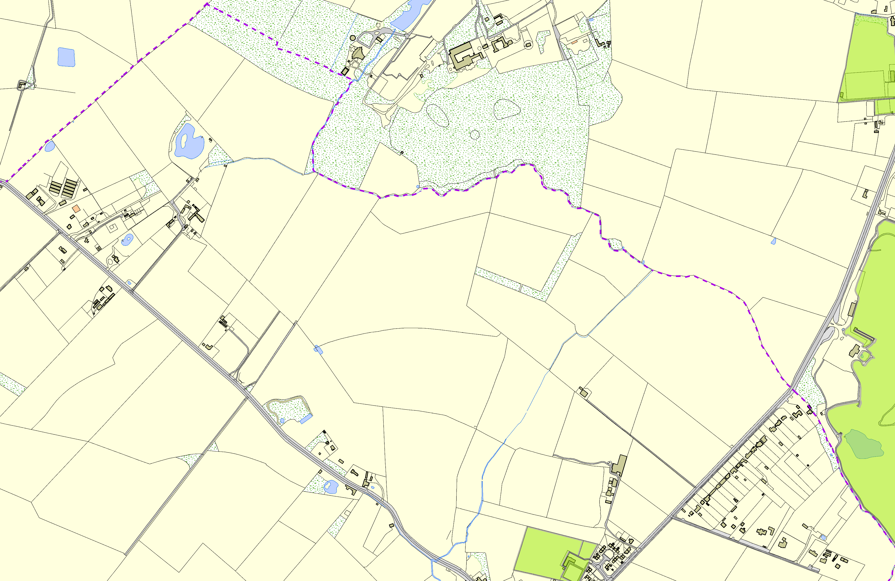
Not recommended for LGS Designation Recommended for LGSSpdoertssFiigeldninaNtioorthnKilworth Wildlife Sites

Open Space, Sport and Recreation Sites
All Weather Courts in North Kilworth

OS MM Boundary
DESCTERM
!!!!!!!!!!!!!!!!!!!! County

District Electoral Parish

Kilworth Springs Golf Club

Childrens Play Equipment Area - South Kilworth Playing Field, Leys Crescent - South Kilworth

Bowling Green - South Kilworth

©Crown Copyright. All rights reserved. Harborough District Council 100023843 2014

