Stockerston OSSR sites, LGS sites and Wildlife Sites Note the LGS sites are proposals only at Sept 2015

Mature Ash Tree 10, King's Hill Lodge

Mature Ash Tree 4, King's Hill Lodge

Mature Ash Tree 6, King's Hill Lodge

Mature Ash Tree 8, King's Hill Lodge
Mature Ash Tree 7, King's Hill Lodge

LegendEyebrook Valley Woods 1
Mature Ash Tree 9, King's Hill Lodge

Not recommended for LGS Designation Recommended for LGS designation Wildlife Sites
Open Space, Sport and Recreation Sites
OS MM Boundary
DESCTERM
!!!!!!!!!!!!!!!!!!!! County

District Electoral Parish

Stockeston Churchyard

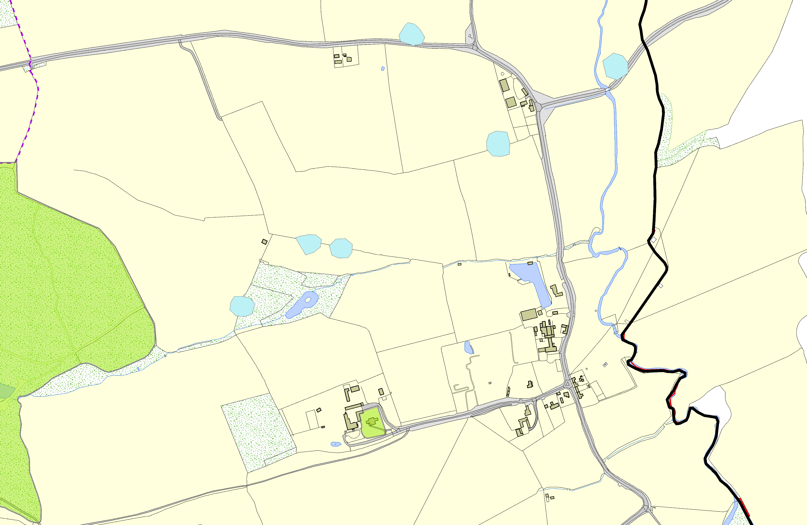©Crown Copyright. All rights reserved. Harborough District Council 100023843 2014

